
Sargent, R. F. (1944, June 6). Into the jaws of death [Photograph]. Wikimedia Commons. https://en.wikipedia.org/wiki/Into_the_Jaws_of_Death#

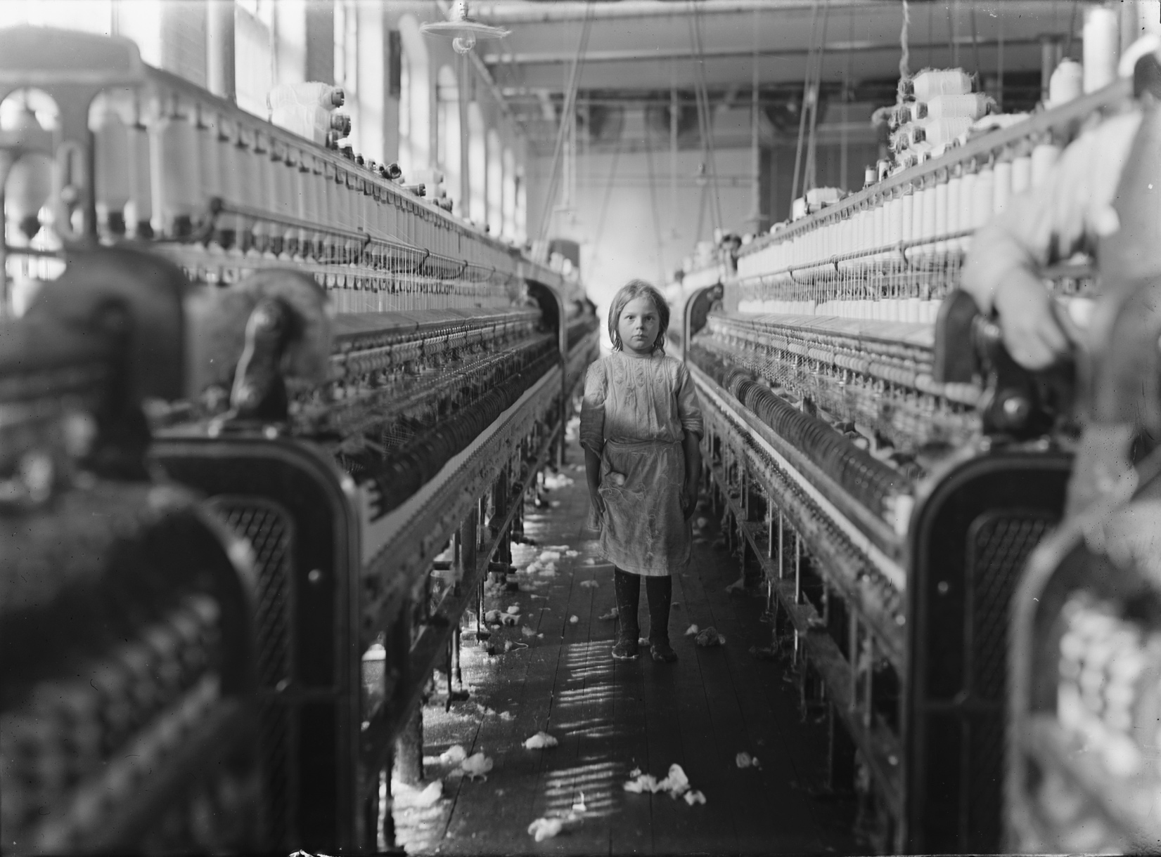
Hine, L. W. (1908, December 3). A little spinner in the Mollahan Mills, Newberry, S.C. [Photograph]. Library of Congress. https://www.loc.gov/item/2018674902/

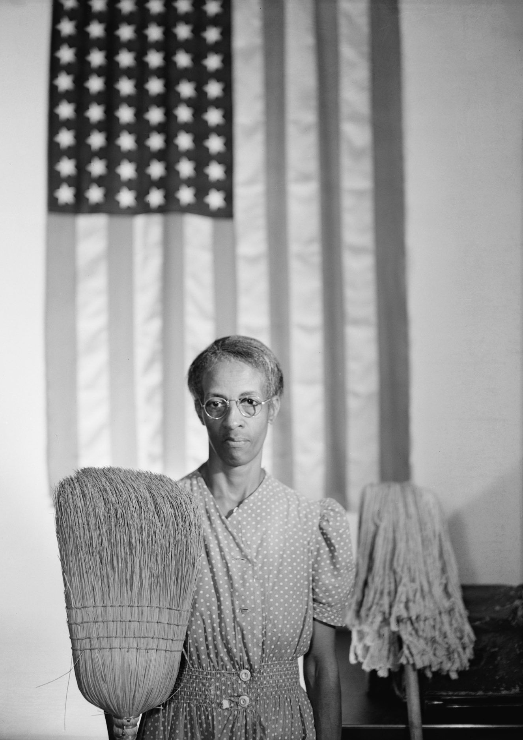
Parks, G. (1942, August). American Gothic [Photograph]. Wikimedia Commons. https://commons.wikimedia.org/wiki/File:Gordon_Parks_-_American_Gothic.jpg

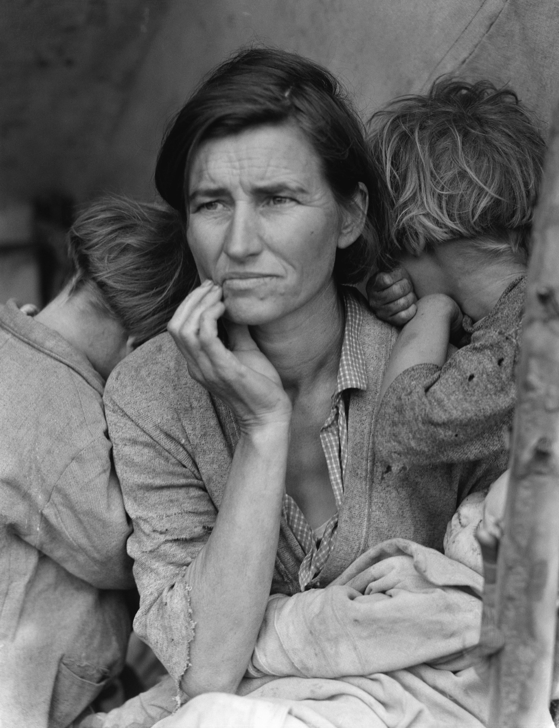
Lange, D. (1936, March). Destitute pea pickers in California. Mother of seven children. Age thirty-two. Nipomo, California [Image]. Library of Congress. https://loc.gov/pictures/resource/ppmsca.12883/

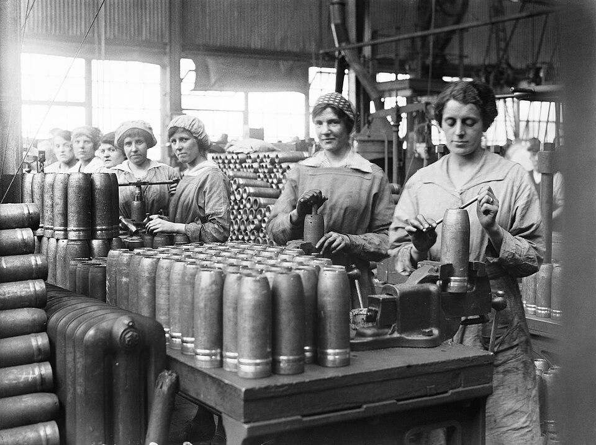
Women working in the munitions industry during the First World War [Photograph]. (1917, May). Wikimedia Commons. https://commons.wikimedia.org/wiki/File:Women_Working_in_the_Munitions_Industry_during_the_First_World_War_Q108474.jpg

