NOTE CATCHER

My Next Move Interest Profiler Instructions
- Go to https://www.mynextmove.org/explore/ip

- To advance through to the survey, you will need to click the Next button in the bottom right corner of each box.
Click Next 4 times to start the survey. Be sure to read all the helpful information as you go.
  - Answer 60 survey questions related to how you feel about different work activities, from “Strongly Dislike” to “Strongly Like.”
  - Focus only on how much you like or dislike doing the work described.
  - Don’t rush, but also don’t spend too much time on each question.
- Answer all questions. When finished, click Next.
- Here are your Interest Profiler results. Each letter represents different areas of interest, and the numbers assigned to them show how strongly you feel toward that area of work.
- Based on your top 3 letters, a list of “Job Zones,” or groups of careers that require the same amount of preparation, has been listed.

Exit Ticket - I Used To Think… But Now I Know

Write out your thoughts on majors, salaries, or any other thoughts before today’s session, and what you know now.
I used to think… | But now I know…

Occupation Search
- Go to https://www.onetonline.org/
- Search for your career under the “Occupation Keyword Search”
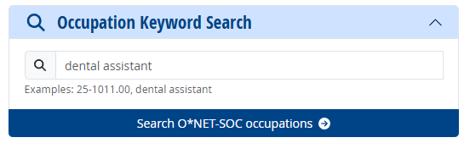
- Click on the job title to open the full profile.
- Scroll down to the “Wages & Employment Trends” section.

- Choose Oklahoma and record the median salary in the box provided.
- Choose a different state other than Oklahoma (e.g., your home state or a state you may want to move to). Record the median salary for each state in the same box.
- Repeat steps 2-6 for 1 or 2 more different occupations.

Compare your chosen career paths’ salary info with the state of Oklahoma and one other state that you could see yourself living in.
State | Career | Average Salary
EX: Oklahoma  EX: North Carolina | Dental Assistant  Dental Assistant | $44,450  $48,710

