PROJECT ONE: LOGO DESIGN

Goals
- Create a primary logo.
- Create 3 variant logos that are:
  - Text only
  - Graphics only
  - An alternate logo for specific purposes

Instructions: Designing a Logo in Canva
- Navigate to Canva.com. If this is your first time using Canva, create an account. Consider using the Google login option so your designs can be saved and shared via Google Drive.
- On the left sidebar menu, select the plus (+) sign labeled “Create.”
- In the new menu that appears, scroll to the bottom and select “Custom Size.”
- Set the Width to 1200 and the Height to 1200, making sure the Units box is set to “px” (pixels). This size creates a large logo that can be scaled down while still maintaining quality.
- Select the “Submit” button.
- Decide what your graphic should look like. Aim to represent the service offered by the business, or use imagery inspired by the business name. This part is highly creative, so feel free to explore.
- For inspiration, visit Logo Examples on Wakelet.
- Using a mix of shapes and lines, design something simple and evocative. Begin with a combination mark, which includes both graphics and text.
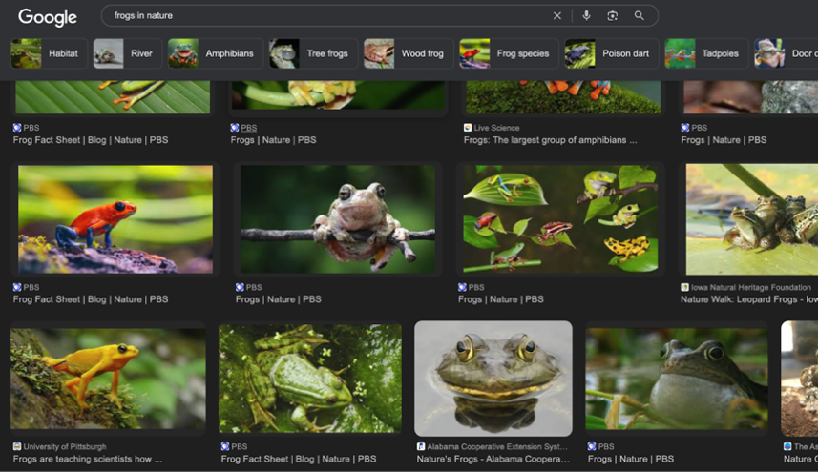
- For this project, create a logo for the fictional business “Frogs Unlimited,” a frog supply service. Start by searching for reference images of frogs online. Select one that appeals to you, copy it, and paste it into Canva.

- Once the image loads into Canva, overlay shapes to recreate the image using broad forms and just one or two colors. To begin, select “Elements” from the left menu of Canva.
- Drag in the relevant shapes from the Elements tab. You can resize any shape by selecting it and dragging one of the dots on the bounding box that appears around it.
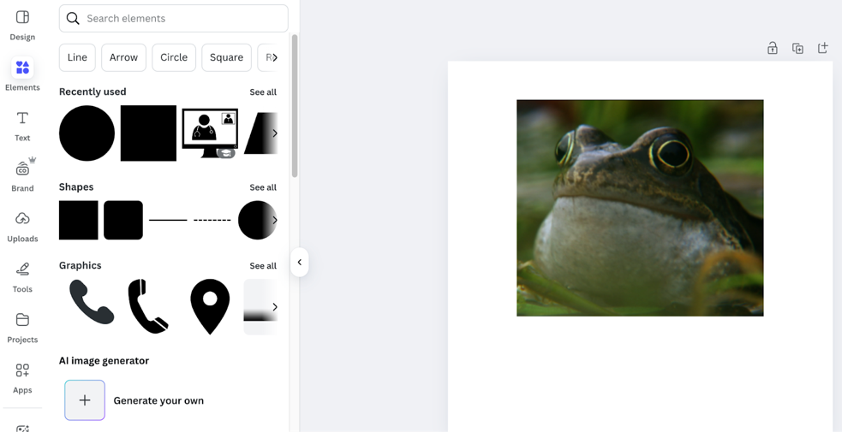
    - For example, you can layer circles and a square to create a simple silhouette that loosely resembles a frog.
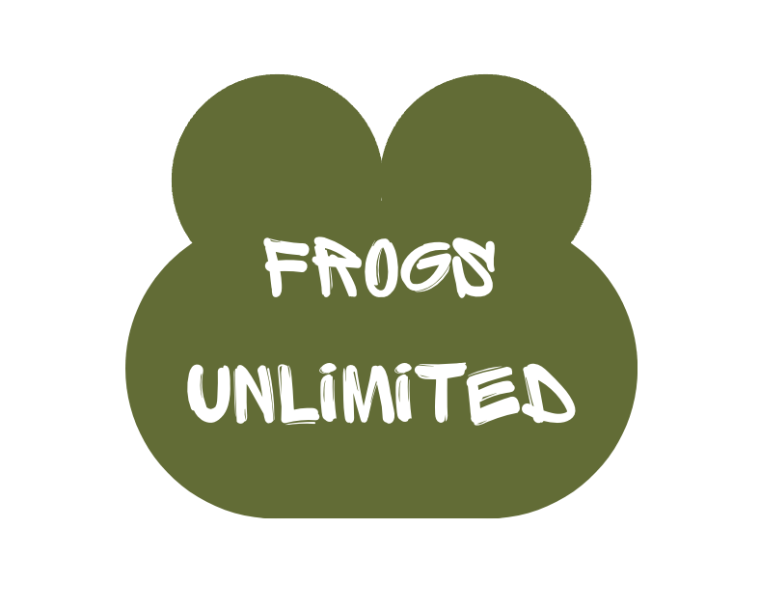
- Once you’re satisfied with the shape, delete the original reference image.
- Choose a font that fits your brand and add it to the center of the graphic. To add text, select the “Text button” beneath Elements on the left sidebar. Select “Add a Text Box.” Once your text is placed, you can resize the entire logo, including the text and graphics, by dragging a selection box around all of the elements then selecting and dragging a corner until you reach your desired size.
- To make the background transparent, first select the “Download” button in the upper-right corner of the page. Select the “PNG” file type, then check the “Transparent background” option.
- Create at least 3 logo variations. One should be a graphic-only logo, and one should be a text-only logo. To create each version, delete the unnecessary elements and re-save each logo. However, one logo may be too comical for the context, and if there is anything Frogs Unlimited is, it is serious. In this case, you may need to keep working to find an appropriate alternate logo.
    - For example, this logo uses a different typography in addition to the logo to give the viewer a greater understanding of the business. The frogs are, in fact, unlimited.
