EXPERIENCE TO EXPERTISE

AI chat tools can be incredibly useful for making resumes more impactful. By providing basic information about a job or experience, the AI can suggest more professional and action-oriented ways to describe those experiences. This helps you present your skills and accomplishments in a way that stands out to potential employers or college admissions officers.

*Example*

Instead of simply stating “Worked at a coffee shop,” the AI can help transform this into “Executed daily coffee and beverage preparation, delivered exceptional customer service, and maintained a clean and organized workspace at [Name of Coffee Shop].

# Task

Ask the AI Chatbot of your choice to make any of the following Sample Student Work Experiences more actionable. 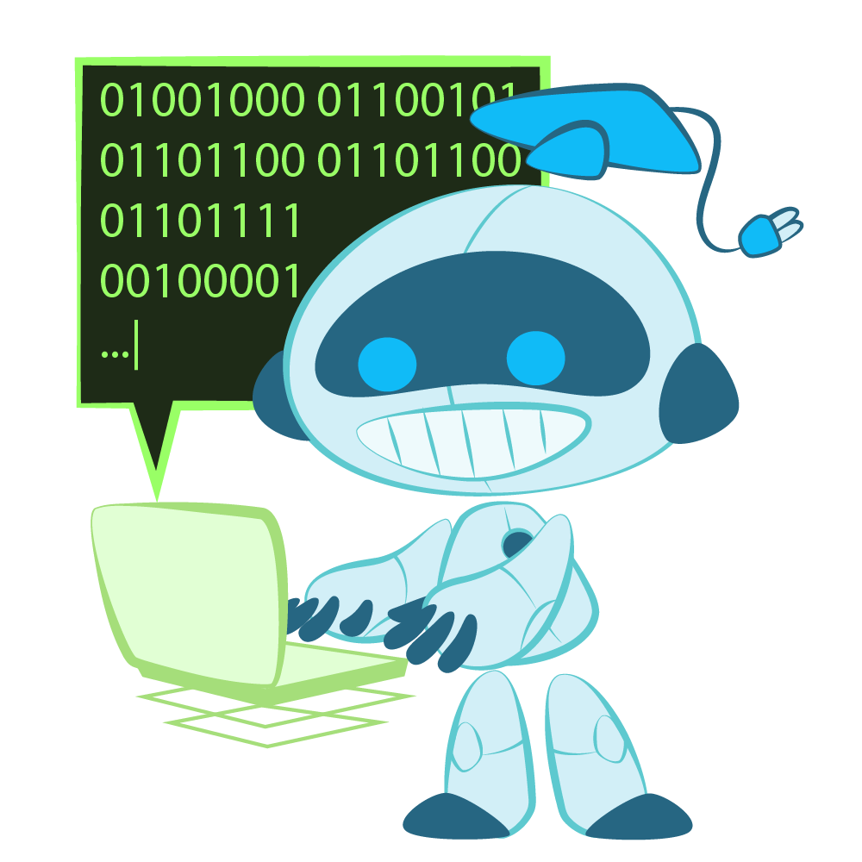

## **Account-Based AI Chat Bots** https://claude.ai https://copilot.cloud.microsoft https://gemini.google.com

## **Open AI Chat Bots** <https://www.meta.ai> <https://www.perplexity.ai> [https://openai.com](https://openai.com/)

# Sample Student Work Experiences

* Worked at a coffee shop
* Volunteered at a local animal shelter
* Tutored younger students in math
* Participated in the school debate club
* Interned at a local business during the summer
* Babysat for neighborhood families
* Served as a cashier at a grocery store
* Captain of the school soccer team
* Organized a charity event for the community
* Assisted in the school library
* Participated in a science fair
* Worked as a camp counselor during the summer
* Led a group project in a science class
* Played an instrument in the school band
* Volunteered at a food bank

# 

# I Notice, I Wonder

After exploring how AI can help with resume writing, reflect on the experience below.

|  |  |
| --- | --- |
| **I Notice** | **I Wonder** |
|  |  |