GETTING STARTED WITH AI

**Introduction**

In today’s digital world, artificial intelligence (AI) offers you helpful tools—especially when building a professional resume. However, you still need to know how AI works and how to use it responsibly.

**AI Digital Literacy Skills**

AI does not think like a person. Instead, it analyzes massive amounts of data—millions of resumes, job postings, and examples—and generates responses based on patterns. When you ask AI to help with your resume, it predicts the structure, language, and content most likely to match your goal. 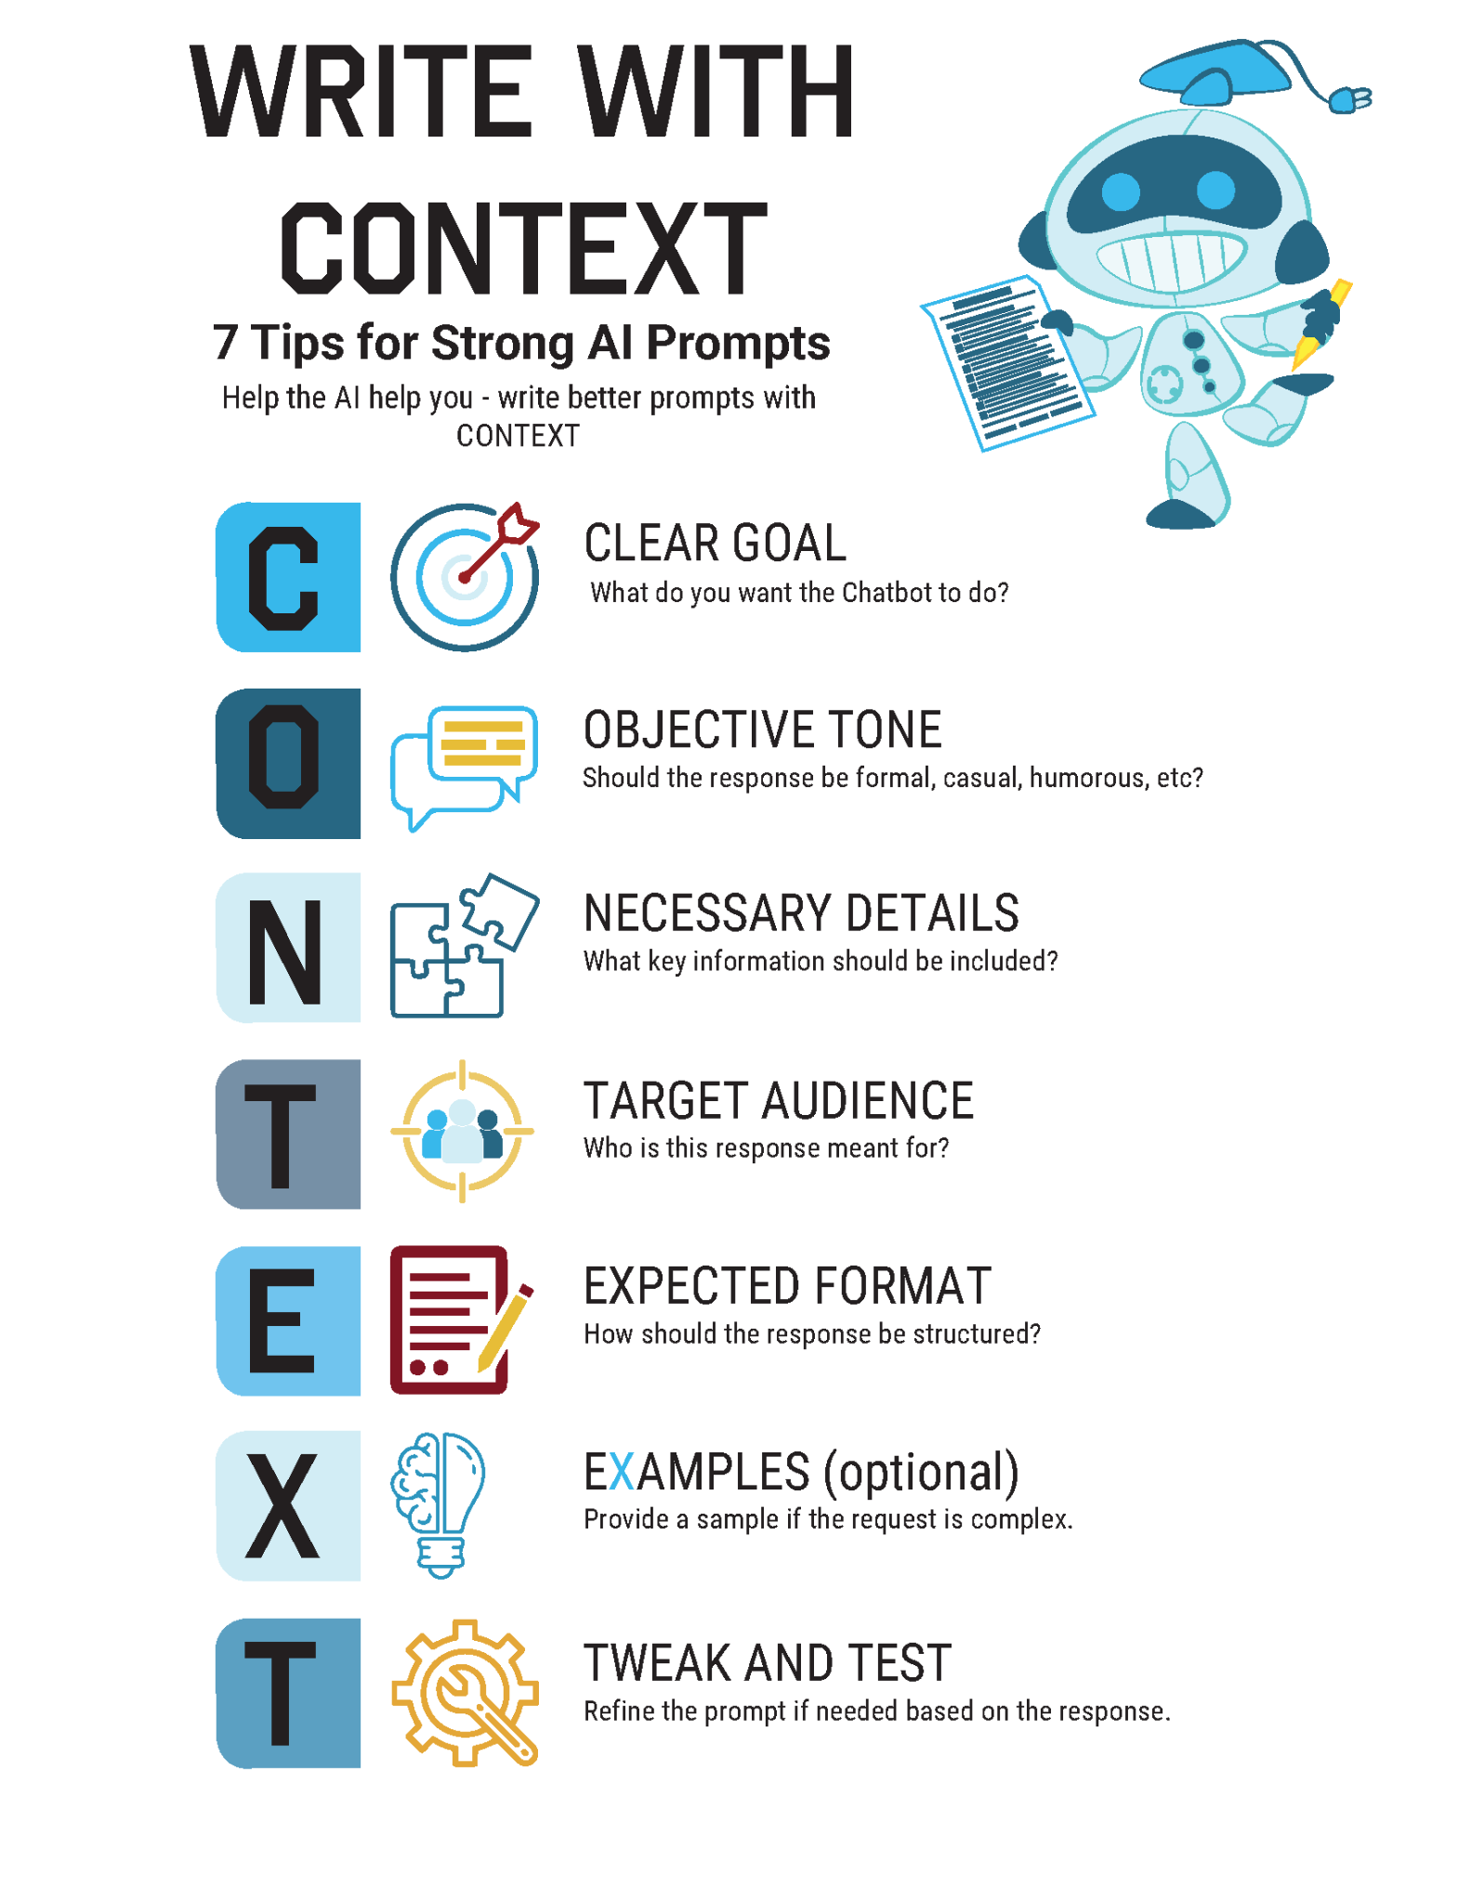

## What can you do?

* Cross-check sources.
* Look for inconsistencies.
* If content feels off, investigate!
* Question perfect narratives.
* Notice emotional manipulation.
* Learn AI’s patterns.
* Test AI tools yourself.
* Understand AI limitations.

**Prompt Writing**

It’s all about the wording! The quality of AI output directly relates with the quality of your input.