Student growth mindset goal activity sheet
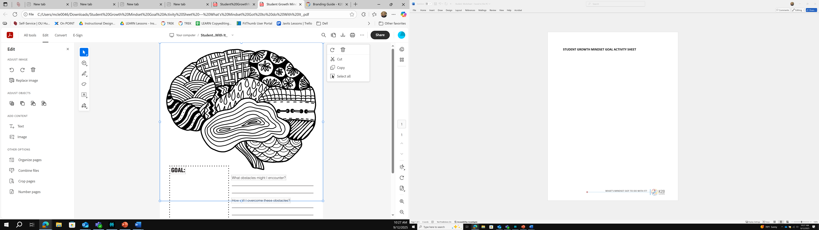

GOAL: What obstacles might I encounter?
_________________________________________
_________________________________________
How will I overcome these obstacles?
_________________________________________
_________________________________________
What other strategies might I need to apply
in order to accomplish this goal more efficiently?
_________________________________________
_________________________________________

