MY CHECKLIST
Directions. Revisit this checklist before moving to the next phase of the Engineering Design Process.

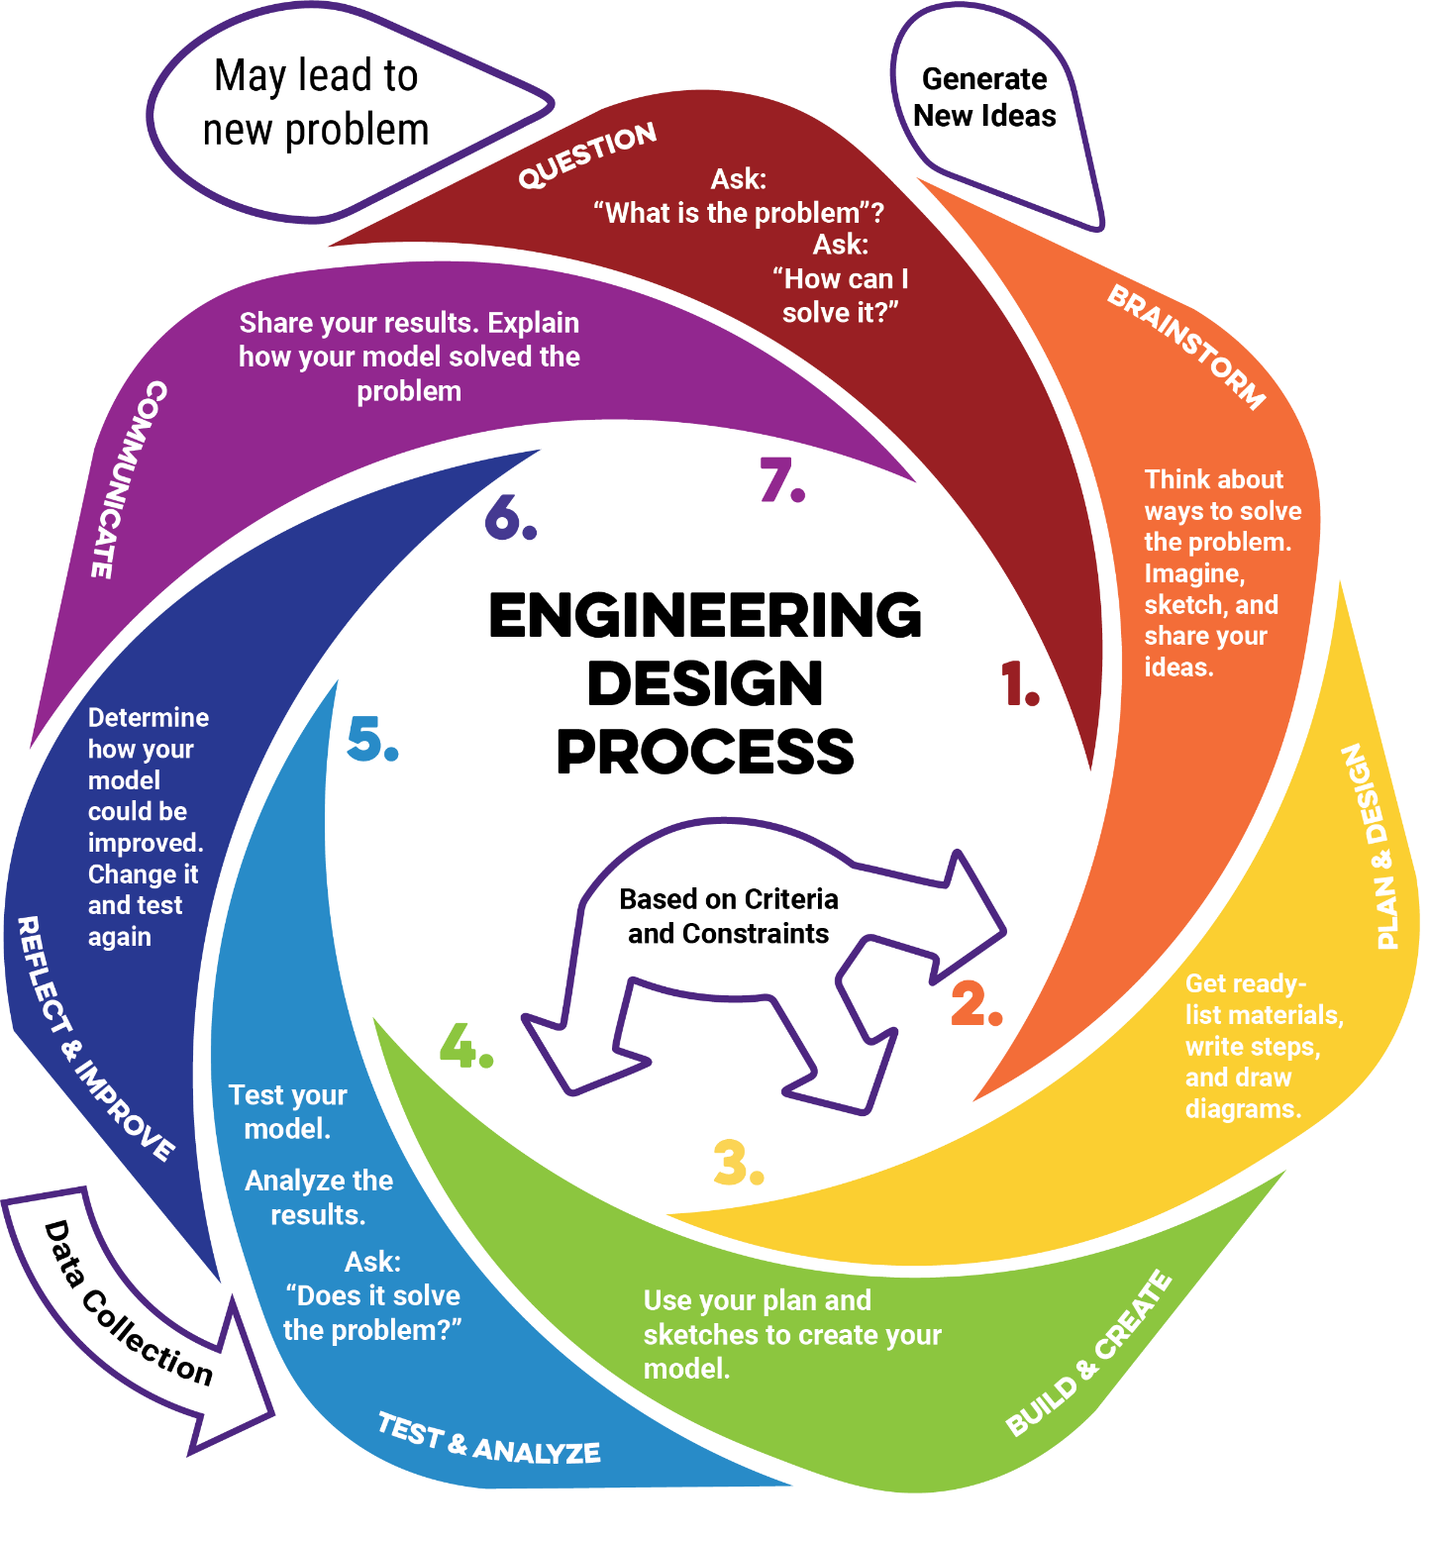

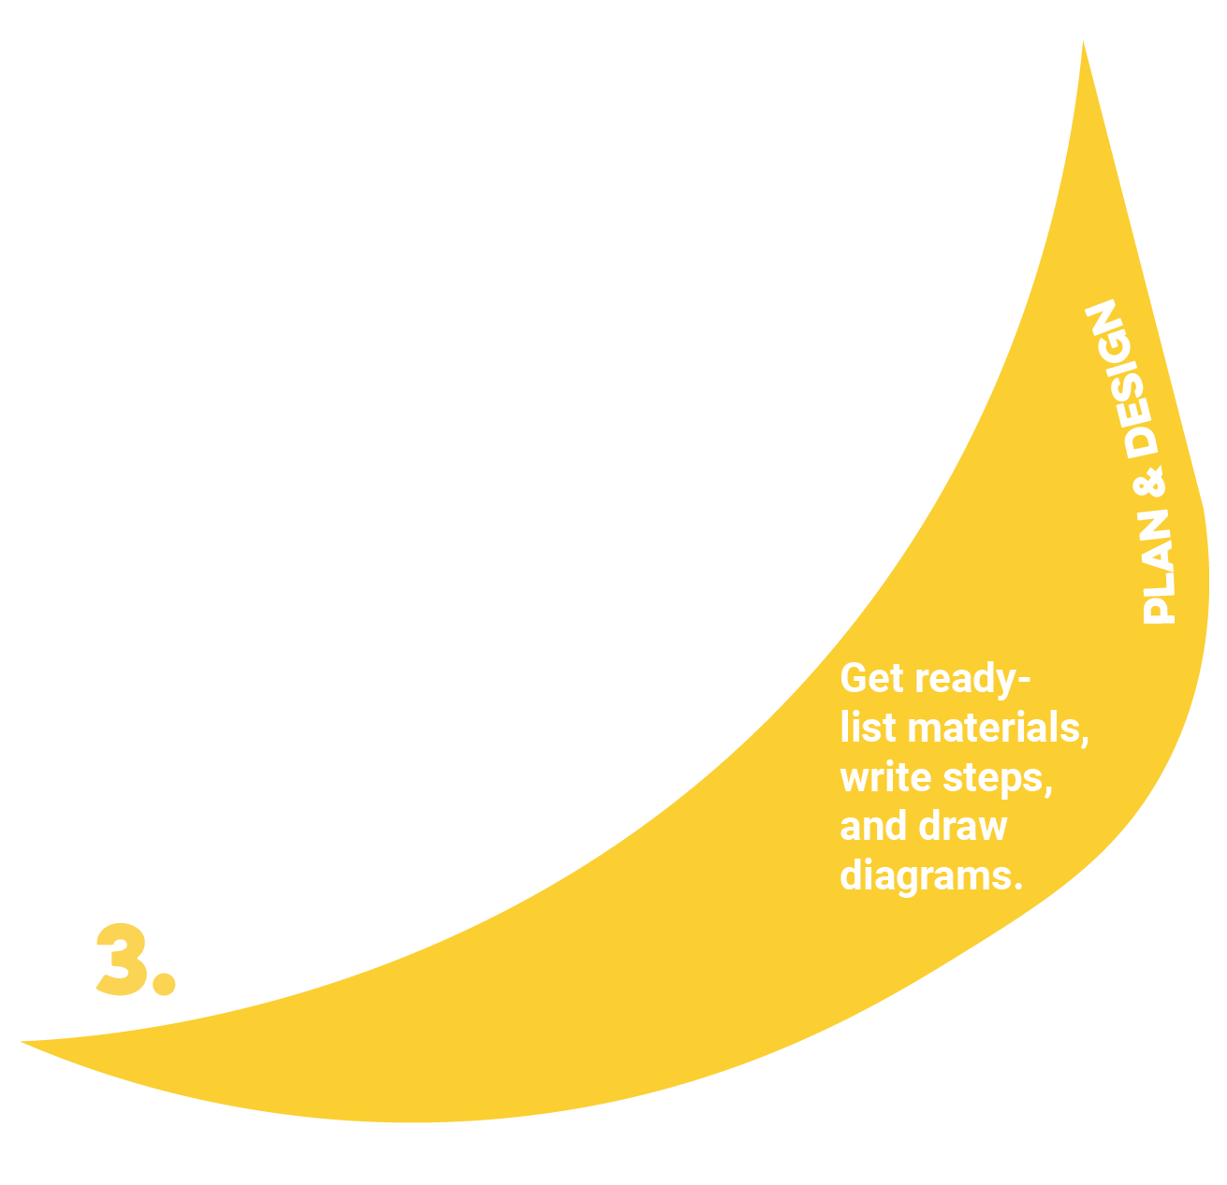
Plan & Design
Check Before Moving On:
- My plan includes at least one drawing of the design.
- My plan includes a model (physical or digital) that represents the design.
- All diagrams are labeled clearly.
- I have listed all required materials, tools, and costs.
- Measurements or dimensions are included and accurate.
- The plan contains clear, step-by-step building instructions.
- The design meets all criteria and works within the constraints.

Build & Create
Check Before Moving On:
- I followed my plan, drawings, and model during the build process.
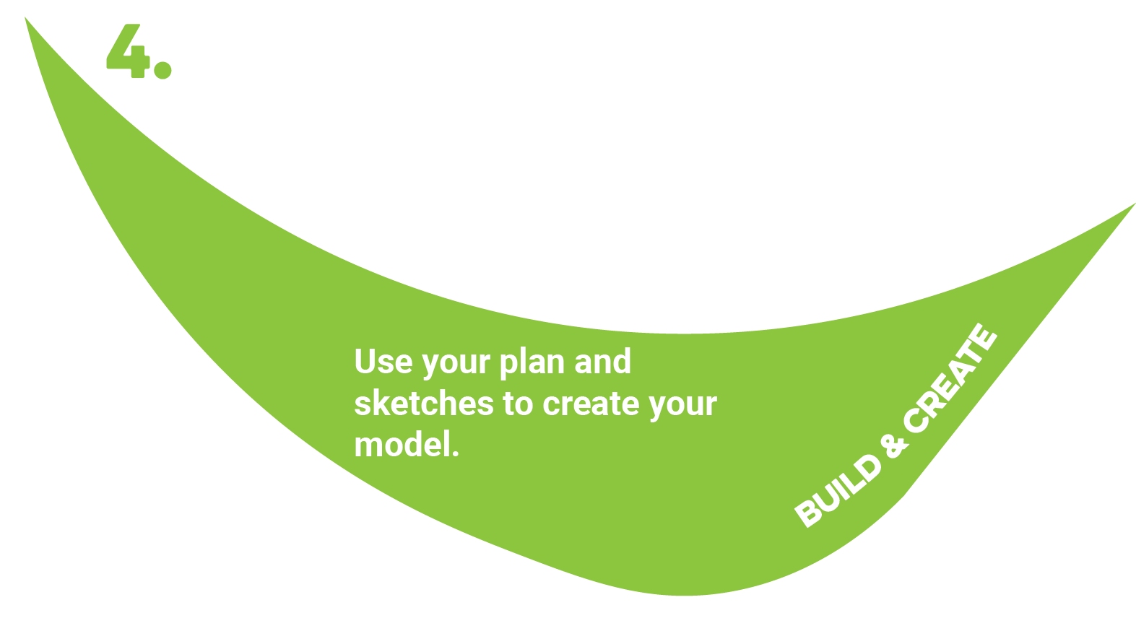
- I used materials and tools safely and correctly.
- I documented my build progress (photos, notes, or updated sketches).
- I made adjustments only when necessary and recorded them in my notes.
- I completed a functional prototype that can be tested.

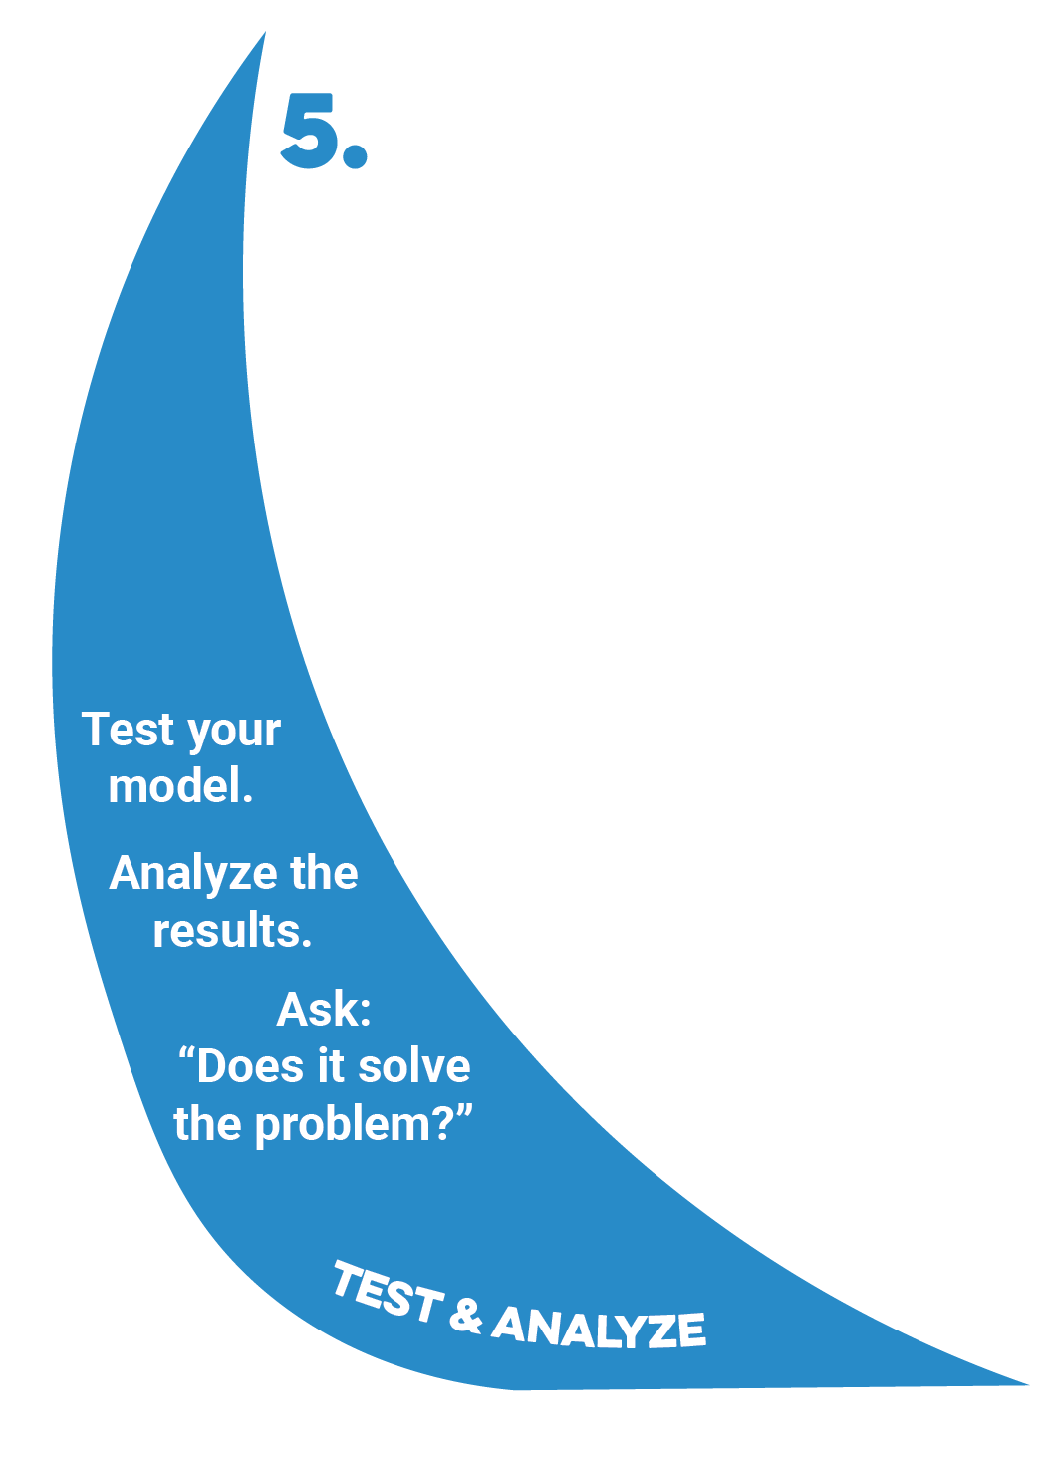

Test & Analyze
Check Before Moving On:
- I tested my prototype using the agreed-upon procedures.
- I measured performance using the original criteria and constraints.
- I collected accurate, organized data during testing.
- I recorded both measurements and observations.
- I can identify strengths and weaknesses in my design based on evidence.

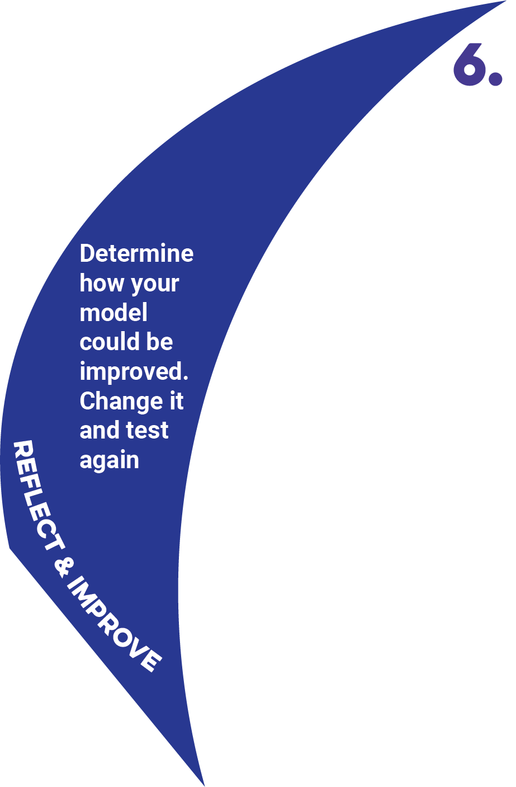

Reflect & Improve
Check Before Moving On:
- I reviewed my test data and identified specific strengths in my design.
- I identified weaknesses or problems backed by evidence.
- I proposed at least one targeted improvement for each major weakness.
- I updated my plan, drawing, or model to reflect the changes.
- I am ready to rebuild or adjust my prototype for the next test or final presentation.

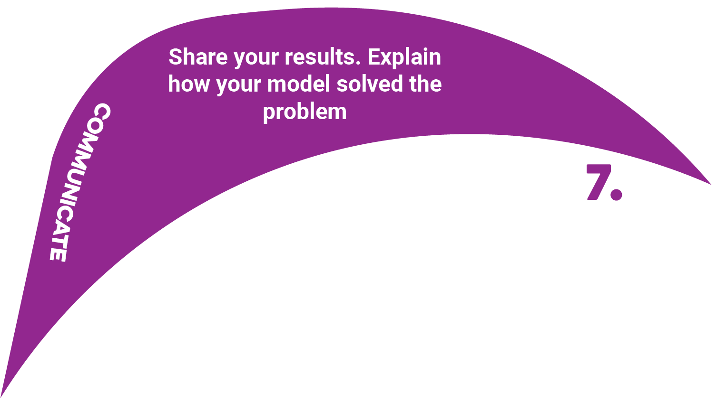

Communicate
Check Before Moving On:
- I explained the original problem and why it matters.
- I described my criteria, constraints, and how they shaped my design.
- I shared my brainstorming process and initial ideas.
- I showed my plan, drawing(s), and/or model(s).
- I described my building process and any challenges I faced.
- I presented my testing process, data, and results.
- I explained how I improved my design based on evidence.
- I used visuals, demonstrations, or examples to make my presentation clear and engaging.

