SHOT LIST

The diagram and vocabulary list below shows examples of various types of camera shots.

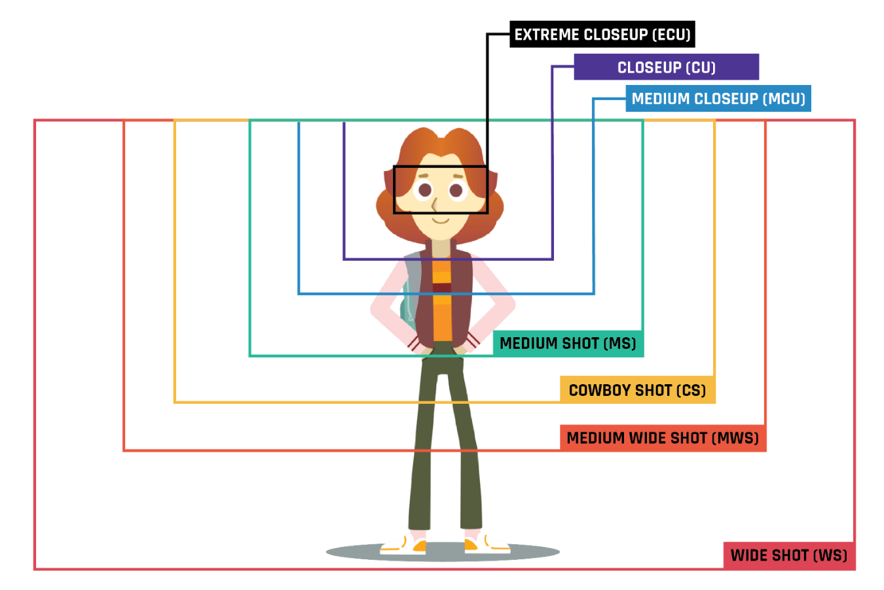
- Wide shot—Establishes a setting (e.g., a shot of the school itself, a hallway, etc.)
- Close-up—Focuses on detail (e.g., someone writing, a locker dial)
- Over-the-shoulder—A shot taken from over a character’s shoulder (e.g., during a conversation, someone looking at something)
- Low angle—Shot of the subject from below to make it look larger or imposing.
- High angle—Shot of the subject from above to make it look smaller or vulnerable.
- Tracking shot—Follows a subject as it moves
- POV shot—Shows what a character is seeing from their perspective.

SHOT LIST

Directions:
Watch the clip and note each separate shot of the sequence. Include the time code at which it took place, its length, and the type of shot used. Refer to the graphic above for examples of different types of shots.
Shot Number | Time Code | Type of Shot | Length of Shot | Description

