STUDENT CHECKLISTS

**Directions.** Revisit this checklist before moving to the next phase of the Engineering Design Process.

# Plan & Design

**Check Before Moving On:**

* My plan includes at least one drawing of the design.
* My plan includes a model (physical or digital) that represents the design.
* All diagrams are labeled clearly.
* I have listed all required materials, tools, and costs.
* Measurements or dimensions are included and accurate.
* The plan contains clear, step-by-step building instructions.
* The design meets all criteria and works within the constraints.

# 

# 

# 

# 

# Build & Create

**Check Before Moving On:**

* I followed my plan, drawings, and model during the build process.
* I used materials and tools safely and correctly.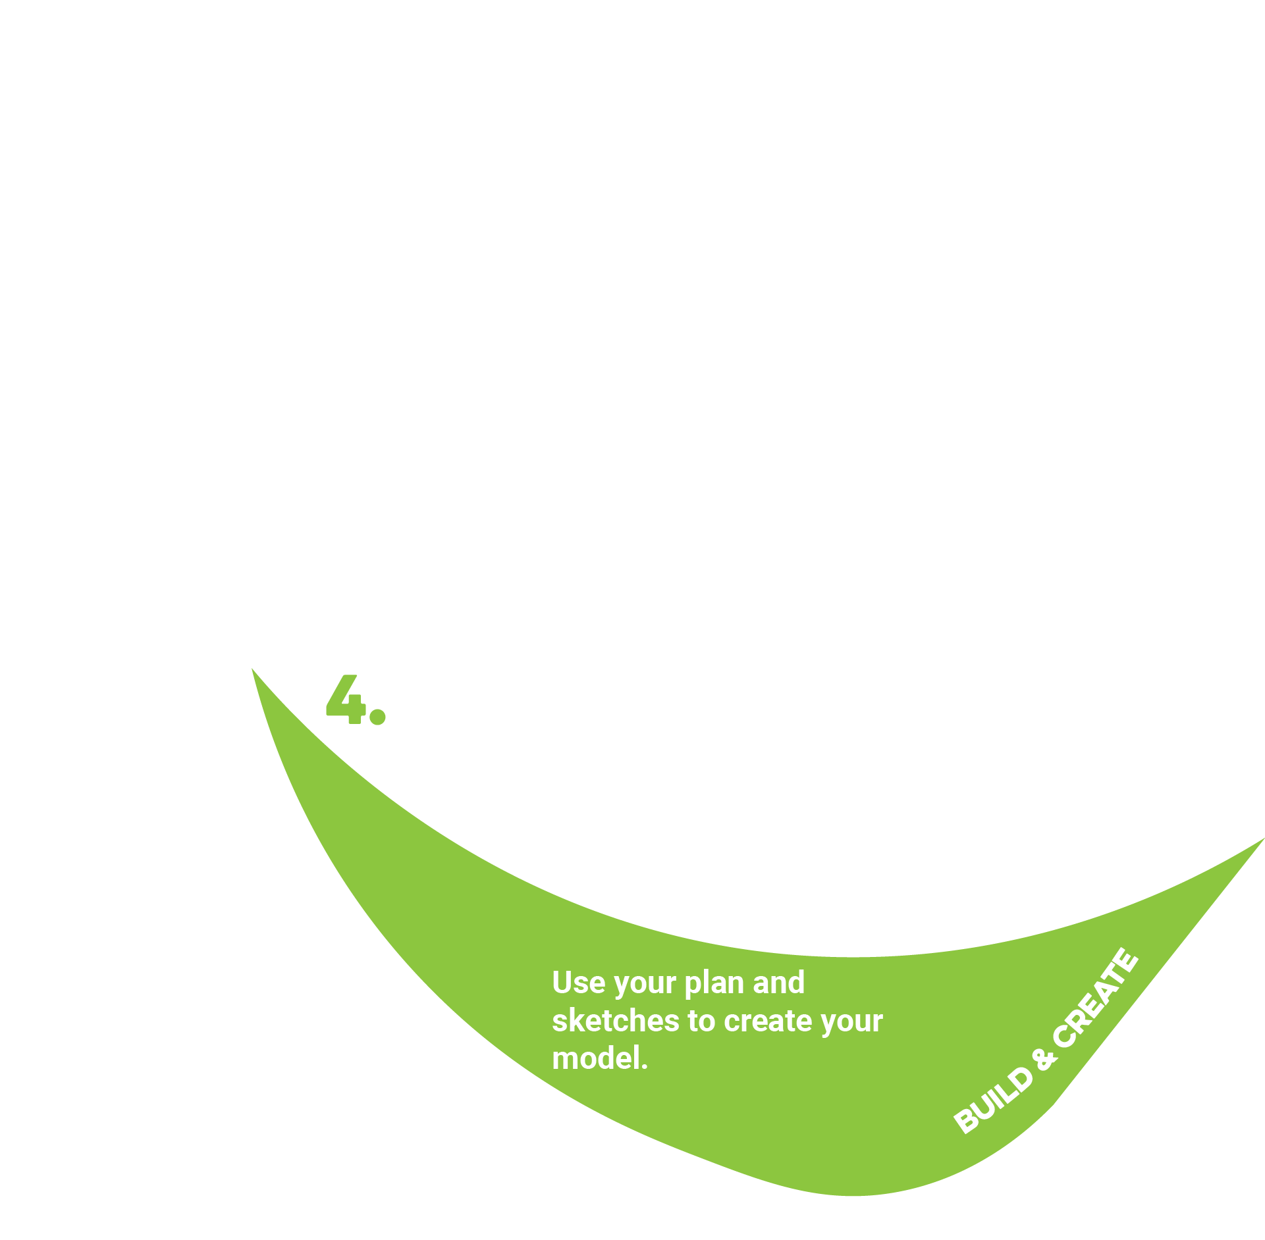
* I documented my build progress (photos, notes, or updated sketches).
* I made adjustments only when necessary and recorded them in my notes.
* I completed a functional prototype that can be tested.

# 

# 

# Test & Analyze

**Check Before Moving On:**

* I tested my prototype using the agreed-upon procedures.
* I measured performance using the original criteria and constraints.
* I collected accurate, organized data during testing.
* I recorded both measurements and observations.
* I can identify strengths and weaknesses in my design based on evidence.

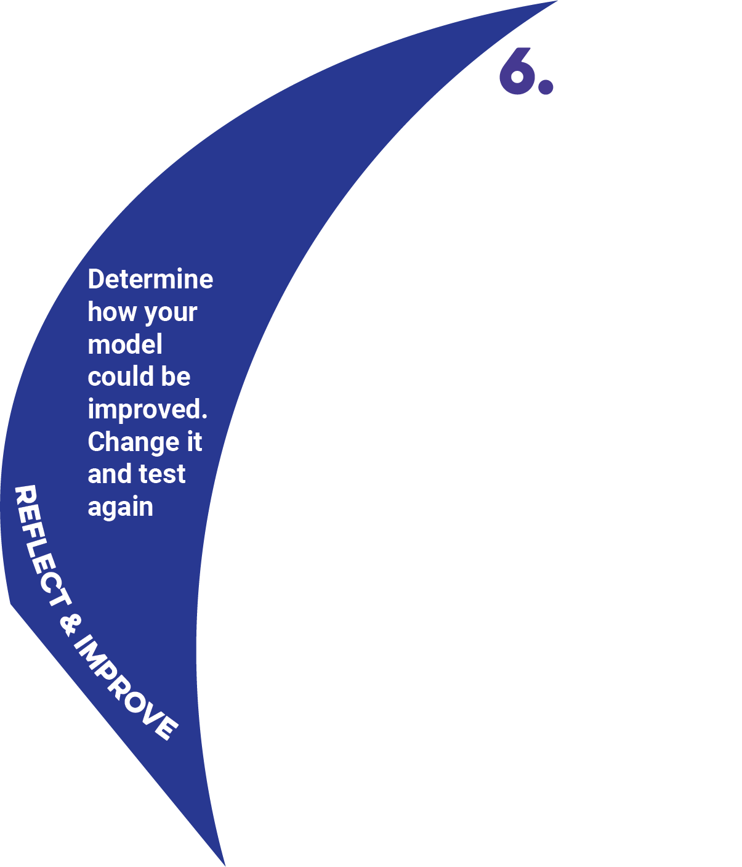

# 

# Reflect & Improve

**Check Before Moving On:**

* I reviewed my test data and identified specific strengths in my design.
* I identified weaknesses or problems backed by evidence.
* I proposed at least one targeted improvement for each major weakness.
* I updated my plan, drawing, or model to reflect the changes.
* I am ready to rebuild or adjust my prototype for the next test or final presentation.

# 

# 

# 

# 

# 

# 

# 

# 

# Communicate

**Check Before Moving On:**

* I explained the original problem and why it matters.
* I described my criteria, constraints, and how they shaped my design.
* I shared my brainstorming process and initial ideas.
* I showed my plan, drawing(s), and/or model(s).
* I described my building process and any challenges I faced.
* I presented my testing process, data, and results.
* I explained how I improved my design based on evidence.
* I used visuals, demonstrations, or examples to make my presentation clear and engaging.