STEM Challenge Facilitator’s Guide

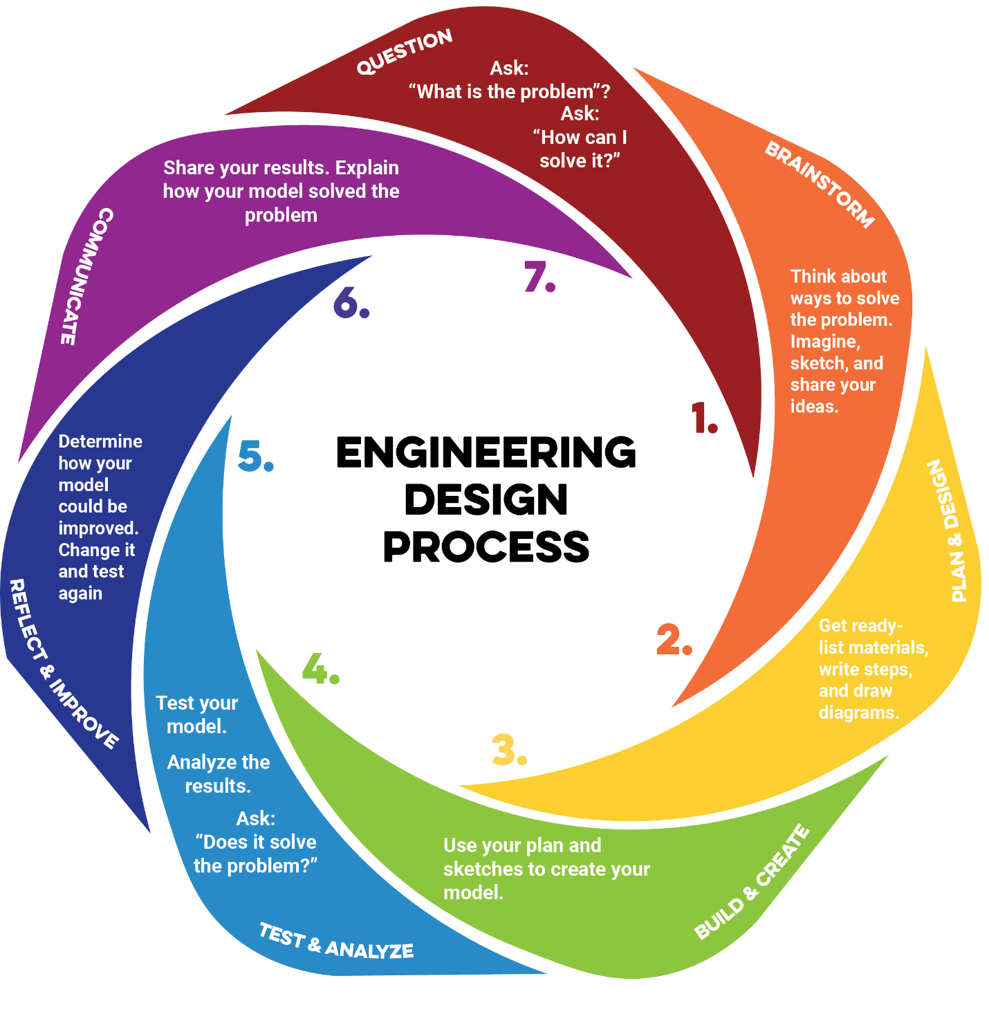

Table of Contents
Overview 3
Purpose of This Guide 3
Objectives 3
Material Setup 4
Optional Enhancements 4
Safety Considerations 4
Prep Tips 4
The Engineering Notebook 5
Data Collection and Analysis Tools 5
Elevator Speech Modifications 5
Materials Needed 5
Notebook Example 5
Facilitation Best Practices 9
Questioning Strategies 9
Scaffolding 9
Encouraging Creativity and Risk Taking 9
Managing Time and Transitions 10
Student Teams: Roles and Responsibilities 11
Core Roles 11
Rotating Roles 11
Alternative Structures 11
Team Accountability 11
Conflict Resolution 11
Facilitator Tips and Tricks 12
Student Motivation 12
Documentation 12
Scaling for Time 12
Debrief Strategies 12

Overview

Purpose of This Guide
This facilitator’s guide is designed to support instructors in leading STEM challenges with fidelity to the engineering design process (EDP). It provides clear guidance on materials, notebook use, and classroom structures so that facilitators can focus on authentic student engagement rather than logistics. By outlining best practices, team roles, and troubleshooting tips, the guide ensures consistency across all of the STEM challenges while allowing room for facilitator flexibility. Ultimately, its purpose is to empower educators to create collaborative, inquiry-driven environments where students learn to think and act like engineers.

Objectives
After reading this facilitator’s guide, participants will be able to:
- Prepare and organize experiment materials in advance to ensure smooth lesson facilitation.
- Effectively guide students in using their engineering notebooks to document each phase of the EDP.
- Apply facilitation best practices to scaffold student learning, encourage creativity, and manage group dynamics
- Implement strategies, tips, and troubleshooting techniques to adapt lessons to varying classroom contexts.
- Foster meaningful reflection and communication activities that highlight the iterative nature of the EDP.

Material Setup
Each K20 Educator Resource provides a basic list of materials assumed for each challenge, but feel free to add more or less.
As part of students’ Engineering Notebook, they are asked to list materials needed and to consider the cost of each. The facilitator can either provide a list of materials that participants can “shop” through OR students can submit a shopping list that the facilitator acquires for the students.

Optional Enhancements
We encourage you to research these challenges online and provide different materials as needed. Some resources may call for the use of laser cutters or 3D printers; consult with your school space coordinator to see if you have access to these resources.

Safety Considerations
As always, safety comes first. Continue to engage in best practices for science lab safety, including wearing appropriate safety wear (e.g., goggles, gloves, aprons, etc.).

Preparation Tips
Carefully read the activity narrative and research similar activities online. Try doing the activity yourself first to understand the experiment fully and identify experiment tweaks and to prepare for possible hurdles students may encounter.
Be sure to make adjustments to the “Suggested Criteria” for each activity as needed including updating slide content when relevant.

The Engineering Notebook

Data Collection and Analysis Tools
For most challenges, basic data collection and analysis tools will be appropriate. However, consult our curated materials list in each activity narrative and/or your outside research to see if there are more specific tools applicable to your project. Potential alternatives could include:
- Lab equipment (glassware, scales, etc.)
- Sensors
- Stop watches

Elevator Speech Modifications
Due to time constraints and/or student needs, consider having students use any of the following tech tools to prerecord their speeches instead of having them present them in person.
- Padlet with Video
- Screencastify Submit
- Vimeo
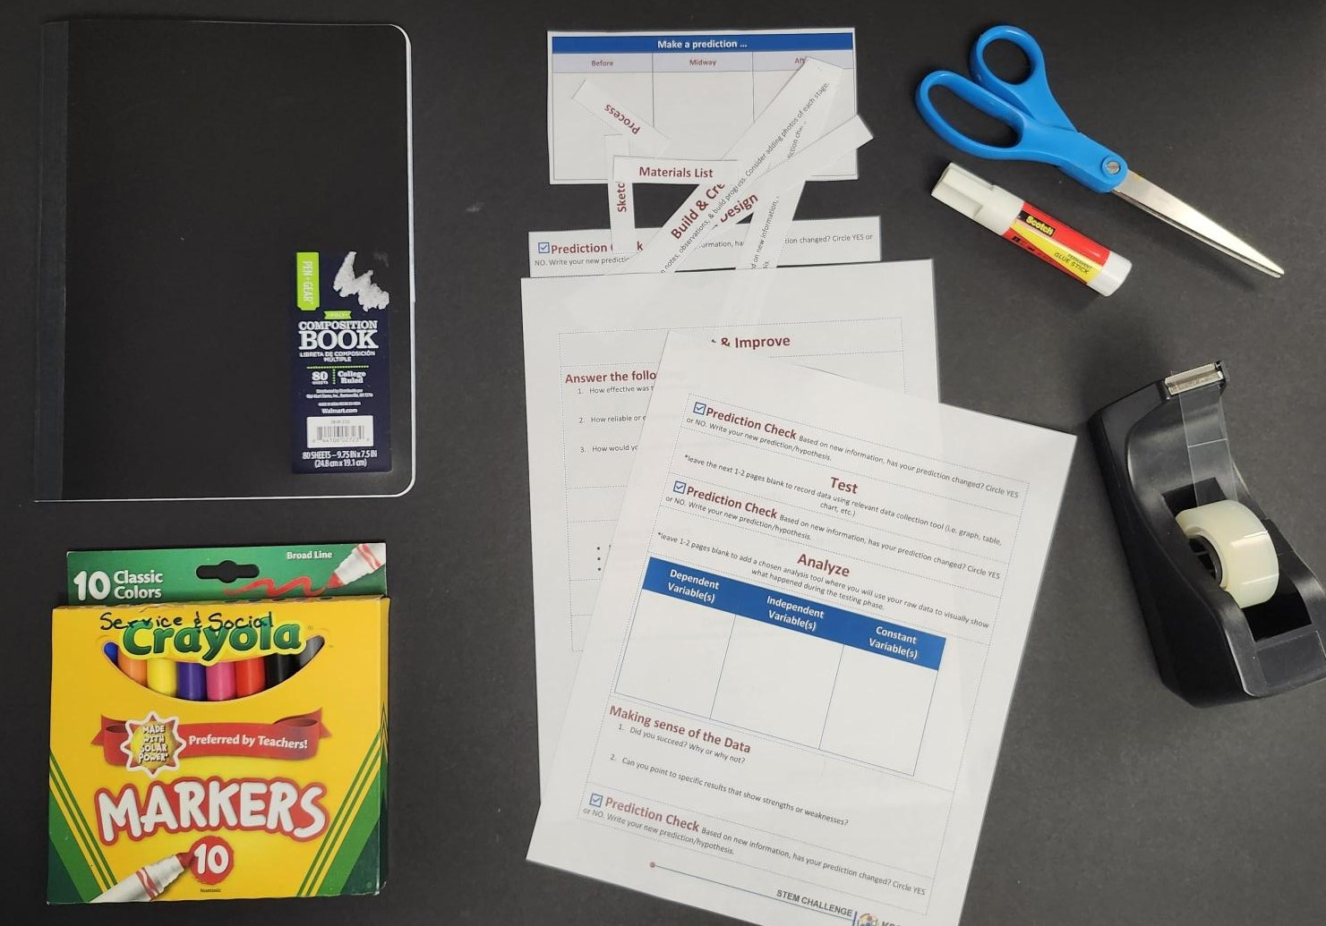
- Figjam

Materials Needed
Students will need the following (keep age discrepancy in mind):
- Notebook (composition book or spiral)
- Scissors
- Tape/glue
- Markers
- Printed version of the Engineering Notebook Materials handout

Notebook Example
Below is one possible configuration of the engineering notebook that you can use as a guide when helping students create their own. While not shown in the model, you can also have students add page numbers and a table of contents to help keep their notebooks organized as an engineer would.

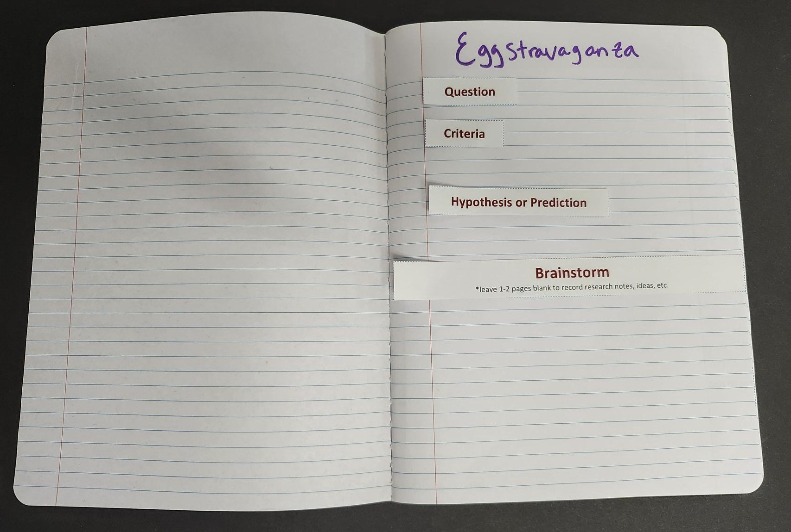 | Image 1: First page of the activity. Reflects the “Question” phase and the start of the “Brainstorm” phase.

Image 2: Range of pages based on how much space students may need for each prompt. Reflects the remaining aspects of the “Brainstorm” phase. | 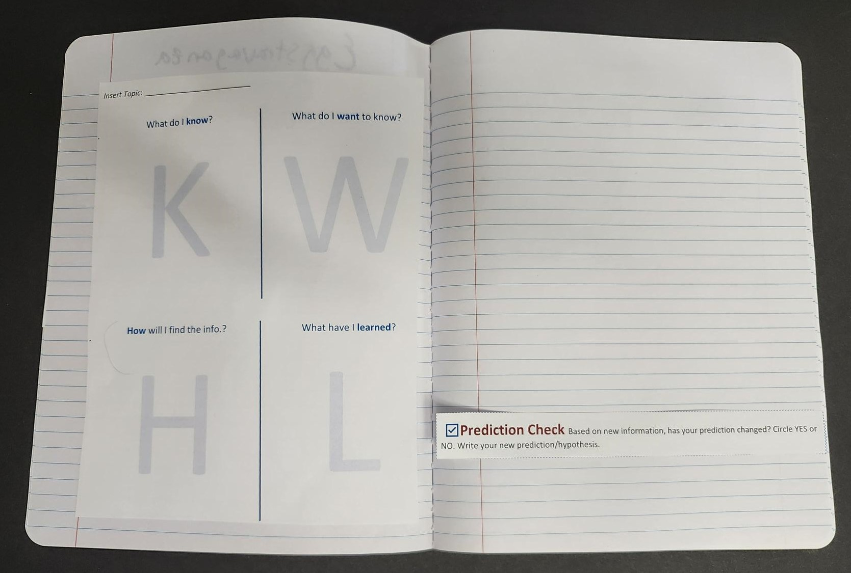

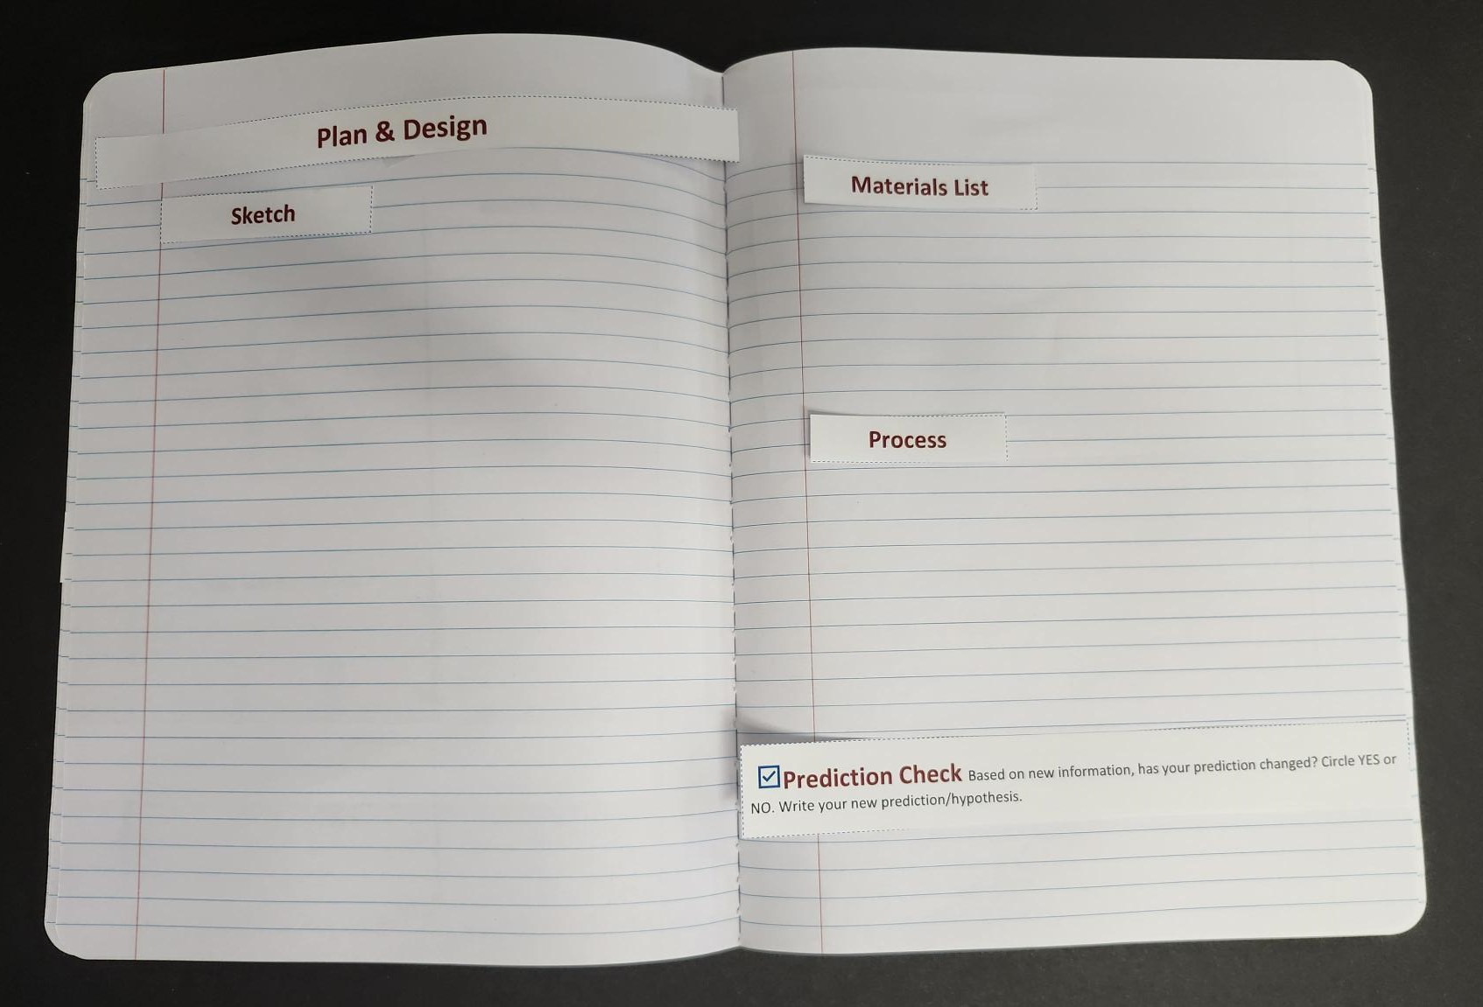 | Image 3: Start of the “Plan & Design” phases. Range of pages based on how much space students may need for each prompt.

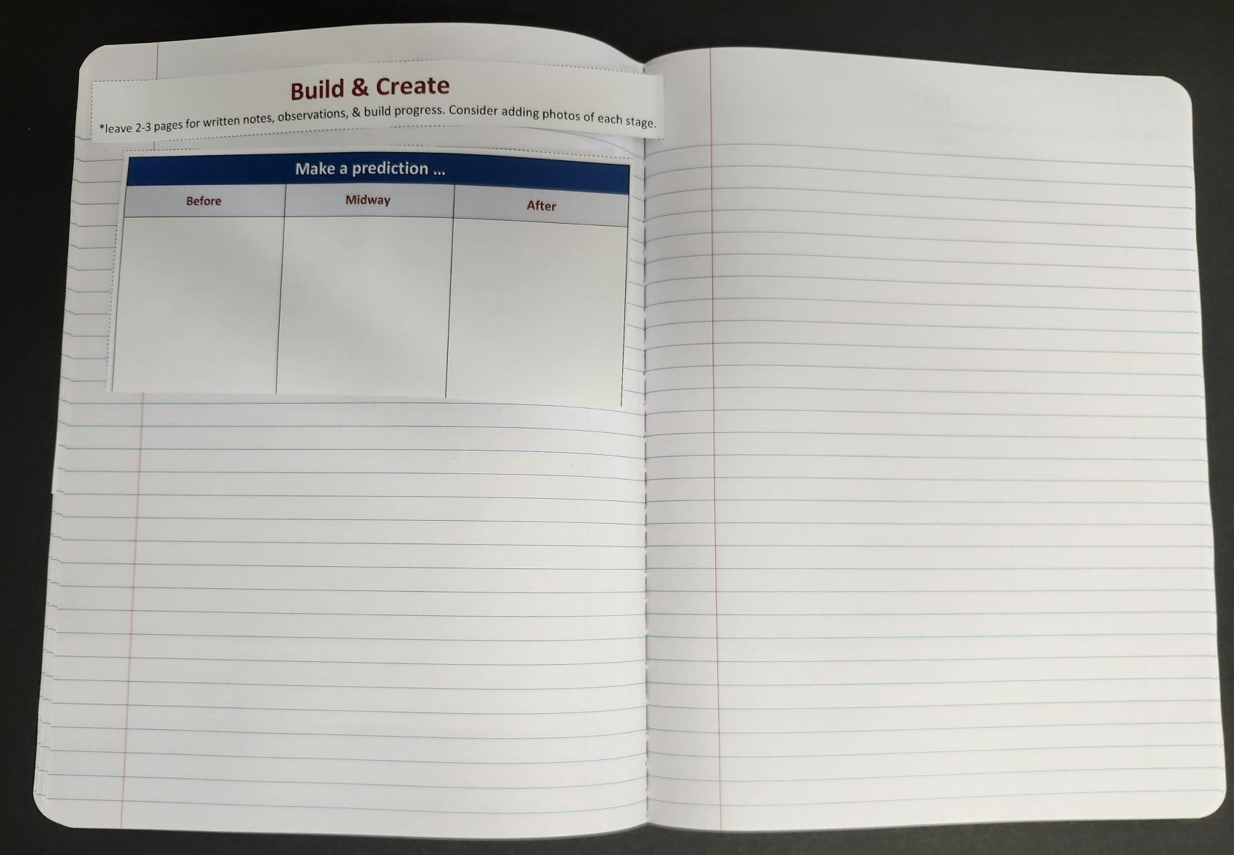 | Image 4: Start of the “Build & Create” phases. Range of pages based on how much space students may need for each prompt.

Image 5: End of “Build & Create” phase and start of “Test” phase. Range of pages based on how much space students may need for each prompt. | 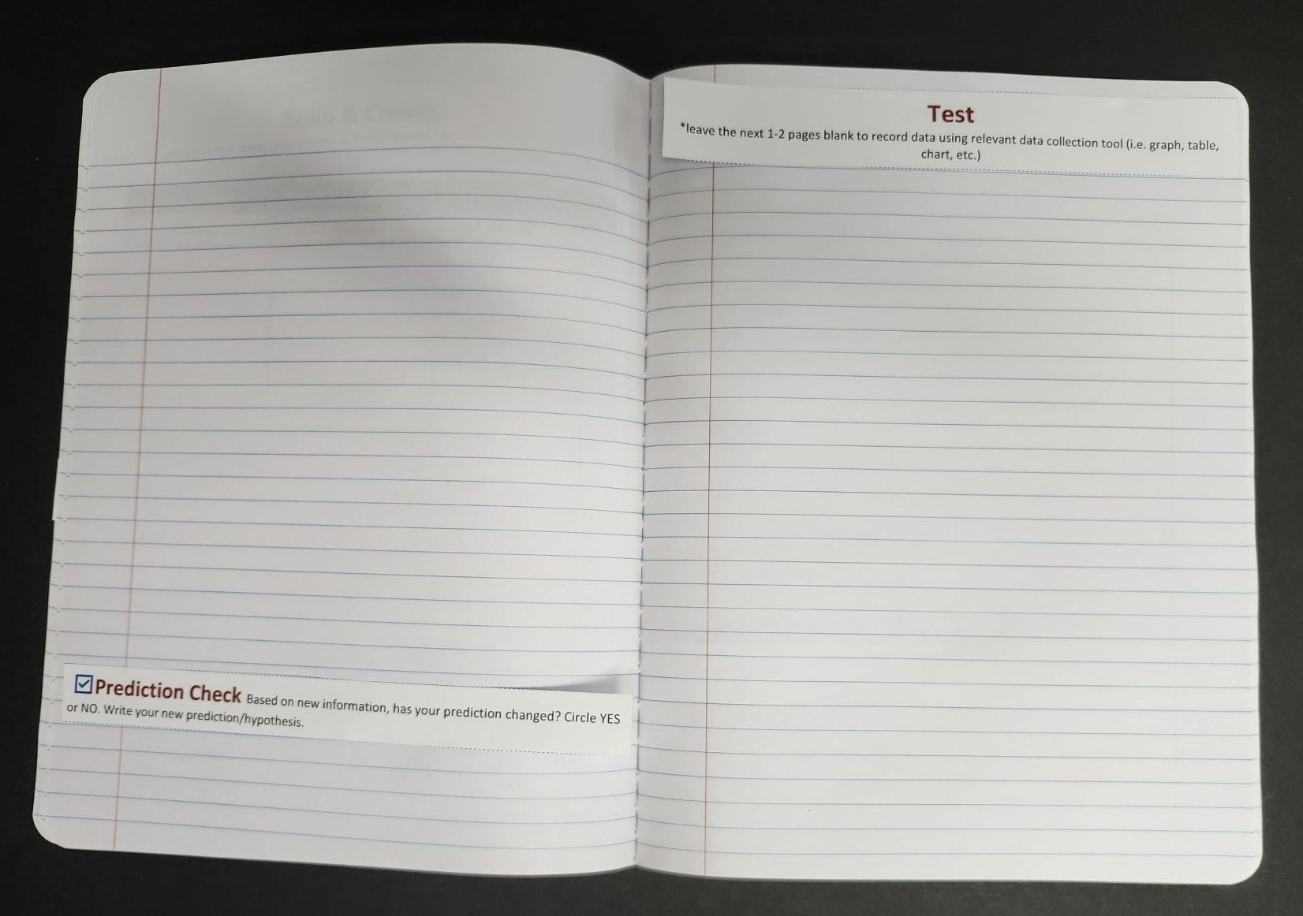

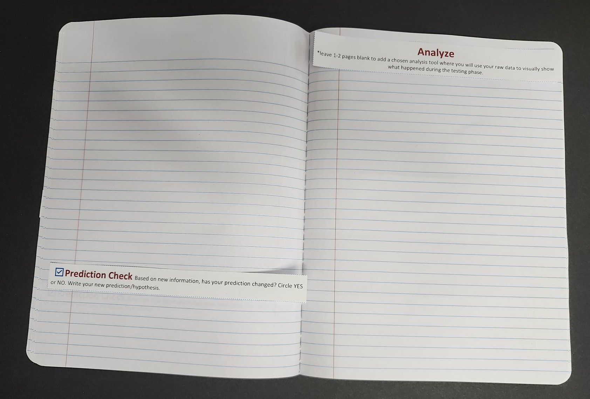 | Image 6: End of “Test” phase and start of “Analyze” phase. Range of pages based on how much space students may need for each prompt.

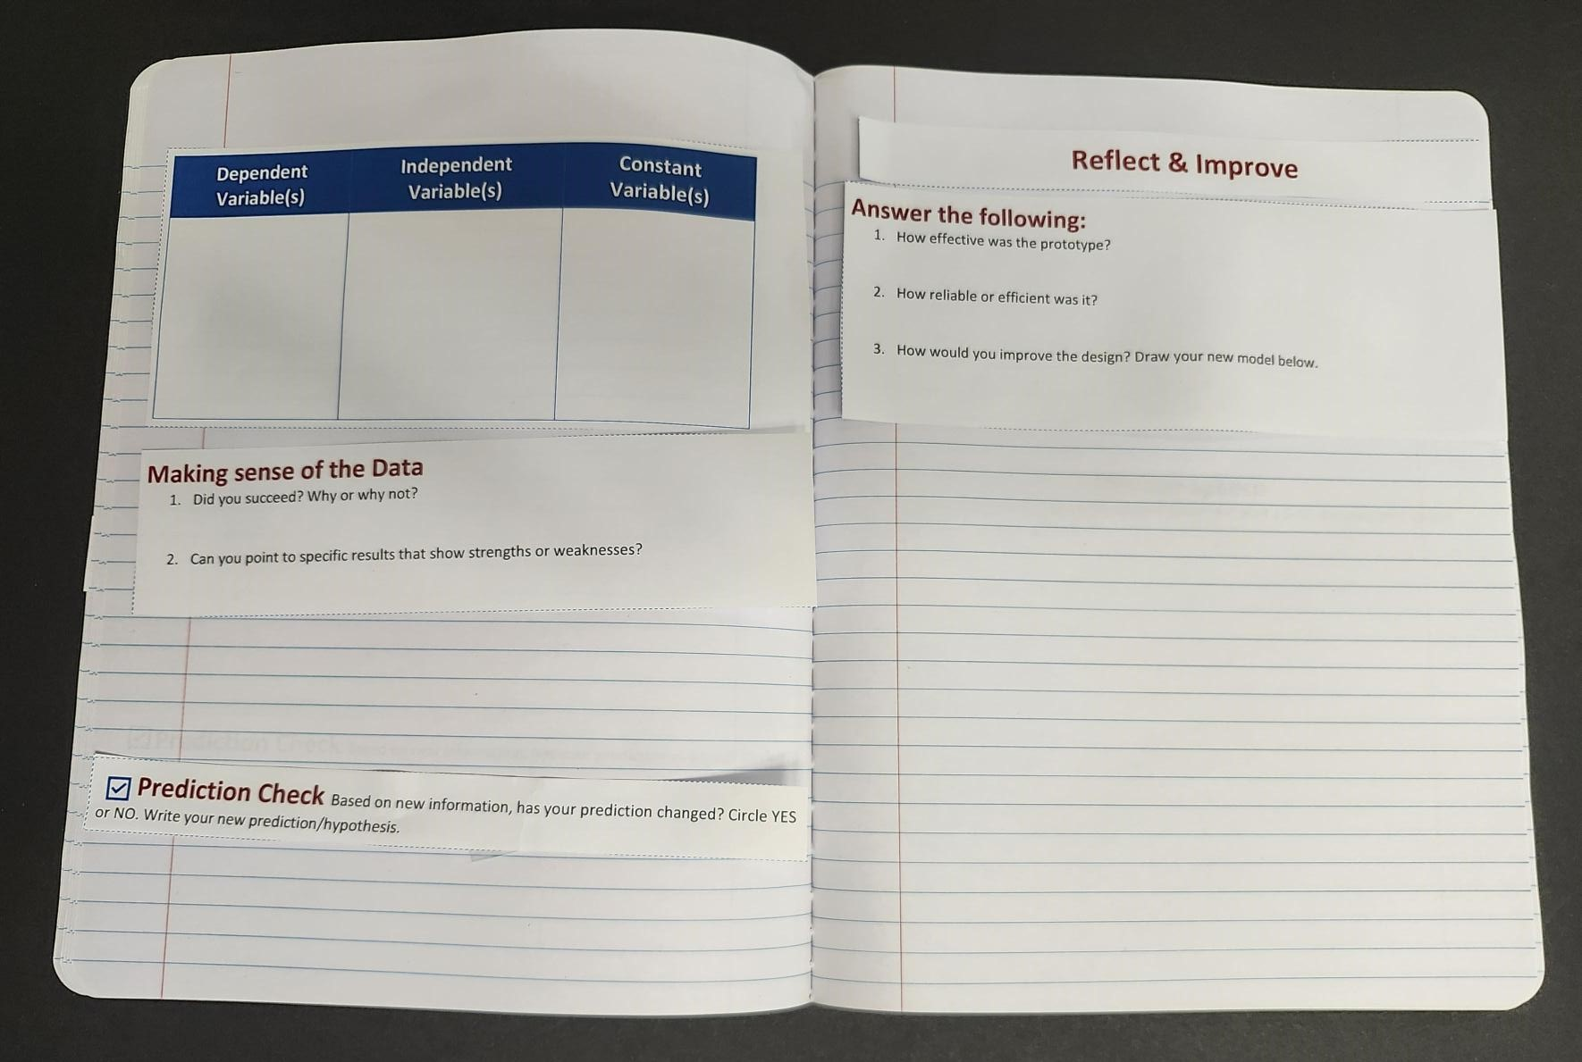 | Image 7: End of “Analyze” phase and start of “Reflect & Improve” phase. Range of pages based on how much space students may need for each prompt.

Image 8: Start of the “Communicate” phase and can range for however much space is needed. End with the “Elevator Speech” phase. | 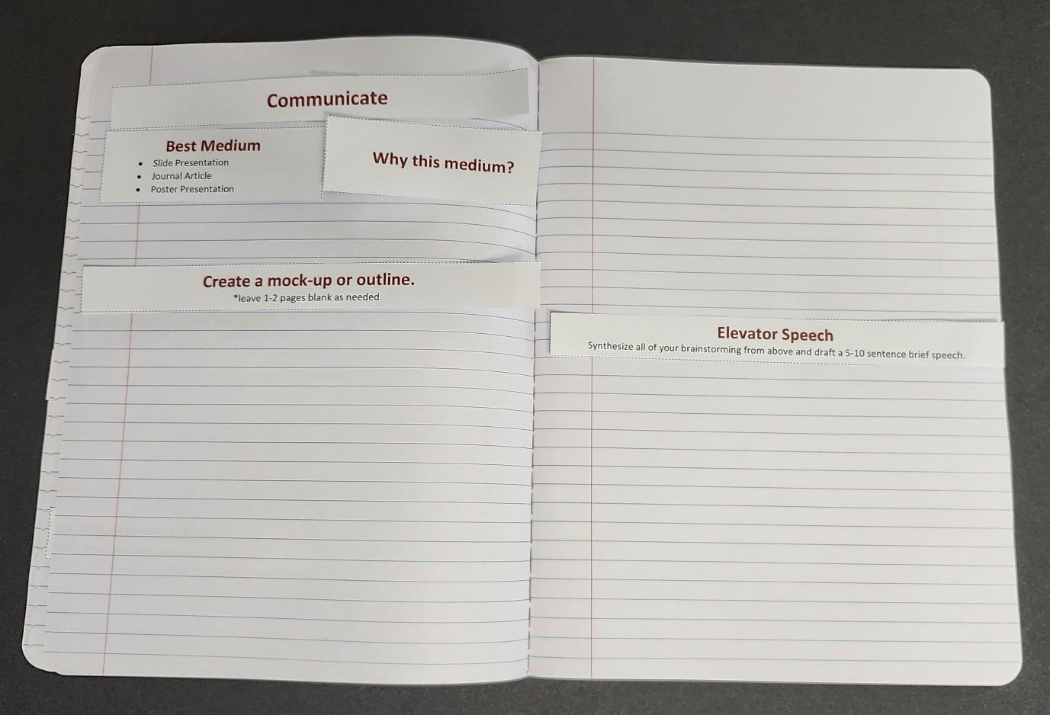

Facilitation Best Practices

Questioning Strategies
Asking thoughtful questions is one of the most effective ways to guide students in STEM learning. Instead of providing direct answers, use questions to:
- Encourage deeper thinking and problem-solving.
- Give students time and space to process information.
- Normalize productive struggle where students can learn from mistakes.
- Foster curiosity and resilience by allowing them to explore multiple approaches.
When students encounter challenges, resist the urge to “rescue” them with quick solutions. Instead, model curiosity and persistence by asking guiding questions. This not only helps students build confidence in their reasoning but also mirrors the authentic processes of scientists and engineers.
Consult the Facilitator Notes in the narrative for examples of effective questions you can use with students.

Scaffolding
Scaffolding helps students access challenging STEM concepts by breaking down complex tasks and providing support that matches their needs. The goal is not to make the work easier, but to make success possible while keeping students engaged and motivated.
Ways to scaffold include:
- Using video demonstrations to show processes step-by-step.
- Providing simulations or interactive models so students can experiment safely and visualize abstract ideas.
- Offering graphic organizers, checklists, or partially completed examples to guide thinking.
- Gradually removing supports as students gain confidence and independence.
Effective scaffolding ensures that every student can enter the activity from their current level of understanding and grow from there. The balance is important—too much support can limit exploration, but just enough enables students to stretch their skills while still feeling capable.

Encouraging Creativity and Risk Taking
STEM learning thrives when students feel free to test bold ideas, even if those ideas don’t work out. Encourage students to brainstorm multiple solutions, experiment with unusual designs, and embrace mistakes as part of the process. When students take risks, they build resilience, learn from failure, and often discover innovative approaches. Reinforce that the goal is not perfection but exploration and growth. Celebrate creative thinking as much as “correct” answers to nurture curiosity and confidence.

Managing Time and Transitions
Clear time management helps keep STEM club activities purposeful and engaging. Use checkpoints to keep the group on pace, and provide warnings before transitions (e.g., “You have 5 minutes left to finish your designs.”). Smooth transitions between tasks minimize downtime and help students stay focused. Remember that flexibility is also key—if students are deeply engaged in productive work, consider extending time when possible.

Student Teams: Roles and Responsibilities

Core Roles
- Recorder - Keeps written notes of what the group discusses, decides, and produces. They keep a record of group progress.
- Timekeeper - Monitors the clock to keep the group on track.
- Facilitator - Guides the group’s discussion, encourages participation, and helps keep everyone focused and respectful.
- Materials Manager - Gathers, organizes, and distributes supplies or resources the group needs.
- Reporter - Shares the group’s ideas, decisions, or final product with the whole class or teacher.

Rotating Roles
If you are assigning students roles, ensure that they rotate through them for each new STEM Challenge activity. This way they all can practice different responsibilities.

Alternative Structures
- Use Thinking Hats instructional strategy.
- Combine roles in small groups. If you want to use the above structure for assigning roles but have fewer than 5 students per group then consider having students double-up on multiple roles.

Team Accountability
Assigning roles helps each student feel responsible for the group’s success. Make expectations for each role clear (e.g., recorder tracks data, materials manager gathers supplies, and the presenter shares results). Encourage teams to check in with one another during activities—remind them that each member’s effort contributes to the group’s overall performance. This structure not only ensures fairness but also builds collaboration and shared responsibility.

Conflict Resolution
Working in groups can sometimes lead to disagreements. Normalize this by framing conflict as part of teamwork and problem-solving. Encourage students to listen respectfully, explain their reasoning, and focus on finding solutions rather than placing blame. Provide sentence starters like “I see your point, but…” or “What if we tried…?” to support productive dialogue. If conflicts persist, guide students back to their shared goal and remind them that collaboration works best when all voices are heard.

Facilitator Tips and Tricks

Student Motivation
Grounded, real-world essential questions build student intrinsic motivation. For example, not all students may see an egg drop experiment as relevant to their lives but framing it as “We all have precious things we want to protect” may help the student see application of the task in their own lives. As you facilitate these STEM Challenges, think of ways to make each scenario as relevant as possible to your students’ lives (either their current communities or future careers). You never know what may inspire a student to pursue a STEM career!

Documentation
Although there are instructions for students to record their notes periodically, reemphasize this as much as possible as recording everything is imperative to scientific exploration.

Scaling for Time
These challenges are designed to occupy 5 class periods, but feel free to adjust for your own time constraints. However, avoid skipping anything: the phases of the Engineering Design Process are meant to flow into one another to scaffold student understanding. If time allows, then students may revisit past stages to improve their design; but the phases should not be skipped.

Debrief Strategies
The K20 Center LEARN repository contains hundreds of research-backed instructional strategies, including several reflection-based debrief strategies. Visit learn.k20center.ou.edu and use the filters to find effective reflective strategies.

