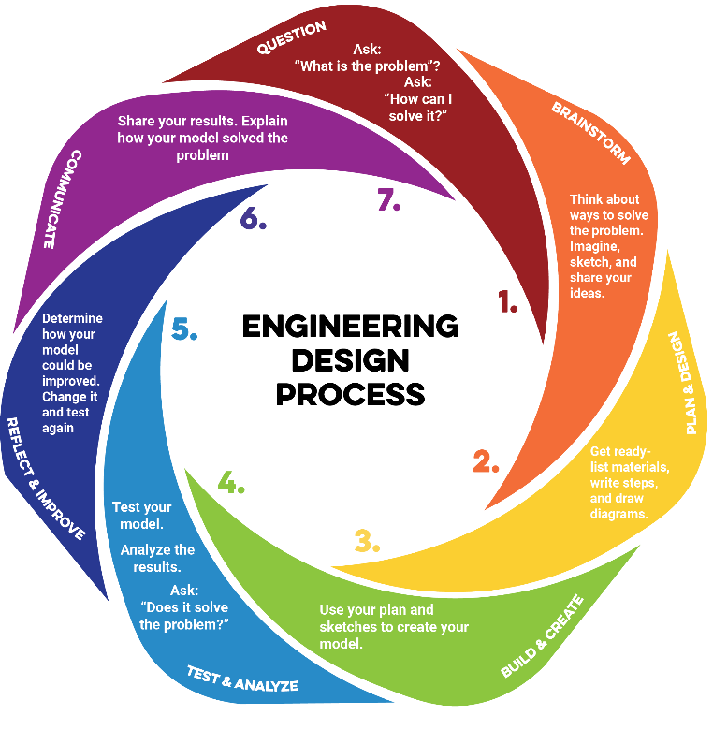
MY CHECKLIST
Directions. Use this checklist as your guide throughout the STEM Challenge. Each section matches a step in the Engineering Design Process.
When you finish all the boxes in a section and feel confident about your work, check in with your teacher before moving on to the next phase.

- Question
Ask: “What is the problem?” “How can I solve it?”
Check Before Moving On:
- I wrote my question and hypothesis in my notebook.
- Brainstorm
Think about ways to solve the problem. Imagine, sketch, and share your ideas.
Check Before Moving On:
- I wrote notes from my research in my notebook.
3. Plan & Design
Get ready – list materials, write steps, and draw diagrams.
Check Before Moving On:
- My plan includes at least one drawing of the constructed language.
- My plan includes a model (physical or digital) that represents the coded (secret) language.
- All diagrams are labeled clearly.
- I have listed all required materials, tools, and costs.
- Measurements or dimensions are included and accurate.
- The plan contains clear, step-by-step creating instructions.
- The design meets all criteria and works within the constraints.

4. Build & Create
Use your plan and sketches to create your model.
Check Before Moving On:
- I followed my plan and drawings during the creation process.
- I used materials and tools safely and correctly.
- I documented my creation progress (photos, notes, or updated sketches).
- I made adjustments only when necessary and recorded them in my notes.
- I completed a functional prototype that can be tested.
5. Test & Analyze
Test your model. Analyze the results. Ask: “Does it solve the problem?”
Check Before Moving On:
- I tested my prototype using the agreed-upon procedures.
- I measured performance using the original criteria and constraints.
- I collected accurate, organized data during testing.
- I recorded both measurements and observations.
- I can identify strengths and weaknesses in my design based on evidence.
6. Reflect & Improve
Determine how your model could be improved. Change it and test again.
Check Before Moving On:
- I reviewed my test data and identified specific strengths in my design.
- I identified weaknesses or problems backed by evidence.
- I proposed at least one targeted improvement for each major weakness.
- I updated my plan, drawing, or model to reflect the changes.
- I am ready to rebuild or adjust my prototype for the next test or final presentation.
7. Communicate
Share your results. Explain how your model solved the problem.
Check Before Moving On:
- I explained the original problem and why it matters.
- I described my criteria, constraints, and how they shaped my design.
- I shared my brainstorming process and initial ideas.
- I showed my plan, drawing(s), and/or model(s).
- I described my creation process and any challenges I faced.
- I presented my testing process, data, and results.
- I explained how I improved my design based on evidence.
- I used visuals, demonstrations, or examples to make my presentation clear and engaging.

