MATCH YOUR WHY CUBE
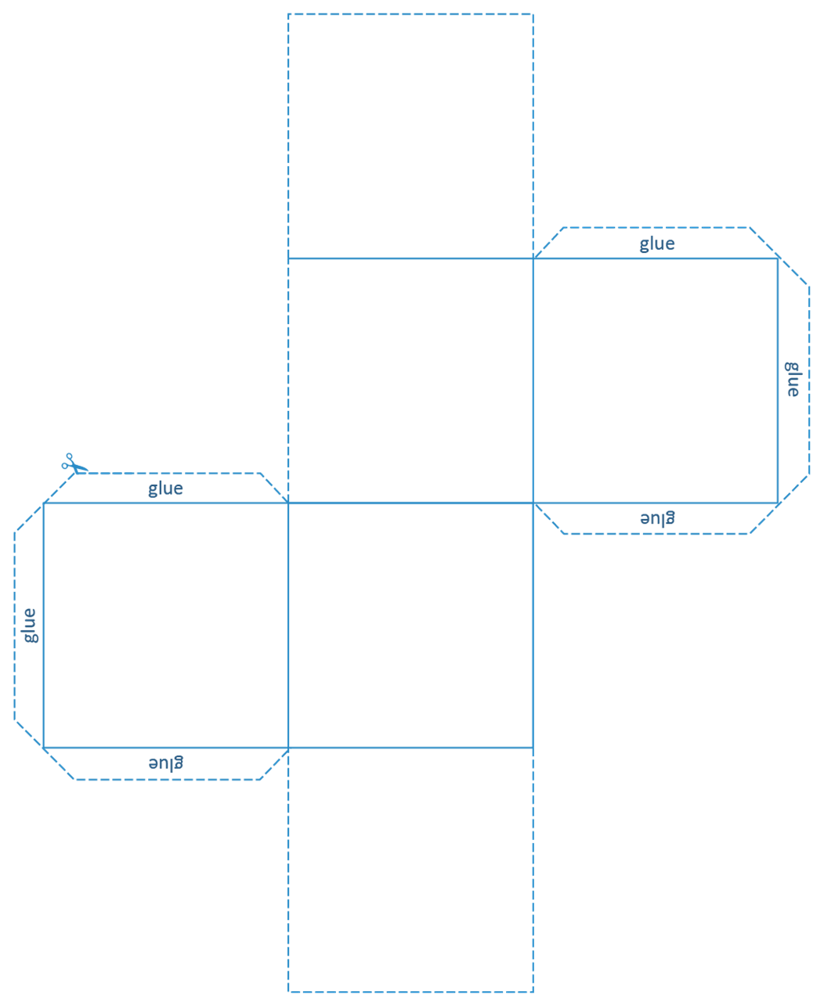
I want to feel supported in…
I want to contribute…
I want to challenge myself by…
I want to explore…
I want to meet…
I want to learn…

