

CASE CARDS



Case Study #1
Canine Caper
Weather Report
Daytime temperatures have been variable over the past three weeks, ranging from
75 °F to 94 °F. Skies have been sunny.
Name: Terry
Weight: 45 lbs.
Height: 21“
Age: 3 years


Observations
- No immediate signs of struggle or forced entry.
- Body found lying on its side near the center of the basement.

I don’t understand…She was just here this morning. Why did this happen?
—Eyewitness
She was my best friend. She never hurt anybody. Who would do this? This isn’t fair.
—Owner
Police Report
The body of a large pit bull terrier was found inside a walk-in basement at a home in Cary. Maggots were found concentrated in the head and region behind the shoulder. The windows were closed, although the open curtains allowed sunlight to enter, and the air conditioner was set at 72 °F.
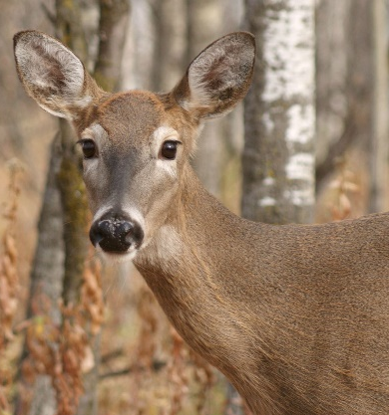
Observations
- The body was lying on its right side, partially concealed by tall grass and debris.
- The ground surrounding the deer showed no significant signs of struggle.

The deer appears to have no visible wounds or signs of predation. Given the location and lack of external injuries, it’s possible the animal was struck by a vehicle and later moved, or the animal stumbled off the roadway before succumbing to internal injuries.
—Animal Control
Case Study #2
Oh, Deer
Weather Report
Daytime temperatures have been consistent for the past three weeks, ranging from
70 °F to 74 °F.
Police Report
The body of a female deer was found behind a fence along a busy two-lane road at the edge of the city limits of Charlotte. Animal Control was called and reported no apparent wounds on the body. It was not hunting season.
Name: Jane Doe
Weight: 98 lbs.
Height: 6‘
Age: 5 years

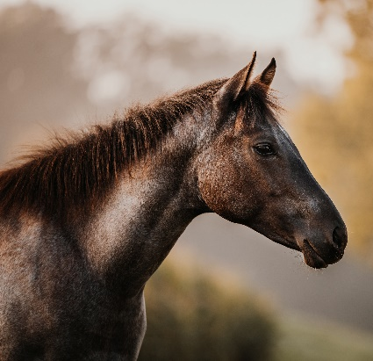
Case Study #3
Dandy’s Death
Weather Report
Daytime temperatures have been unusually warm over the past three weeks, ranging from 84 °F to 86 °F.
Police Report
The body of a young male horse was found in a pasture in a small town near Wilmington. The autopsy from the vet school reveals that the cardiac glycoside oleandrin (a powerful heart stimulant) was present in the body. Oleander is found in the oleander plant. Oleander is a common ornamental shrub in this area, but none grows within 200 feet of the pasture.
The horses in the pasture fidgeted with anticipation when they heard Mr. Johnson’s lawn mower nearby. Little did anyone know that one of them would soon end up dead as a result.
—Eyewitness
Observations
- No visible external injuries.
- Charlie was found lying on his left side near the center of the pasture.

Name: Charlie
Weight: 950 lbs.
Height: 15 hands high
Age: 18 months


Observations
- No immediate signs of predation or scavenging.
- Hamlet was lying on his side, partially obscured by fallen branches.

This is an unusual and troubling discovery for our community. We take matters of animal welfare seriously. I have full confidence in our investigators and forensic experts to determine what happened.
—Mayor
Weather Report
Daytime temperatures have been average over the past three weeks, ranging from 70 °F to
73 °F. Temperatures in the woods would be approximately 5 degrees cooler due to the lack of sun in the shady environment.
Case Study #4
Porky’s Peril
Police Report
The body of a large pot-bellied pig was found in a dense stand of evergreen trees far from any urban area in Buncombe County. Hairs around the pig’s neck were worn away in a band pattern.
Name: Hamlet
Weight: 150 lbs.
Height: 15” tall, 3’ long
Age: 10 years

