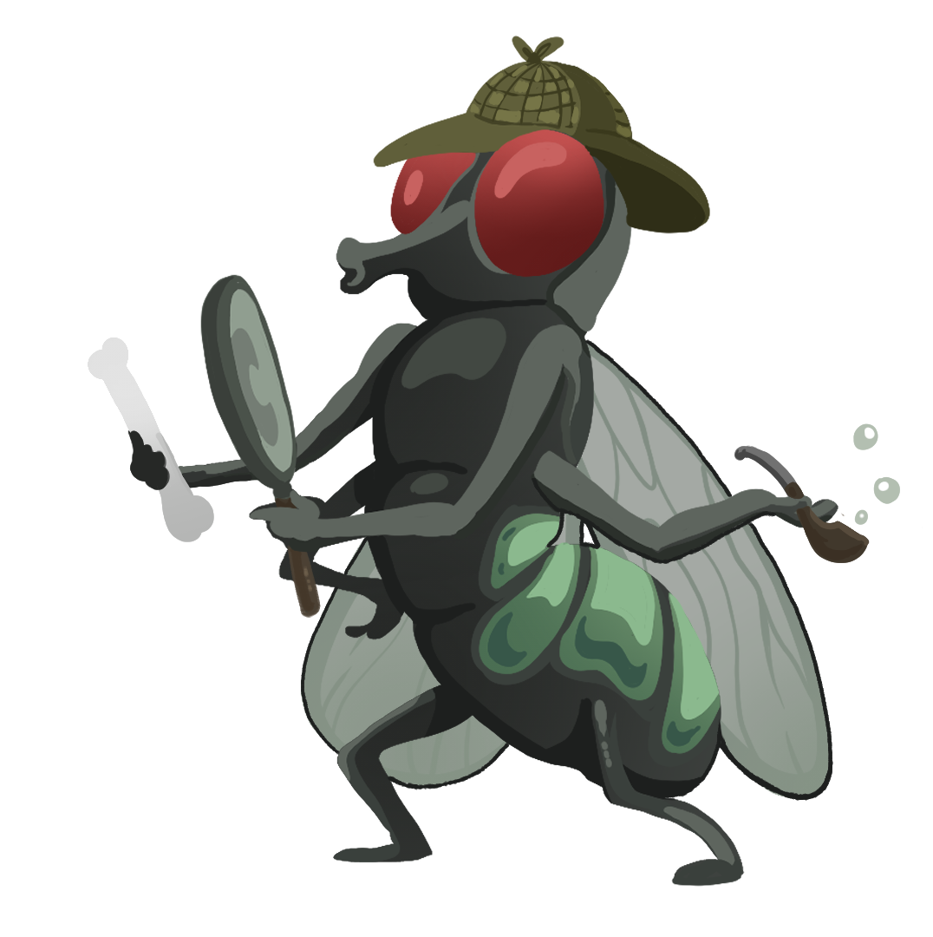
FORENSIC ENTOMOLOGY GUIDED NOTES

Directions
Use your Life Cycle Card Sort and the slides to complete the following.

Blow Fly Life Cycle
Blow flies are attracted to dead bodies and often arrive within _____________________ of the death of an animal. They have a ___________________ life cycle that consists of egg, larva, pupa, and adult stages.

Label the life cycle diagram.

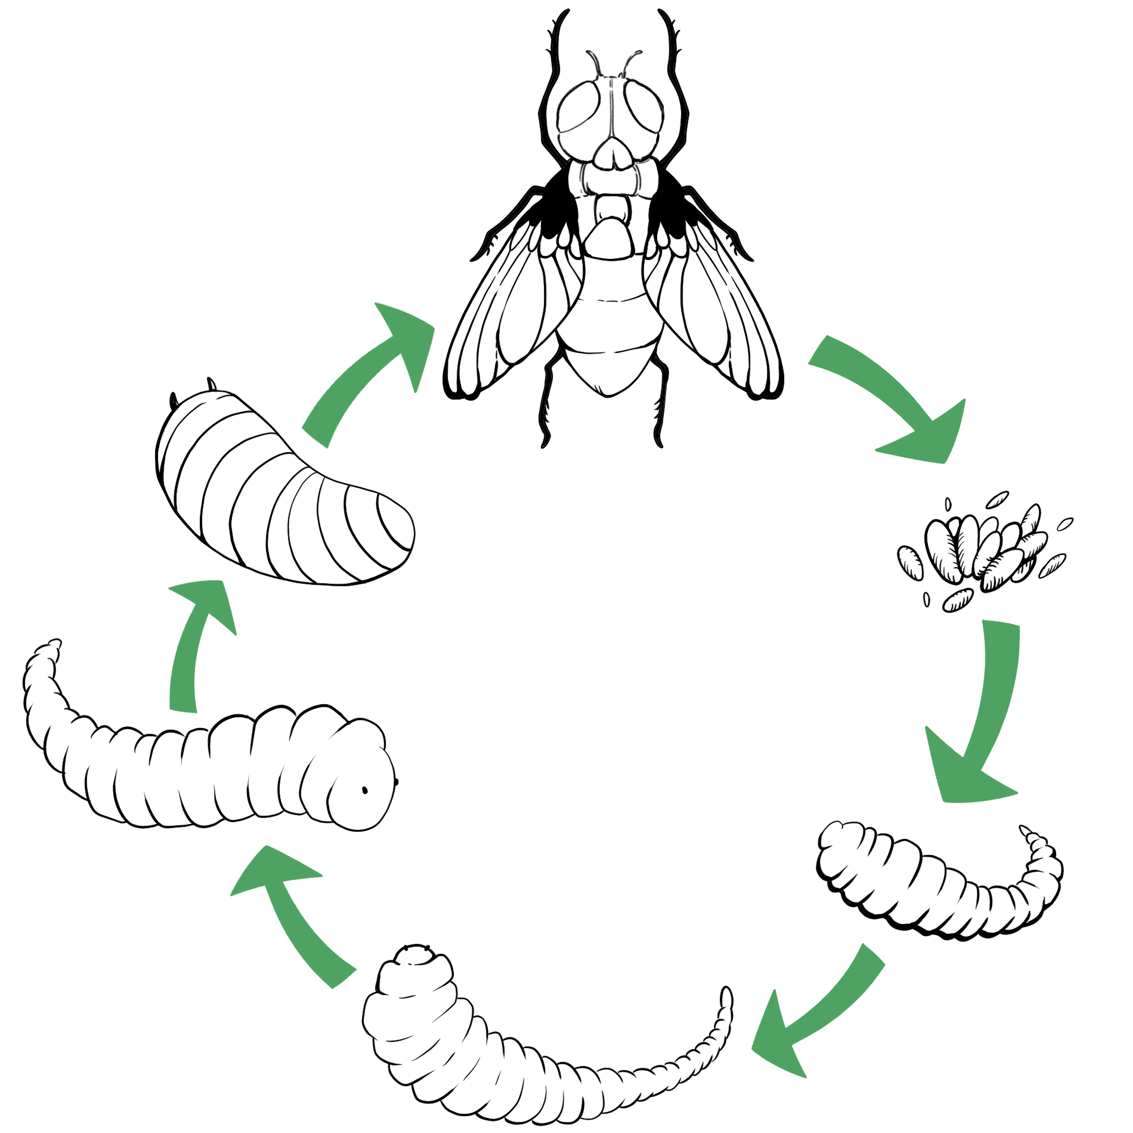
Fill in the blanks below.

1st: Adult flies lay eggs on the carcass.
2nd: Eggs hatch into larva (maggots) in ___–___ hours.

3rd: Larvae continue to grow and molt (shed their exoskeletons) as they pass through the various instar stages.
- 1st Instar: ___ mm long after ___ days.
- 2nd Instar: ___ mm long after ___ days.
- 3rd Instar: ___ mm long after ___ days.

4th: The larvae (___mm) develop into pupa after burrowing in surrounding soil.
5th: Adult flies emerge from pupa cases after ___–___ days.

What do they do?
- Forensic ______________________ apply their knowledge of entomology to provide information for criminal investigations.
- A forensic entomologist’s job may include:
  - Identification of insects at various stages of their __________ _____________, such as eggs, larva, pupa, and adults.
  - Collection and preservation of insects as ________________.
  - Determining an estimate for the postmortem interval or ______________ (the time between death and the discovery of the body) using factors such as insect evidence, weather conditions, location and condition of the body, etc.
  - ____________________________ in court to explain insect-related evidence found at a crime scene.

Video Reflection
I Notice | I Wonder

Stages of Decomposition

Summary: What happens during each stage of decomposition?
________________________________________________________________________________________________________________________________________________________________________________________________________________________________________________________________________________________________________________________

Insects as Evidence
Forensic entomologists use their knowledge of insects and their life cycles and __________________ to give them clues about a crime.
Most insects used in investigations are in two major orders: _____________ (flies) and _______________ (beetles).
Species ____________________________ may also provide clues for investigators. Some species may feed on a _______________ corpse, while another species may prefer to feed on one that has been dead for two weeks. Investigators will also find other insect species that ________________ on the insects feeding on the corpse.

Other Factors
_________________ data is also an important tool in analyzing insect evidence from a corpse. Investigators will make note of the temperature of the ____________, ground surface, the interface area between the body and the ground, and the ____________ under the body as well as the temperature inside any ________________ masses. They will also collect weather data related to daily ________________ (highs/lows) and ________________ for the period of time before the body was discovered to the time the insect evidence was collected.
What are some other factors that could affect a forensic entomologist’s estimate of PMI? ____________
_________________________________________________________________________________________________________________________________________________________________________________________________________________________________________________________________________________________________________________________________________________________________________________________________________________________________________
_____________________________________________________________________________________

