Field Notes | Supplemental Notes
 | What is soil?
 | What is trace evidence?
 | What is soil transfer?
 | How is soil tested?

SUSPECTS

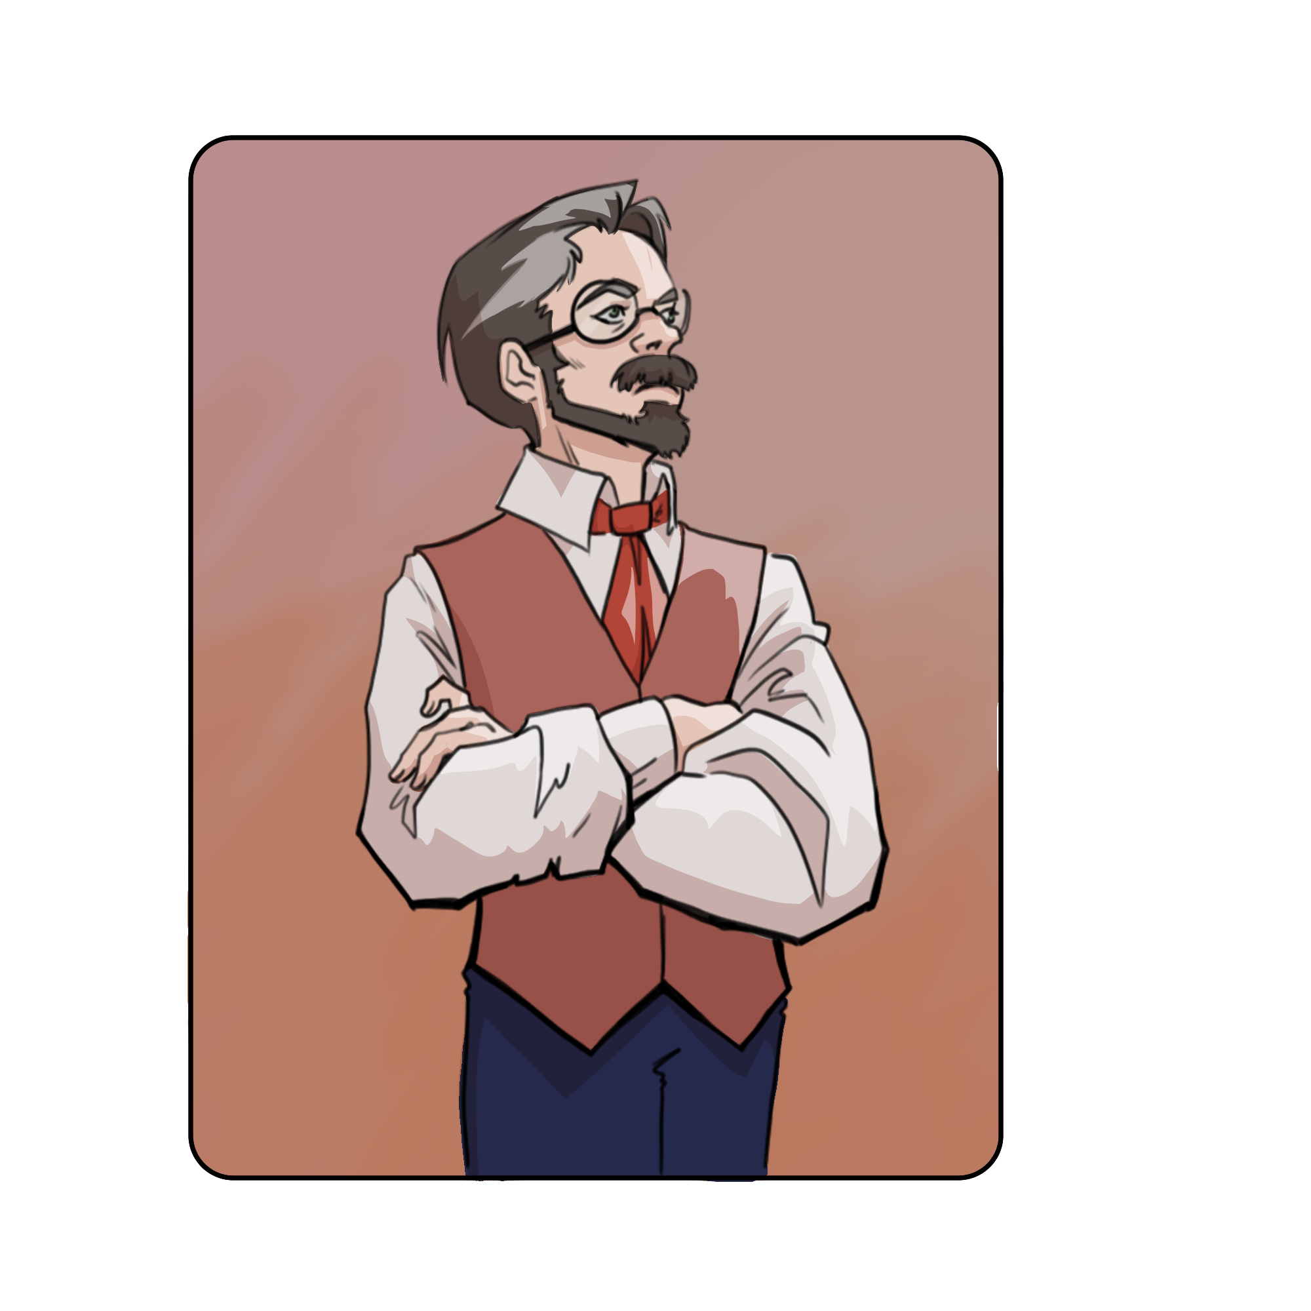
Doreen Hazelton Wolfgang Swift Gnorman Mann
Thief | Evidence

