GOOGLE CLASSROOM FOR FAMILIES RESOURCES

Thank you so much for attending our Google Classroom for Families webinar. We hope that you found the resources that we presented useful. Included on this document you should find additional resources that you may find helpful in navigating the realm of virtual learning through Google Classroom!

Be sure to download these documents by clicking the download button:

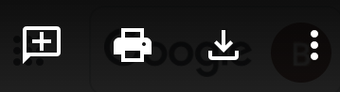

- Webinar Recording
  - View the [insert webinar recording here]
- Video Tutorials
  - These are additional recordings, separated by topic, for how to successfully use Google Classroom.
    - Google Workplace, Google Classroom, and the Stream Page
    - Upcoming and the Google Calendar
    - Student Work Submissions
    - Student Grades
    - Class Drive Folder
    - Email Summaries
- Tutorial Cards
  - The tutorial cards guide you, step by step, through how to use each component of Google Classroom.
- Teacher Letter Template
  - The teacher letter template is a form letter that you can email to your student’s teachers to request access to Parent/Guardian email summaries for their Google Classroom.
- Survey
  - If your student attends a GEAR UP partner school, please complete this brief survey. It should take about 1 minute. Thank you.
Contact us:
[insert contact information]

