Pictures of Classrooms in the Present

Storytime in First Grade
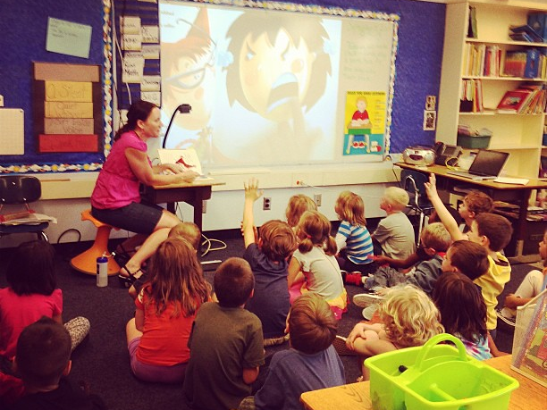
Source: Lauer, T. (2013, September 5). Visiting Ms. Murphy's 1st Grade Classroom. Flickr.

First Grade at Work
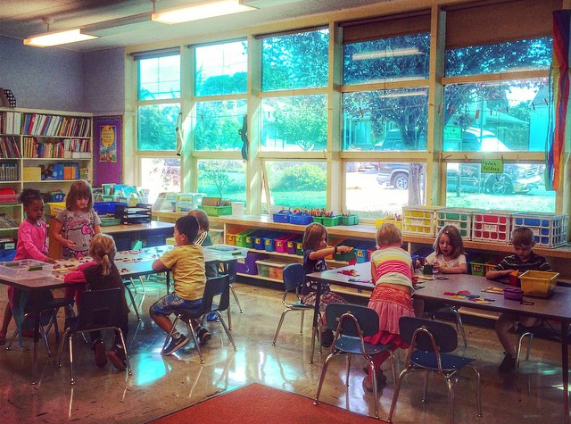
Source: Lauer, T. (2014, September 4). Visiting Mrs. Jamesbarry's 1st Grade Classroom. Flickr.

Working Together in First Grade
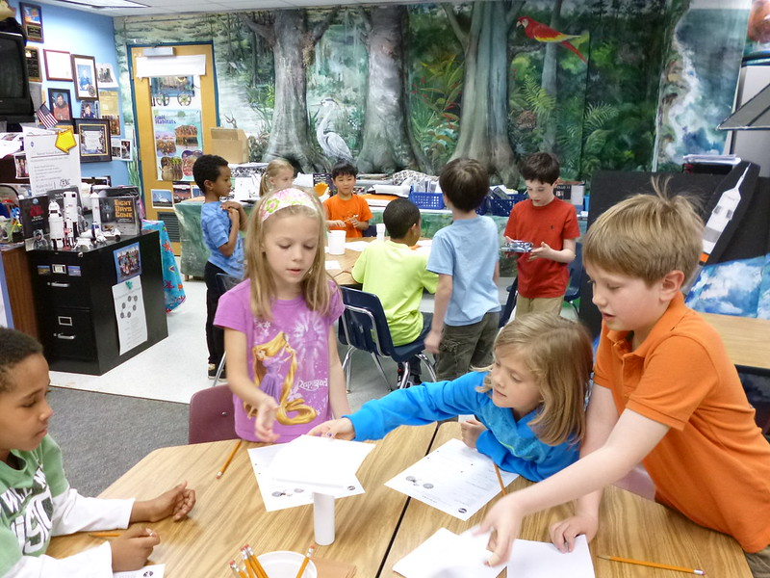
Source: Sullivan, L. (2014, May 1). P1010133. Flickr.

Technology in First Grade
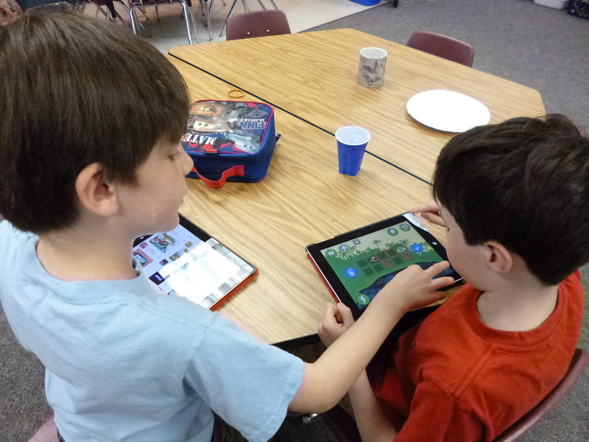
Source: Sullivan, L. (2014, May 1). P1010191. Flickr.

