Uganda by Cliffanie Forrester

Forrester, C. (2015). Uganda [Painting]. The Metropolitan Museum of Art, New York, NY.
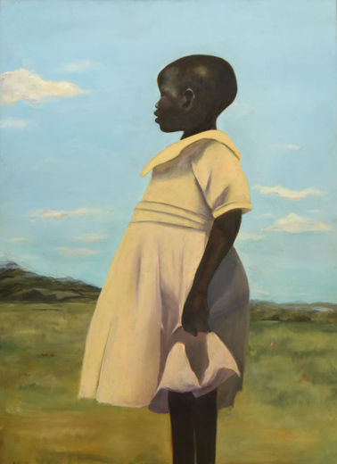

The Old Guitarist by Pablo Picasso
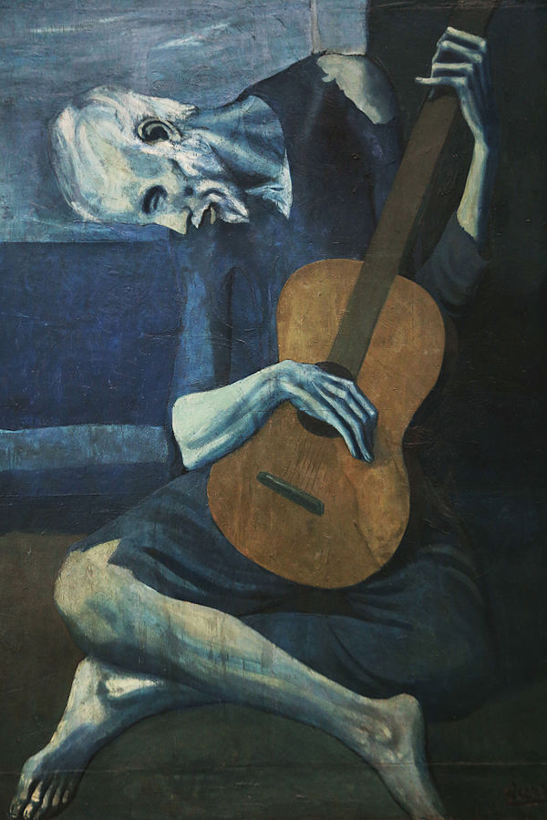

Picasso, P. (1903–1904). The old guitarist [Painting]. Art Institute of Chicago, Chicago, IL.

The Church at Auvers by Vincent Van Gogh
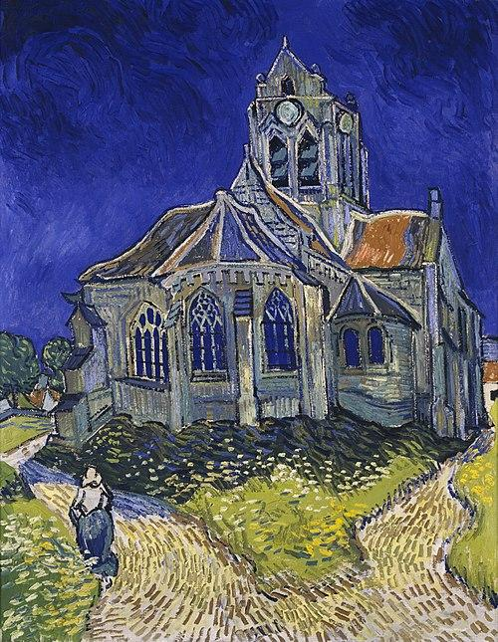
Van Gogh, V. (1890). The church at Auvers [Painting]. Musée d'Orsay, Paris, France.

The Persistence of Memory by Salvador Dalí

Dalí, S. (1931). The persistence of memory [Painting]. Museum of Modern Art, New York, NY.
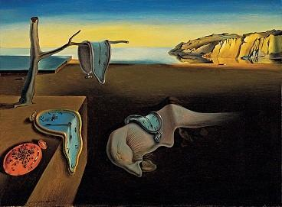

Nighthawks by Edward Hopper
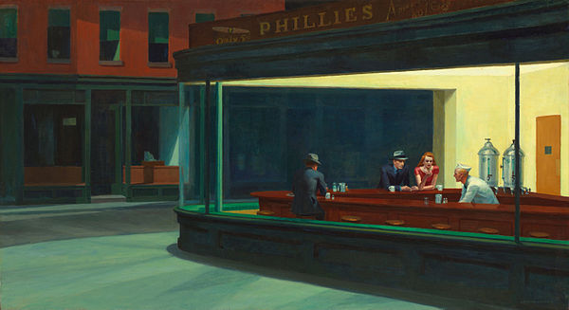

Hopper, E. (1942). Nighthawks [Painting]. Art Institute of Chicago, Chicago, IL. https://www.artic.edu/artworks/111628/nighthawks

