MOON PHASE VIEWER

Materials:
Black construction paper (1 per student)
Clear plastic cups (2 per student)
Yellow paint or yellow dot (1 per student)
Sharpie
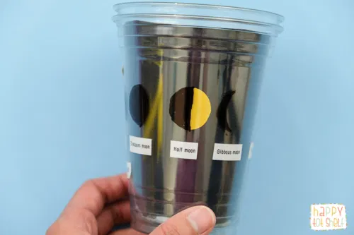
Happy Tot Shelf. (2020). Moon Phases Learning Toy. https://happytotshelf.com/moon-phases-learning-toy/

Instructions:
- Cut black construction paper to fit inside one of the clear plastic cups.
- Paint a yellow dot, or place the yellow dot sticker, in the center of the black paper.
- Place the paper into the clear plastic cup with the dot facing out.
- Place this cup inside of the other plastic cup.
- While holding the cup, use the sharpie to color over the yellow dot like the moon would be seen for a new moon.
- Rotate the inside cup so the yellow circle is visible again.
- Color with the sharpie over this next moon to show a crescent.
- Rotate the inside cup so the circle is visible again.
- Color with a sharpie over this moon to show a half moon.
- Continue rotating the cup and coloring in the moon phases until all have been shown.

