Adapted from: http://php.med.unsw.edu.au/embryology/index.php?title=K12_Comparative_Embryology’

ANIMAL EMBRYO DEVELOPMENT

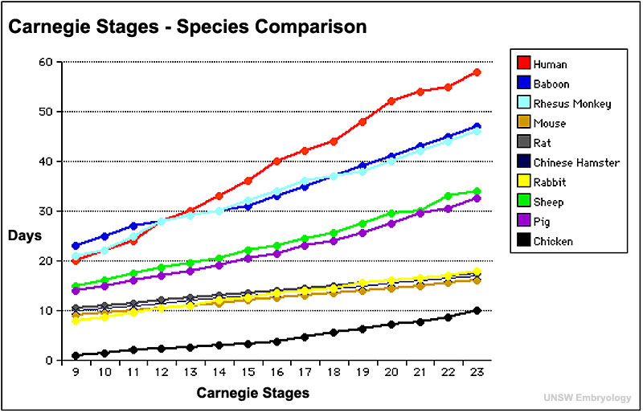

Using the above graph, color the stage table below to show each developmental week range for each species over the weeks 1 to 8. See chicken example in table. Complete the last column by showing when that animal is born in weeks.

Stage | 9 | 10 | 11 | 12 | 13 | 14 | 16 | 17 | 18 | 19 | 20 | 21 | 22 | 23 | Born
Animal
Chicken | Week 1 |  |  |  |  |  |  |  |  |  | Week 2

- Which animal species have the most similar developmental stages/weeks?

- What conclusions about animal type and embryo development can be made from the graph?

