Examples of Letters

Example 1: A Letter from Roald Dahl

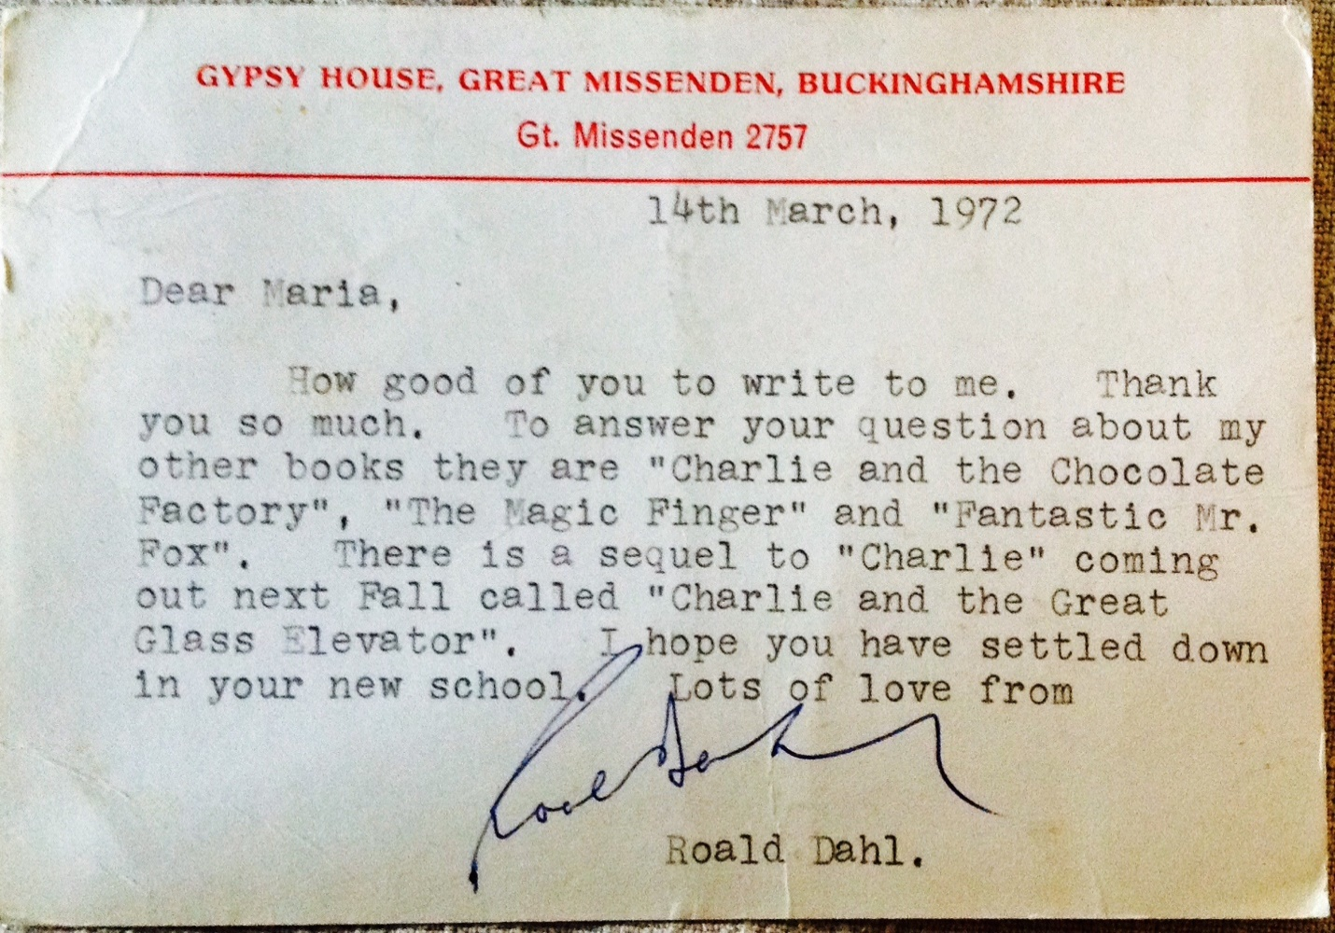
Source: Albee, S. (2015, February 10). Roald Dahl Letter [Image]. The Power of the Crayon [Blog post]. Nerdy Book Club. https://nerdybookclub.wordpress.com/2015/02/10/the-power-of-the-crayon-by-sarah-albee/

Example 2: A Letter from Courtney

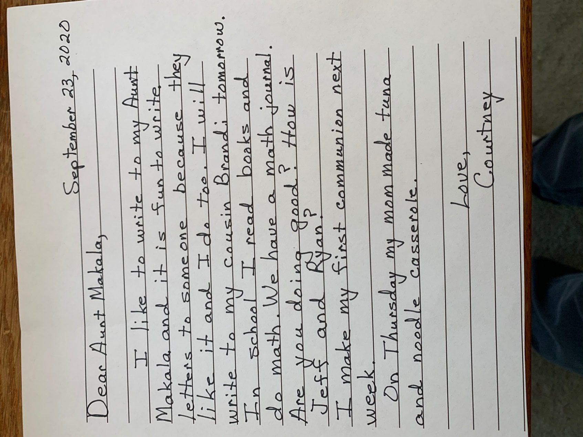
Source: K20 Center. (n.d.). A Letter from Courtney [Image].

Example 3: A Letter from the Queen’s Lady-in-Waiting

Source: Albee, S. (2015, February 10). Queen Elizabeth Letter [Image]. The Power of the Crayon [Blog post]. Nerdy Book Club. https://nerdybookclub.wordpress.com/2015/02/10/the-power-of-the-crayon-by-sarah-albee/

Example 4: Letters from Ryan and Jeff

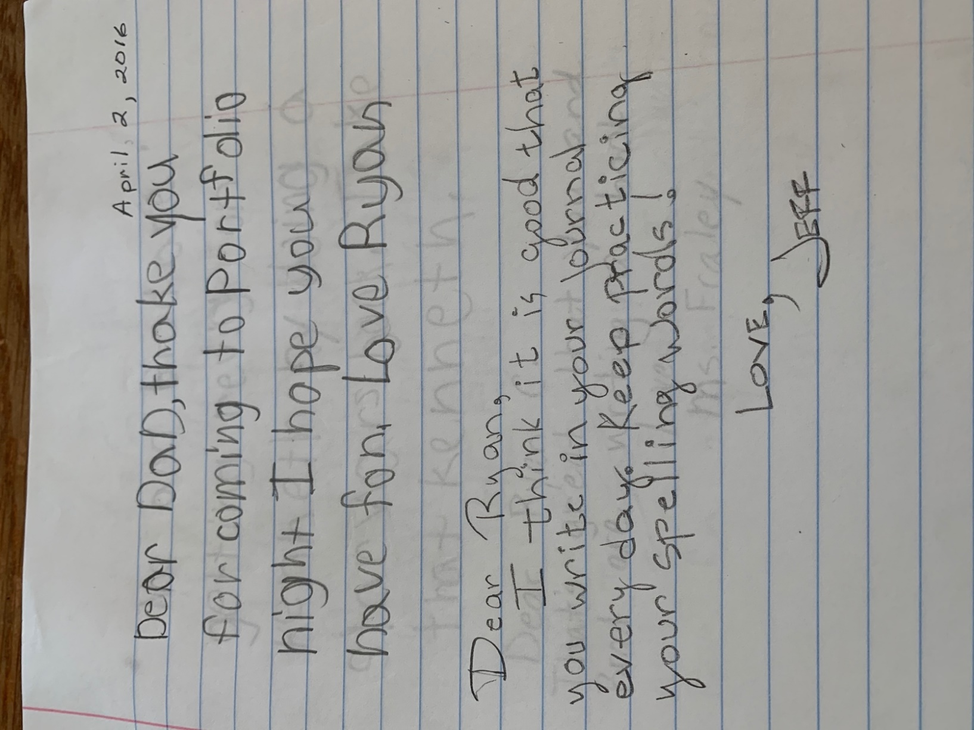
Source: K20 Center. (n.d.). Letters from Ryan and Jeff [Image].

Example 5: A Letter from Ethan

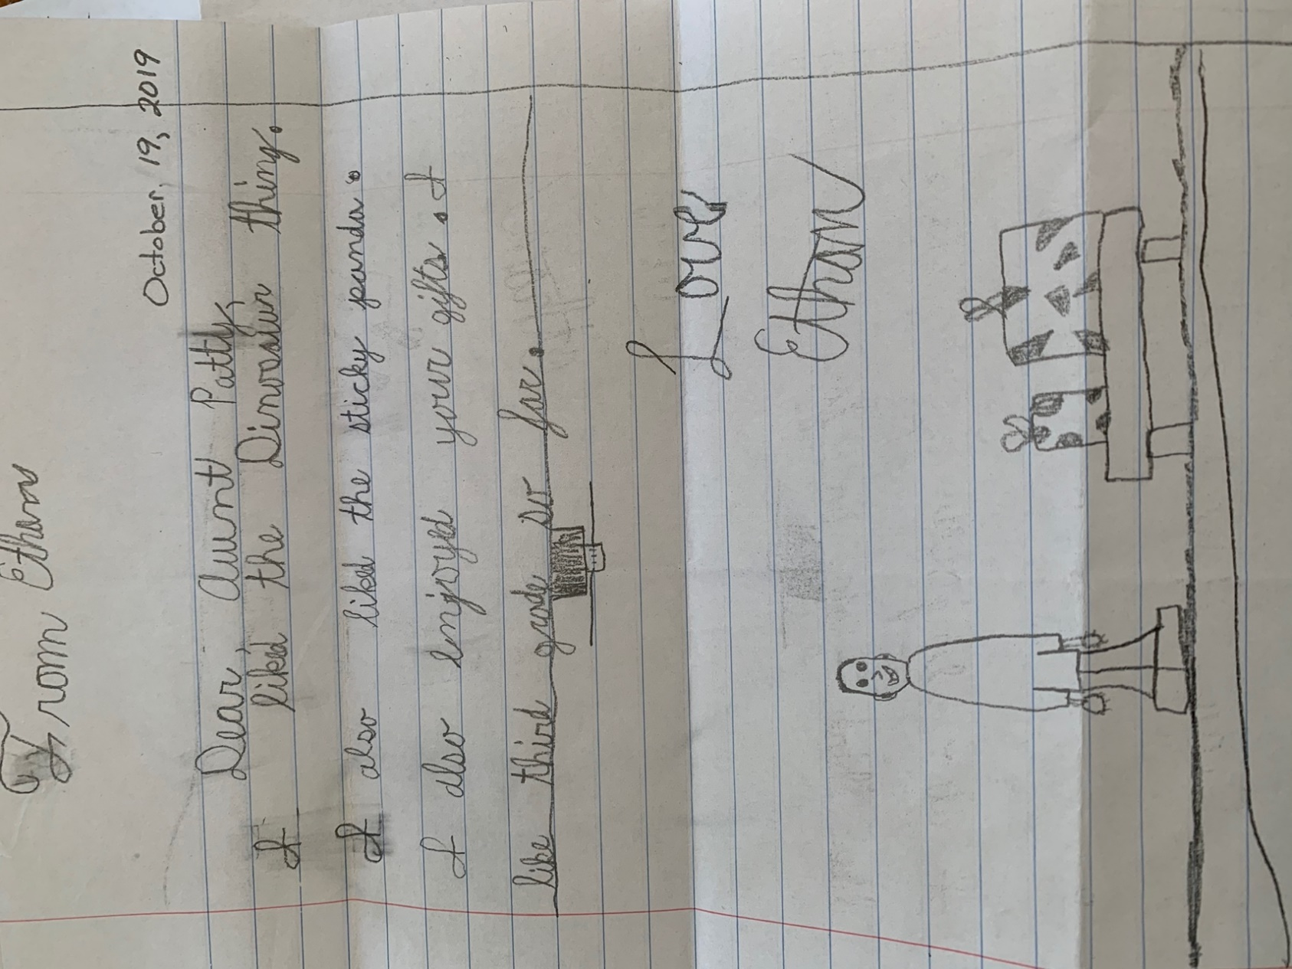
Source: K20 Center. (n.d.). A Letter from Ethan [Image].

Example 6: A Letter from Mom

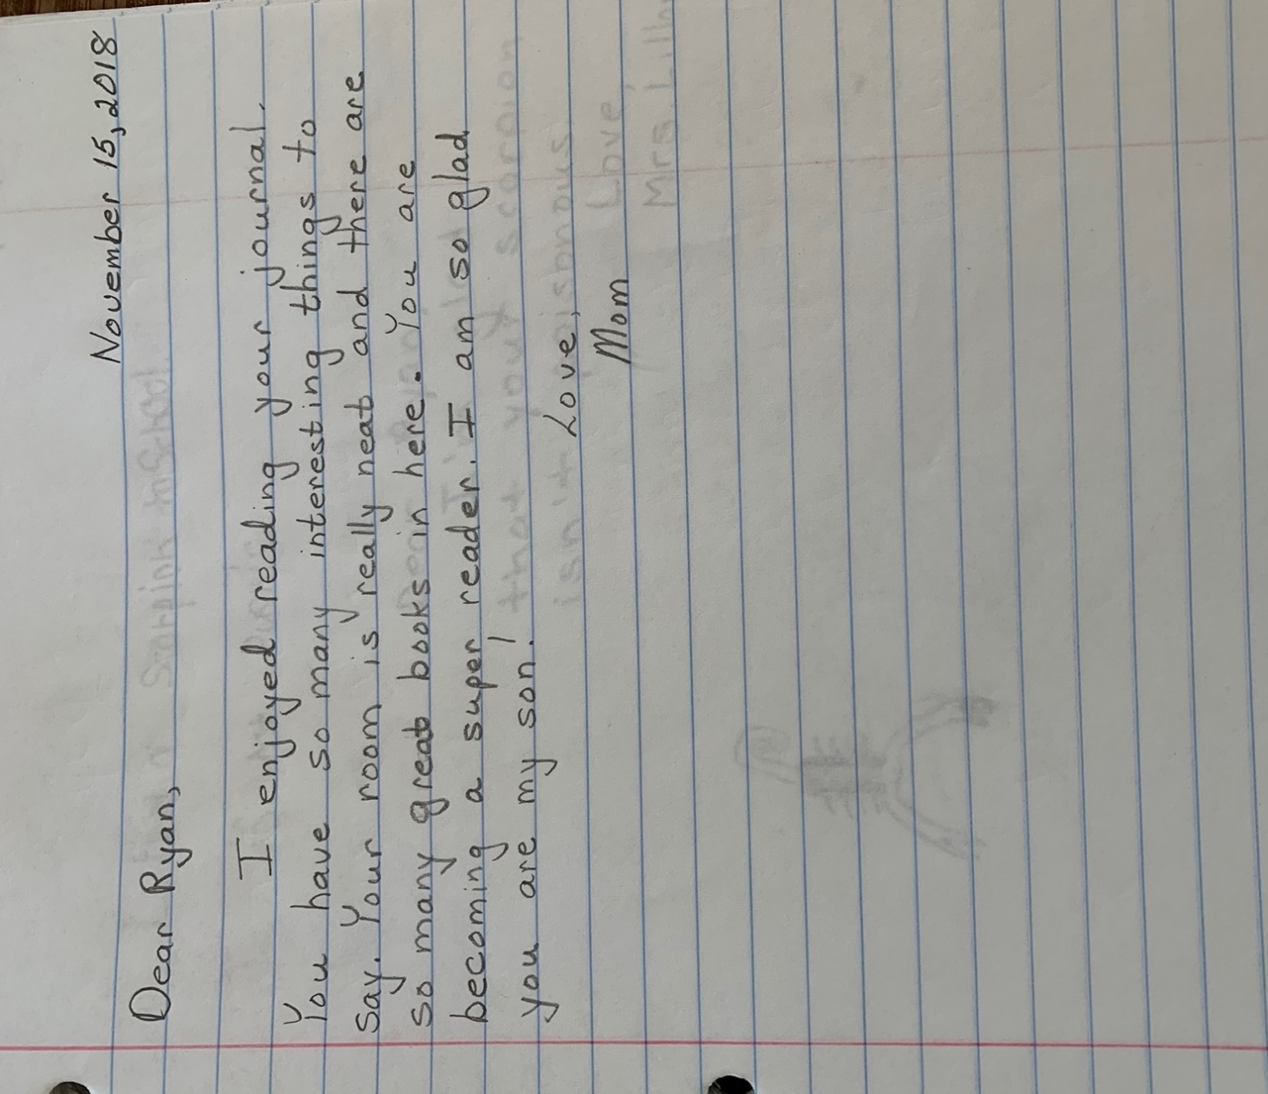
Source: K20 Center. (n.d.). A Letter from Mom [Image].

Example 7: A Letter from J.M. Brewin

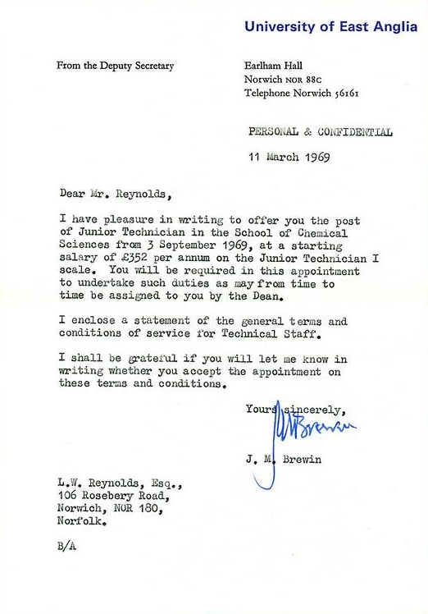
Source: Reynolds, L. (2019, July 3). 40 Years Ago: First Job Offer Letter [Image]. Flickr. https://www.flickr.com/photos/lwr/3771121009/

Example 8: A Letter from Emma and Her Mother

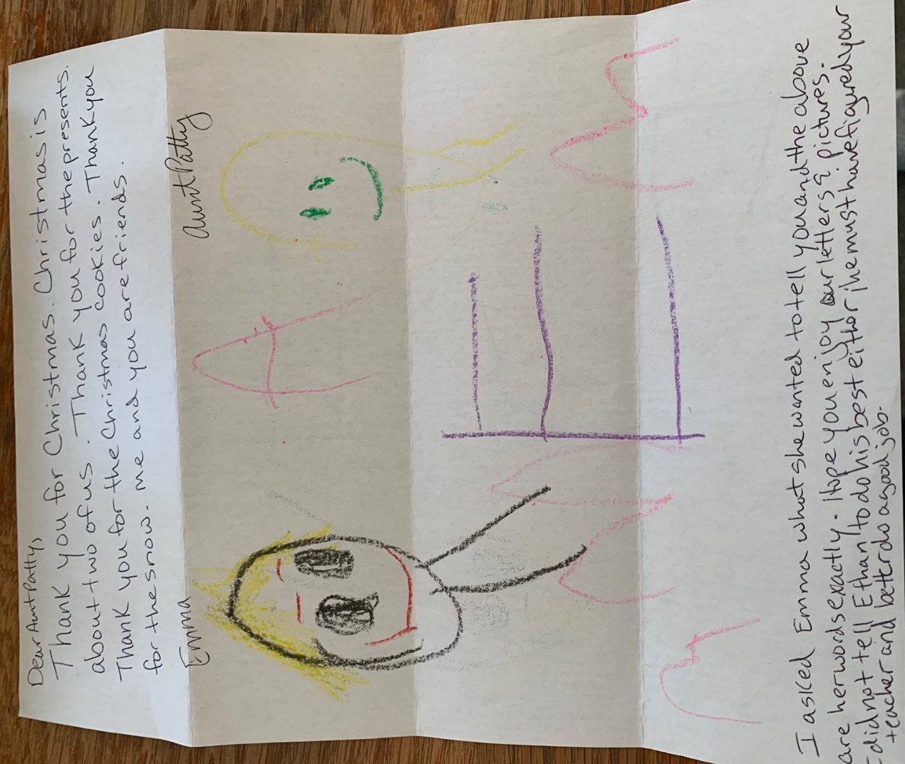
Source: K20 Center. (n.d.). A Letter from Emma and Her Mother [Image].

Example 9: A Letter from Jason

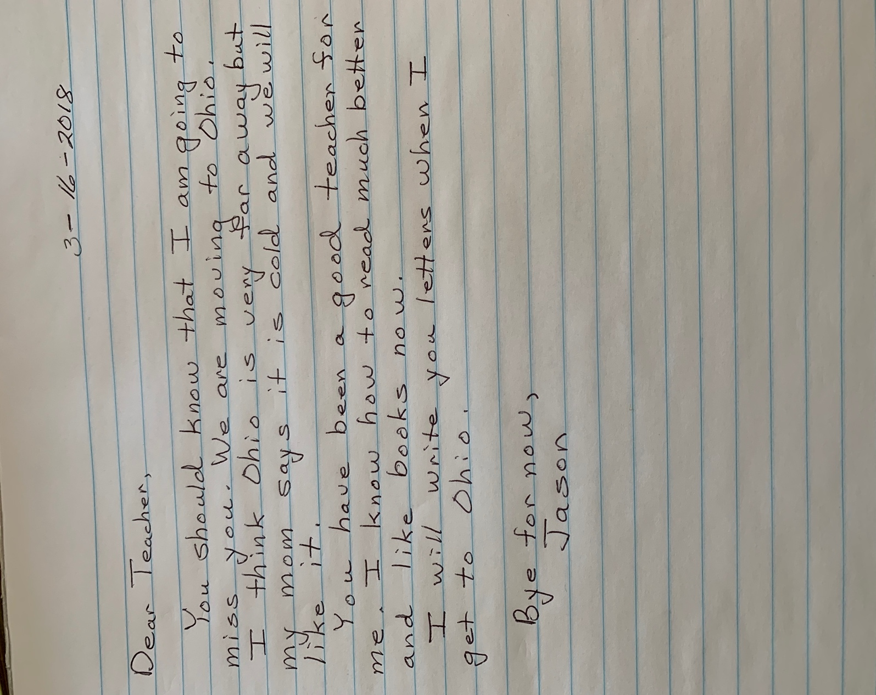
Source: K20 Center. (n.d.). A Letter from Jason [Image].

