**SOIL HAND TEXTURE**

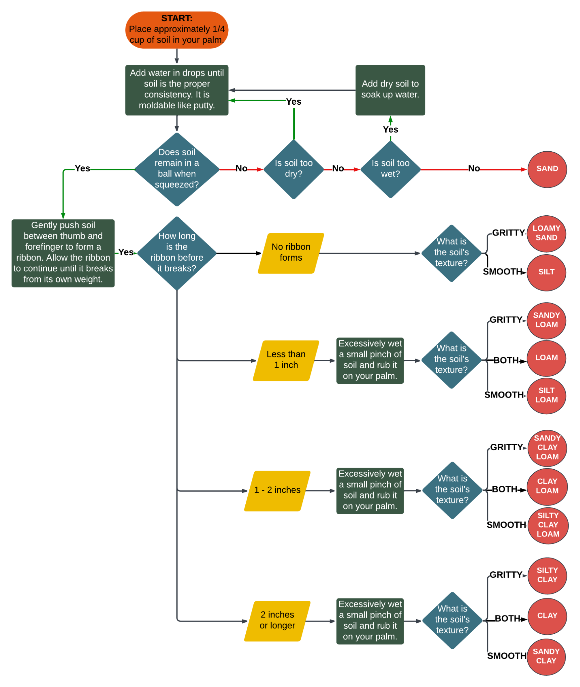



**HOW DOES YOUR GARDEN GROW?**