TEXTURA DE LA MANO DEL SUELO
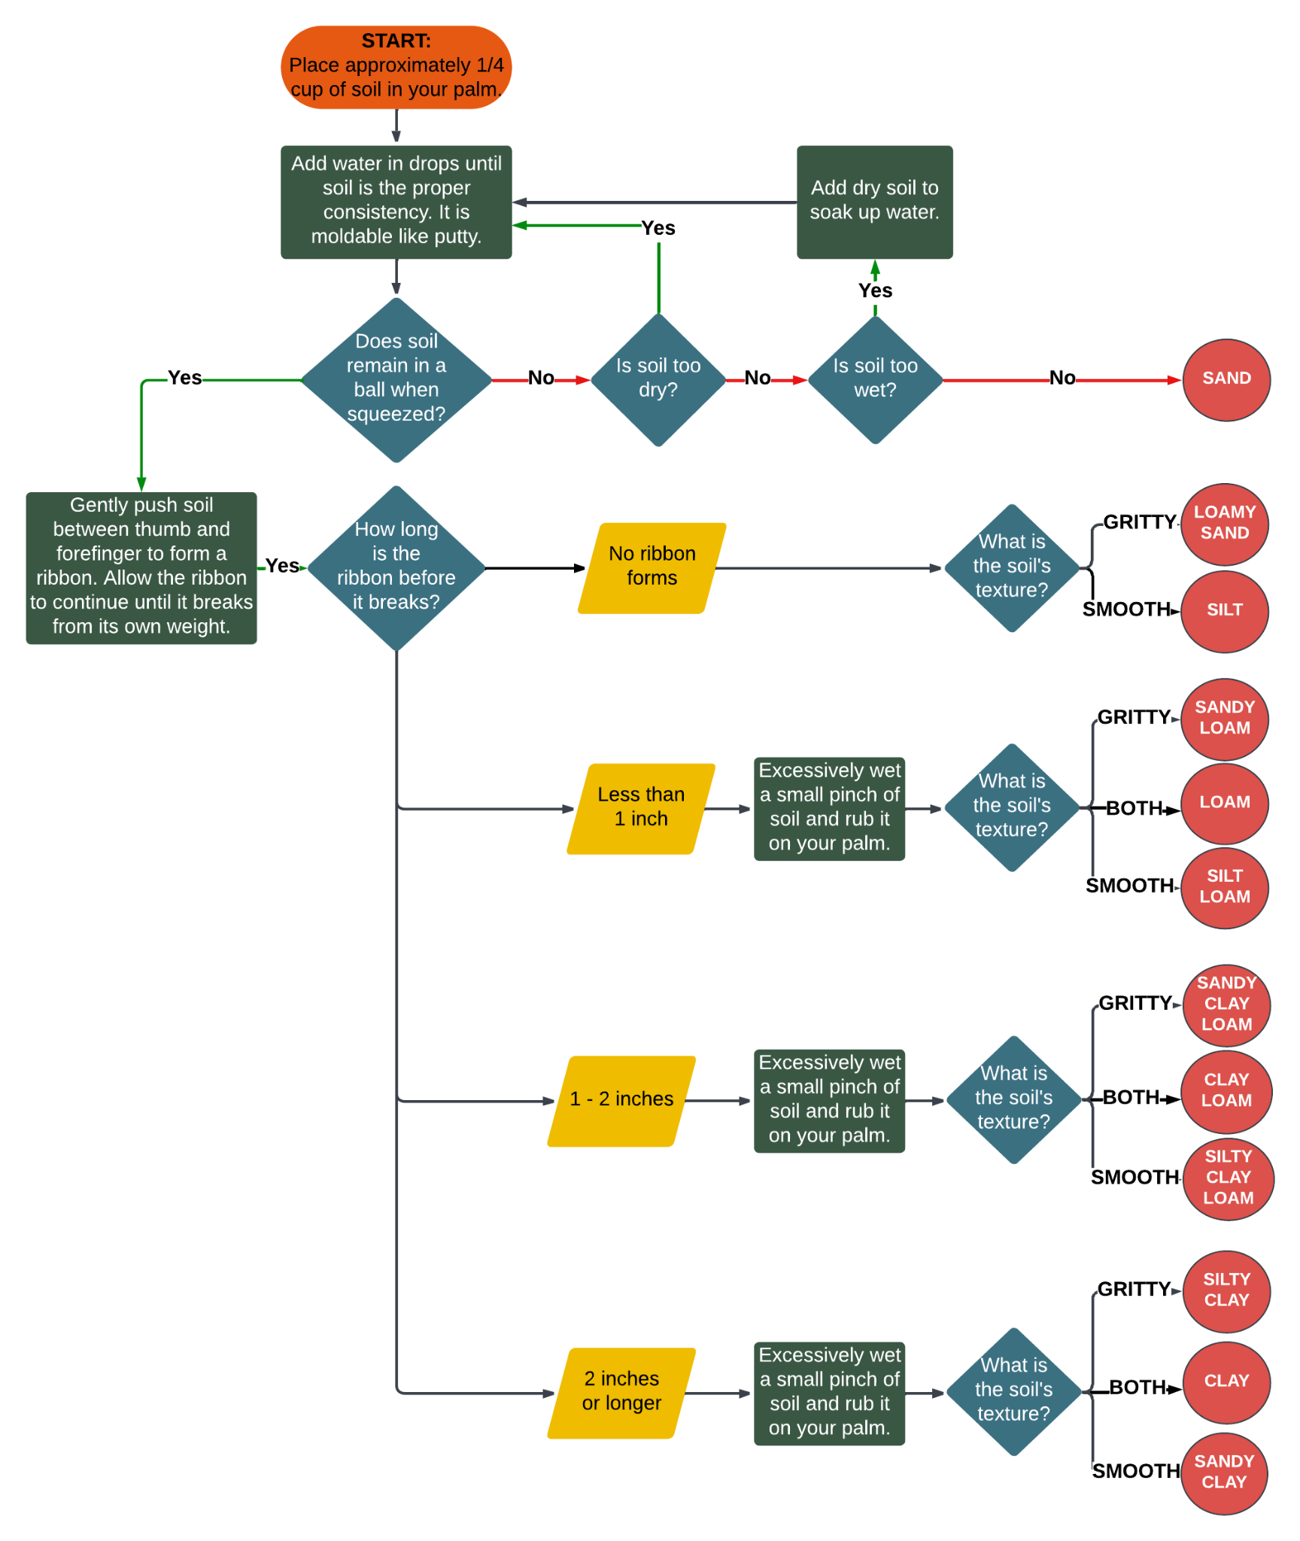

HOW DOES YOUR GARDEN GROW?

