SOIL HAND TEXTURE
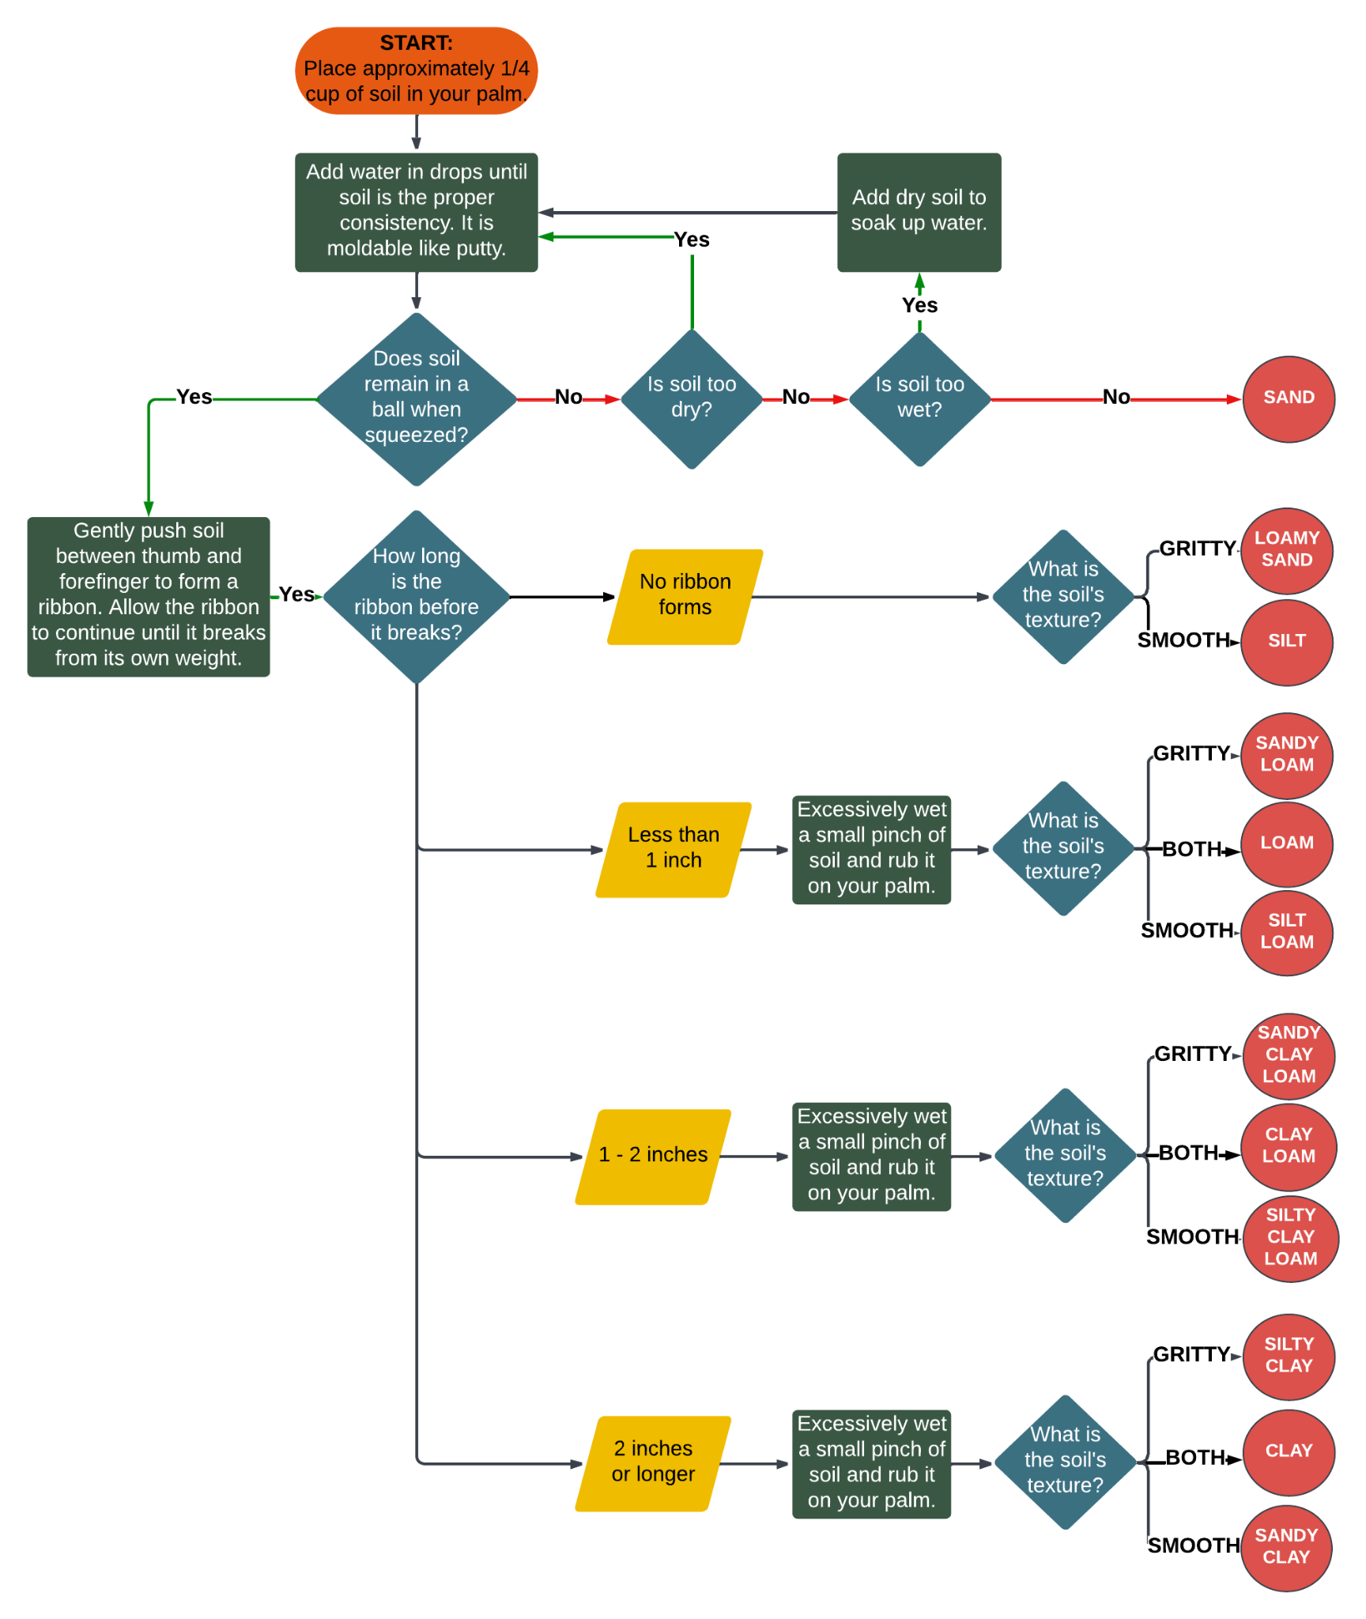

HOW DOES YOUR GARDEN GROW?

