DIGESTIVE SYSTEM MODEL
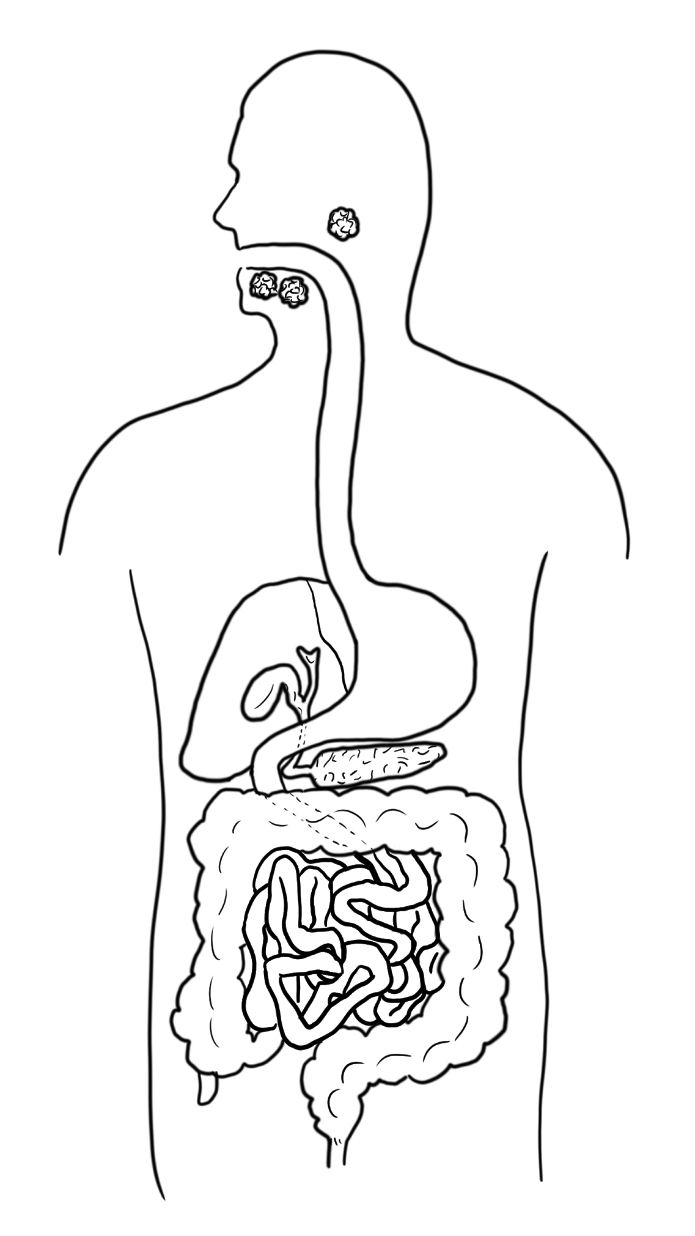
Use the digestive system model above to construct an explanation for how the process of digestion left bone fragments in the coprolites of “bone-crushing” dogs.

