THE DIGESTIVE SYSTEM
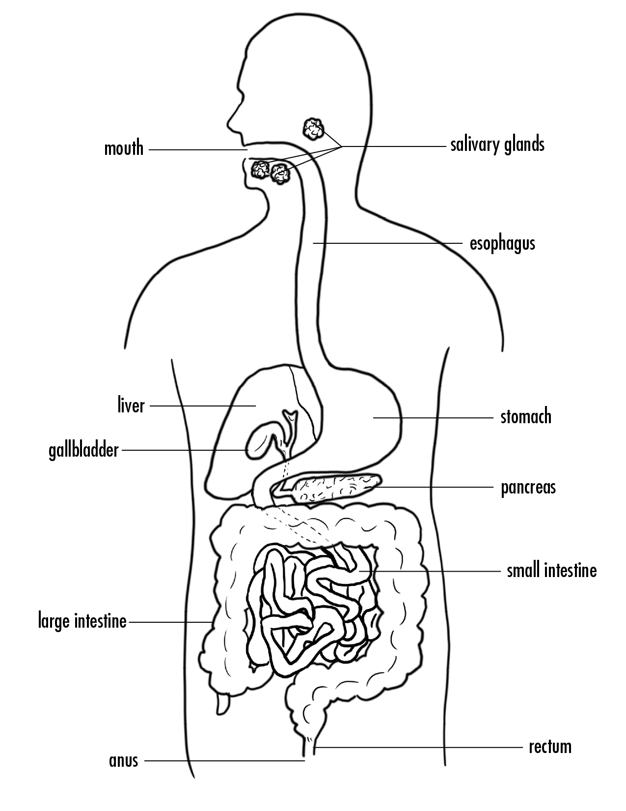
Describe what happened in each step of the model and what part of the body that step occurs in. In other words, what organ does that part of the model represent? What process in digestion does this part of the model represent? Where do you think chemical reactions are happening?
Phase 1
Phase 2
Phase 3
Phase 4
Phase 5

Think back to your observations from the “waste” of the class’s digestive system models. What were you able to identify in the “waste” products?

What types of conclusions would you be able to draw about an animal based on its waste?

