UNVEILING THE DIGESTIVE SYSTEM

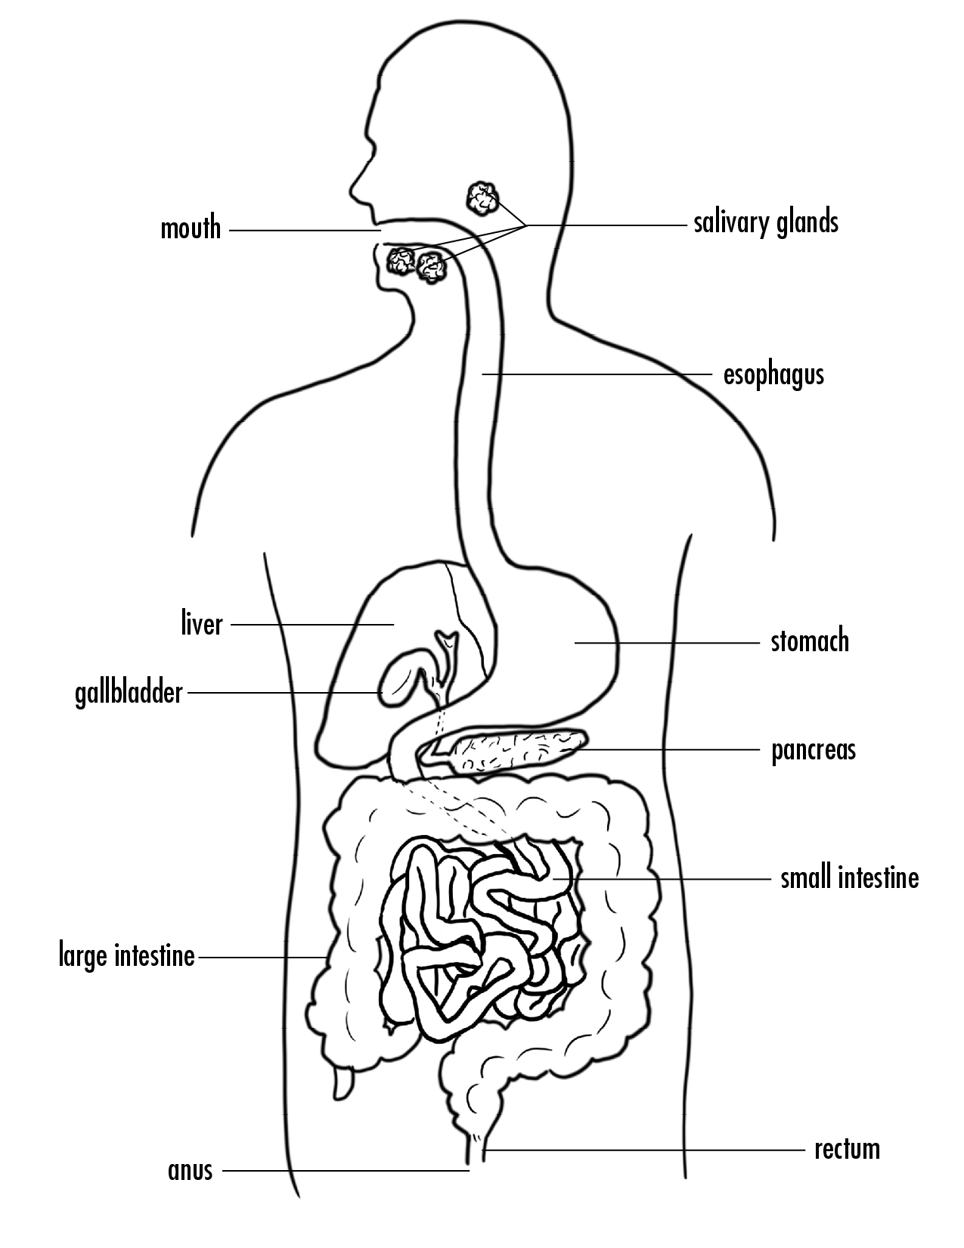

**Instructions**: Describe what happened in each step of the model and what part of the body that step occurs in. *What organ does that part of the model represent? What process in digestion does this part of the model represent? Where do you think chemical reactions are happening?*

|  |  |
| --- | --- |
| **Phase 1** |  |
| **Phase 2** |  |
| **Phase 3** |  |
| **Phase 4** |  |
| **Phase 5** |  |

Think back to your observations from the “waste” of the class’s digestive system models. What were you able to identify in the “waste” products?

|  |
| --- |
|  |

What types of conclusions would you be able to draw about an animal based on its waste?

|  |
| --- |
|  |