DIY SECCHI DISK INSTRUCTIONS
Materials
- Water-resistant paint (white and black)
- Hot glue gun
- Metric ruler
Steps
- Permanent marker • For each disk: o Metal washer (must fit inside the experimental bottle) o Plastic straw

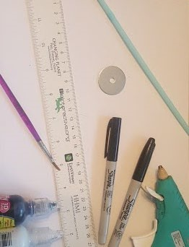 | 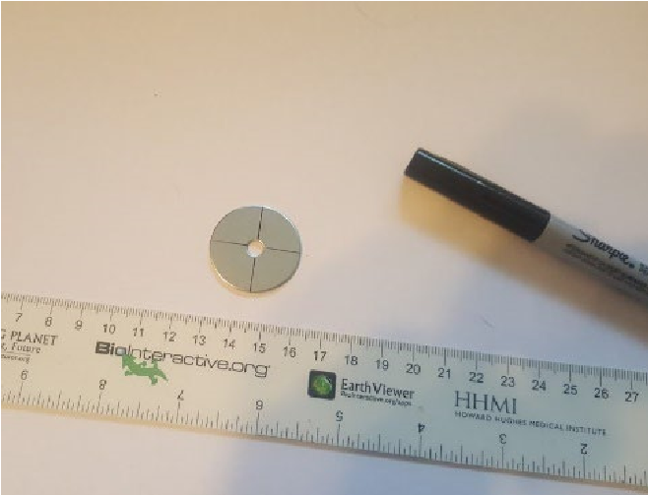 | 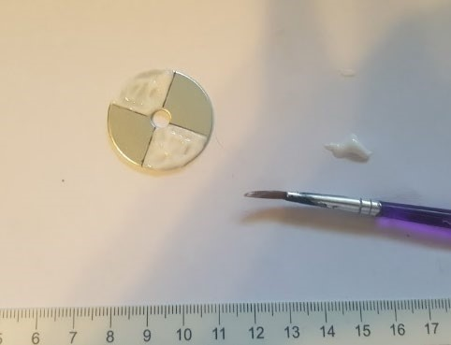
1. Gather a washer, a plastic straw, black and white paint, a permanent marker, a hot glue gun, and a metric ruler. | 2. Draw lines on one side of the washer to divide the circle into quarters. | 3. Paint two of the opposite quarters white.
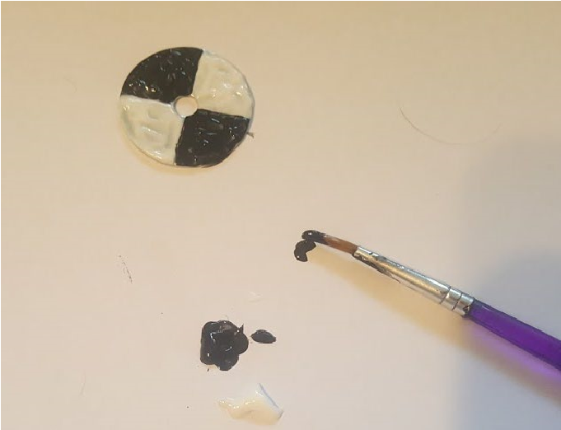 | 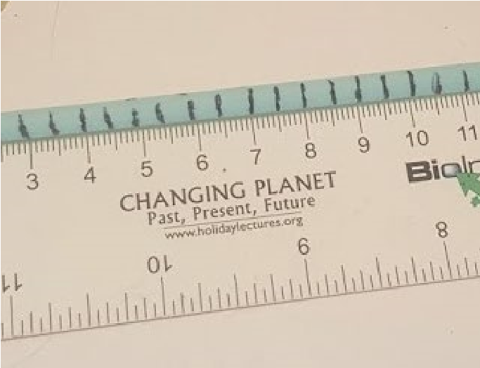 | 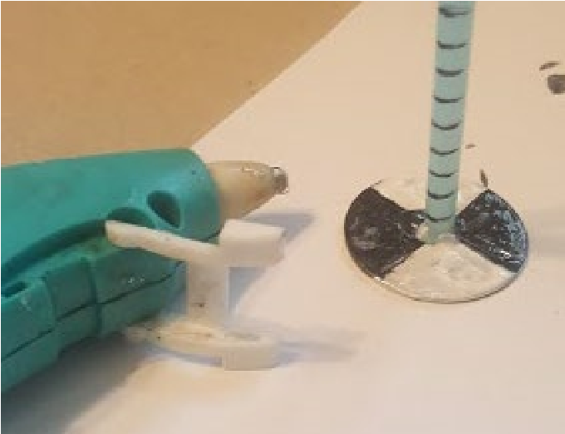
4. Paint the other two opposite quarters black so there is a black-white-black-white pattern on the washer. | 5. Line up the bottom of the straw with the 0 cm mark and use a marker to make a mark every 0.5 cm along the straw. | 6. Use hot glue to attach the bottom of the straw to the center of the painted side of the washer.
CLEAR AS PHYTOPLANKTON: A TALE OF FOUR LAKES

