DIY SECCHI DISK INSTRUCTIONS

Materials
- Water-resistant paint (white and black)
- Hot glue gun
- Metric ruler
- Permanent marker
- For each disk:
  - Metal Washer (must fit inside the experimental bottle)
  - Plastic straw

Steps
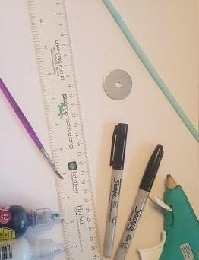 | 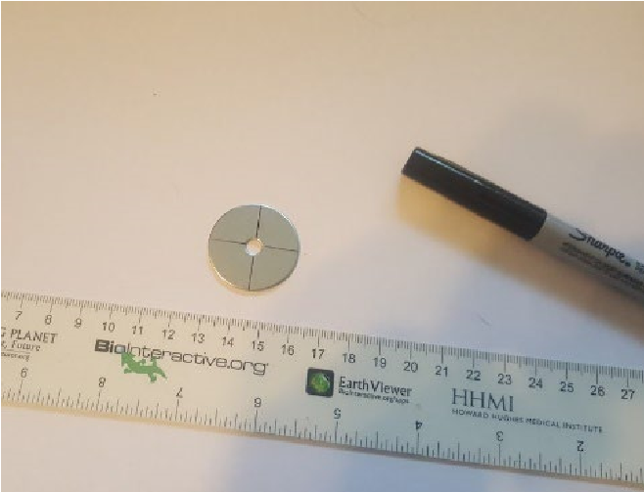 | 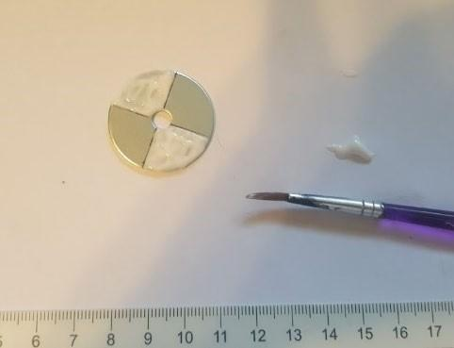
1. Gather black and white paint, a washer, plastic straw, permanent marker, hot glue gun, and metric ruler. | 2. Draw lines on one side of the washer to divide the circle into quarters. | 3. Paint two of the opposite quarters white.
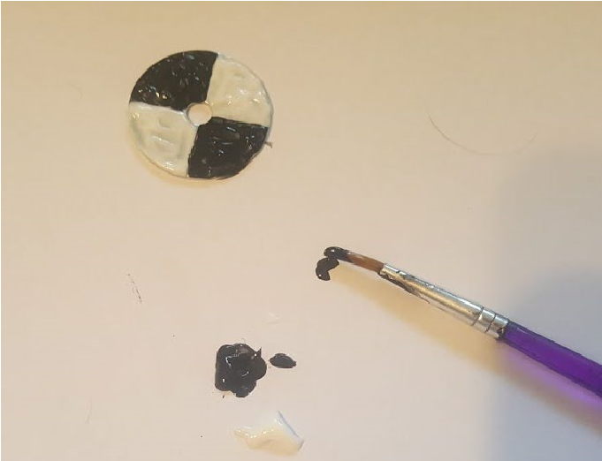 | 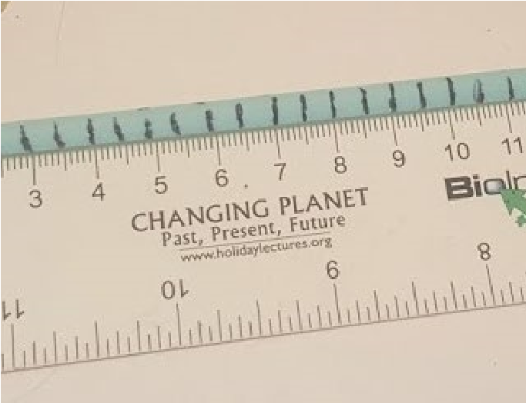 | 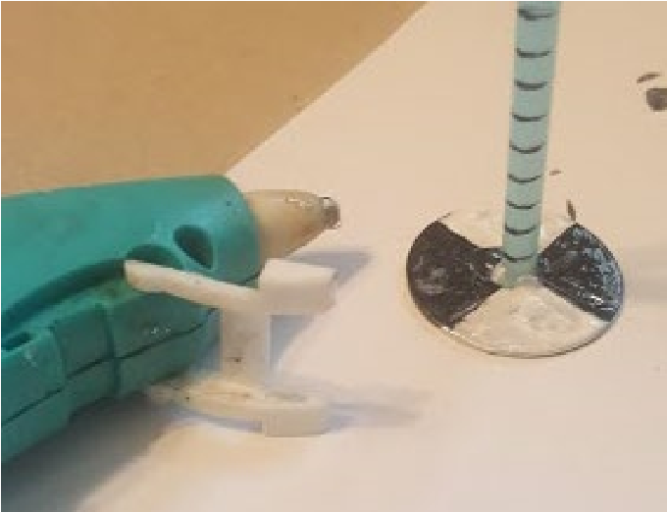
4. Paint the other two opposite quarters black. There should be a black-white-black-white pattern on the washer. | 5. Line up the bottom of the straw with the 0 cm mark. Use a marker to make a mark every 0.5 cm along the straw. | 6. Use hot glue to attach the bottom of the straw to the center of the painted side of the washer.

