Shawnee Twin No. 1 |  |  |  |  |  |  |  |  |  |  | 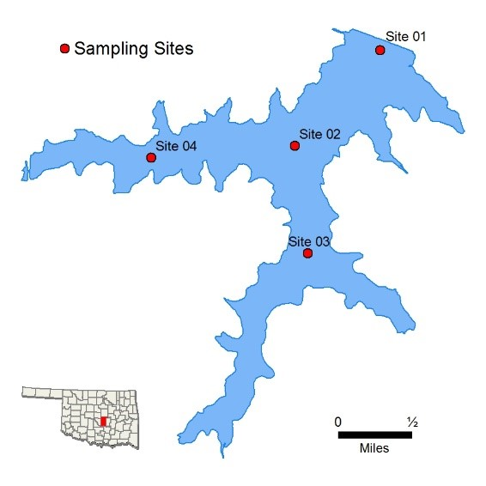
Sample Period |  |  |  |  | Times  Visited |  |  | Sampling Sites
November 2018 – September 2019 |  |  |  |  | 4 |  |  | 4
General | Location |  | Pottawatomie County
 | Impoundment |  | 1935
 | Area |  | 1,336 acres
 | Capacity |  | 22,600 acre-feet
 | Purposes |  | Water Supply, Recreation
Parameters |  | Parameter (Descriptions) |  |  |  | Result |  |  |  |  |  | Notes/Comments
 | In  -  Situ | Average Turbidity |  |  |  | 12 NTU |  |  |  |  |  | 100% of values < OWQS of 25 NTU
 |  | Average Secchi Disk Depth |  |  |  | 74.2 cm
 |  | Water Clarity Rating |  |  |  | Good
 |  | Chlorophyll-a |  |  |  | 8.93 mg/m3
 |  | Trophic State Index |  |  |  | 52 |  |  |  |  |  | Previous Value = 47
 |  | Trophic Class |  |  |  | Eutrophic
 | Profile | Salinity |  |  |  | 0.09 – 0.13 ppt
 |  | Specific Conductivity |  |  |  | 195.2 – 277.1 µS/cm
 |  | pH |  |  |  | 7.10 – 8.27 pH units |  |  |  |  |  | Neutral to slightly alkaline
 |  | Oxidation-Reduction Potential |  |  |  | 45.1 to 468.0 mV
 |  | Dissolved Oxygen |  |  |  | Up to 30% of water column < 2 mg/L in September
 | Nutrients | Surface Total Nitrogen |  |  |  | 0.375 mg/L to 0.765 mg/L
 |  | Surface Total Phosphorus |  |  |  | 0.012 mg/L to 0.026 mg/L
 |  | Nitrogen to Phosphorus Ratio |  |  |  | 31:1 |  |  |  |  |  | Phosphorus limited
Beneficial Uses |  | Click to learn more about Beneficial Useshttp://www.owrb.ok.gov/quality/monitoring/bump/pdf_bump/BENEFICIAL_USES-COMPREHENSIVE.pdf |  |  |  | Turbidity | pH |  | Dissolved  Oxygen | Metals | TSI | True  Color | Sulfates | Chlorides | T  otal  Dissolved  Solids | En  terro.  &  E. coli | Chlor  -  a
 | Fish & Wildlife Propagation |  |  |  |  | NS | S |  | NEI | S
 | Aesthetics |  |  |  |  |  |  |  |  |  | S | *
 | Agriculture |  |  |  |  |  |  |  |  |  |  |  | S | S | S
 | Primary Body Contact Recreation |  |  |  |  |  |  |  |  |  |  |  |  |  |  | S
 | Public & Private Water Supply
 | S = Fully Supporting  NS = Not Supporting  NEI = Not Enough Information |  |  | Notes |  | *Standards revision, true color is for permitting purposes only
NTU = nephelometric turbidity units OWQS = Oklahoma Water Quality Standards mg/L = milligrams per liter ppt = parts per thousand µS/cm = microsiemens per centimeter mV = millivolts µS/cm = microsiemens/cm En = Enterococci E. coli = Escherichia coli Chlor-a = Chlorophyll-a
Sampling and Assessment by the Oklahoma Water Resources Board – 3800 Classen Blvd, Oklahoma City, OK, 73118 – 405.530.8800 – http://www.owrb.ok.gov
Bathy map available: http://www.owrb.ok.gov/maps/PMG/owrbdata_Bathy.html
Stanley Draper |  |  |  |  |  |  |  |  | 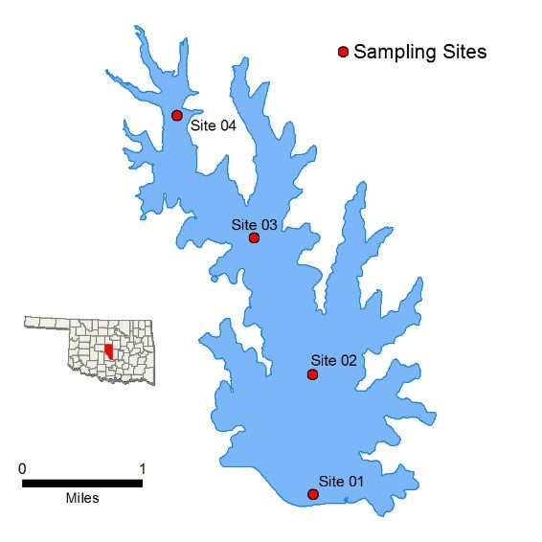
Sample Period |  |  |  | Times  Visited |  | Sampling Sites
October 2015 – August 2016 |  |  |  | 4 |  | 5
General | Location |  | Cleveland County
 | Impoundment |  | 1962
 | Area |  | 2,900 acres
 | Capacity |  | 100,000 acre-feet
 | Purposes |  | Water Supply, Recreation
Parameters |  | Parameter (Descriptions) |  |  | Result |  |  |  |  | Notes/Comments
 | In Situ | Average Turbidity |  |  | 8 NTU |  |  |  |  | 100% of values < OWQS of 25 NTU
 |  | Average Secchi Disk Depth |  |  | 104 cm
 |  | Water Clarity Rating |  |  | Excellent
 |  | Chlorophyll-a |  |  | 2.7 mg/m3
 |  | Trophic State Index |  |  | 40 |  |  |  |  | Previous value = 36
 |  | Trophic Class |  |  | Oligotrophic
 | Profile | Salinity |  |  | 0.05 – 0.06 ppt
 |  | Specific Conductivity |  |  | 108.7 – 132.7 µS/cm
 |  | pH |  |  | 6.81 – 8.34 pH units
 |  | Oxidation-Reduction Potential |  |  | 176.1 – 463.7 mV
 |  | Dissolved Oxygen |  |  | Up to 62% of water column < 2 mg/L in August
 | Nutrients | Surface Total Nitrogen |  |  | 0.26 mg/L to 0.55 mg/L
 |  | Surface Total Phosphorus |  |  | 0.010 mg/L to 0.015 mg/L
 |  | Nitrogen to Phosphorus Ratio |  |  | 31:1 |  |  |  |  | Phosphorus limited
Beneficial Uses |  | Click to learn more about Beneficial Useshttp://www.owrb.ok.gov/quality/monitoring/bump/pdf_bump/BENEFICIAL_USES-COMPREHENSIVE.pdf |  |  | Turbidity | pH | Dissolved  Oxygen | Metals | TSI | True  Color | Sulfates | Chlorides | T  otal  Dissolved  Solids | En  terro.  &  E. coli | Chlor  -  a
 | Fish & Wildlife Propagation |  |  |  | NS | S | S | S
 | Aesthetics |  |  |  |  |  |  |  | S | *
 | Agriculture |  |  |  |  |  |  |  |  |  | S | S | S
 | Primary Body Contact Recreation |  |  |  |  |  |  |  |  |  |  |  |  | S
 | Public & Private Water Supply
 | S = Fully Supporting  NS = Not Supporting  NEI = Not Enough Information |  |  | Notes | *Standards revision, true color is for permitting purposes only
NTU = nephelometric turbidity units OWQS = Oklahoma Water Quality Standards mg/L = milligrams per liter ppt = parts per thousand µS/cm = microsiemens per centimeter mV = millivolts µS/cm = microsiemens/cm En = Enterococci E. coli = Escherichia coli Chlor-a = Chlorophyll-a
Sampling and Assessment by the Oklahoma Water Resources Board – 3800 Classen Blvd, Oklahoma City, OK, 73118 – 405.530.8800 – http://www.owrb.ok.gov
Bathy map available: http://www.owrb.ok.gov/maps/PMG/owrbdata_Bathy.html
Tecumseh |  |  |  |  |  |  |  |  | 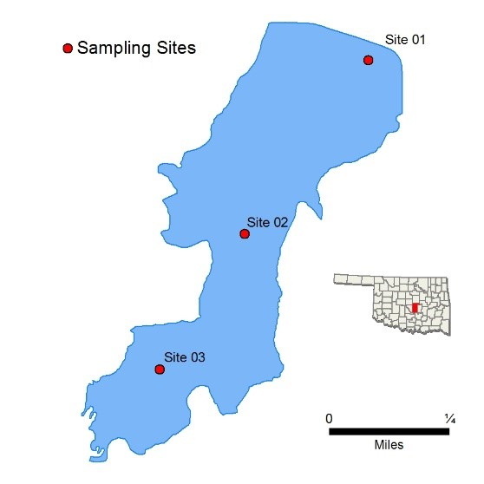
Sample Period |  |  |  | Times  Visited |  | Sampling Sites
October 2007 – July 2008 |  |  |  | 4 |  | 5
General | Location |  | Pottawatomie County
 | Impoundment |  | 1934
 | Area |  | 127 acres
 | Capacity |  | 1,118 acre feet
 | Purposes |  | Waters Supply, and Recreation
Parameters |  | Parameter (Descriptions) |  |  | Result |  |  |  |  | Notes/Comments
 | In Situ | Average Turbidity |  |  | 132 NTU |  |  |  |  | All values > 25 NTU
 |  | Average Secchi Disk Depth |  |  | 11 cm |  |  |  |  | All values > OWQS of 70
 |  | Water Clarity Rating |  |  | poor
 |  | Chlorophyll-a |  |  | 6.52 mg/m3
 |  | Trophic State Index |  |  | 49 |  |  |  |  | Previous value = 57
 |  | Trophic Class |  |  | mesotrophic
 | Profile | Salinity |  |  | 0.00 – 0.10 ppt
 |  | Specific Conductivity |  |  | 105.6 – 141 µS/cm
 |  | pH |  |  | 7.08 – 7.60 pH units |  |  |  |  | Neutral
 |  | Oxidation-Reduction Potential |  |  | 337 to 537 mV
 |  | Dissolved Oxygen |  |  |  |  |  |  |  | D.O. always > 5.0 mg/L
 | Nutrients | Surface Total Nitrogen |  |  | 1.01 mg/L to 1.55 mg/L
 |  | Surface Total Phosphorus |  |  | 0.066 mg/L to 0.131 mg/L
 |  | Nitrogen to Phosphorus Ratio |  |  | 12:1 |  |  |  |  | Phosphorus limited
Beneficial Uses |  | Click to learn more about Beneficial Useshttp://www.owrb.ok.gov/quality/monitoring/bump/pdf_bump/BENEFICIAL_USES-COMPREHENSIVE.pdf |  |  | Turbidity | pH | Dissolved  Oxygen | Metals | TSI | True  Color | Sulfates | Chlorides | T  otal  Dissolved  Solids | En  terro.  &  E. coli | Chlor  -  a
 | Fish & Wildlife Propagation |  |  |  | NS | S | S | S
 | Aesthetics |  |  |  |  |  |  |  | S | *
 | Agriculture |  |  |  |  |  |  |  |  |  | S | S | S
 | Primary Body Contact Recreation |  |  |  |  |  |  |  |  |  |  |  |  | S
 | Public & Private Water Supply
 | S = Fully Supporting  NS = Not Supporting  NEI = Not Enough Information |  |  | Notes | *Standards revision, true color is for permitting purposes only
NTU = nephelometric turbidity units OWQS = Oklahoma Water Quality Standards mg/L = milligrams per liter ppt = parts per thousand µS/cm = microsiemens per centimeter mV = millivolts µS/cm = microsiemens/cm En = Enterococci E. coli = Escherichia coli Chlor-a = Chlorophyll-a
Sampling and Assessment by the Oklahoma Water Resources Board – 3800 Classen Blvd, Oklahoma City, OK, 73118 – 405.530.8800 – http://www.owrb.ok.gov

Modified for "Clear as Phytoplankton: A Tale of Two Lakes." Calculated Chlorophyll-a from Trophic State Index and formula from report's parameter descriptions. Replaced "True Color value."
Thunderbird |  |  |  |  |  |  |  |  | 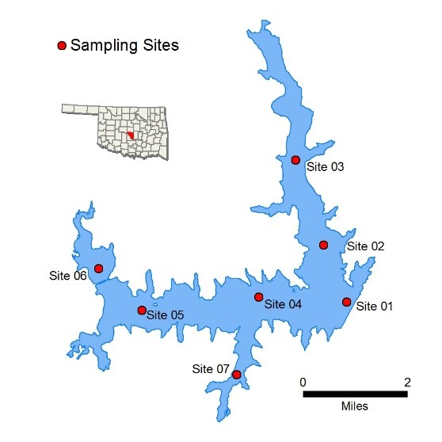
Sample Period |  |  |  | Times  Visited |  | Sampling Sites
October 2014 – July 2015 |  |  |  | 4 |  | 7
General | Location |  | Cleveland County
 | Impoundment |  | 1965
 | Area |  | 6,070 acres
 | Capacity |  | 119,600 acre-feet
 | Purposes |  | Flood Control, Water Supply, Recreation, Fish & Wildlife
Parameters |  | Parameter (Descriptions) |  |  | Result |  |  |  |  | Notes/Comments
 | In Situ | Average Turbidity |  |  | 14 NTU |  |  |  |  | 4% of values > OWQS of 25 NTU
 |  | Average Secchi Disk Depth |  |  | 59 cm
 |  | Water Clarity Rating |  |  | Average
 |  | Chlorophyll-a |  |  | 21 mg/m3
 |  | Trophic State Index |  |  | 61 |  |  |  |  | Previous value = 56
 |  | Trophic Class |  |  | Hypereutrophic
 | Profile | Salinity |  |  | 0.13 – 0.26 ppt
 |  | Specific Conductivity |  |  | 281.5 – 530 µS/cm
 |  | pH |  |  | 7.14 – 8.68 pH units |  |  |  |  | Neutral to slightly alkaline
 |  | Oxidation-Reduction Potential |  |  | 90.2 to 454 mV
 |  | Dissolved Oxygen |  |  | Up to 67% of water column < 2 mg/L in July |  |  |  |  | Occurred at sites 1, the dam
 | Nutrients | Surface Total Nitrogen |  |  | 0.80 mg/L to 1.27 mg/L
 |  | Surface Total Phosphorus |  |  | 0.018 mg/L to 0.064 mg/L
 |  | Nitrogen to Phosphorus Ratio |  |  | 23:1 |  |  |  |  | Phosphorus limited
Beneficial Uses |  | Click to learn more about Beneficial Useshttp://www.owrb.ok.gov/quality/monitoring/bump/pdf_bump/BENEFICIAL_USES-COMPREHENSIVE.pdf |  |  | Turbidity | pH | Dissolved  Oxygen | Metals | TSI | True  Color | Sulfates | Chlorides | T  otal  Dissolved  Solids | En  terro.  &  E. coli | Chlor  -  a
 | Fish & Wildlife Propagation |  |  |  | NS | S | NS | S
 | Aesthetics |  |  |  |  |  |  |  | NEI* | S
 | Agriculture |  |  |  |  |  |  |  |  |  | S | S | S
 | Primary Body Contact Recreation |  |  |  |  |  |  |  |  |  |  |  |  | S
 | Public & Private Water Supply |  |  |  |  |  |  |  |  |  |  |  |  |  | NS
 | S = Fully Supporting  NS = Not Supporting  NEI = Not Enough Information |  |  | Notes | *The lake is listed in the Oklahoma Water Quality Standards (WQS) as a Nutrient Limited watershed (NLW). This listing means that the lake is considered threatened from nutrients until a more intensive study can confirm the Aesthetics beneficial use non-support status.
NTU = nephelometric turbidity units OWQS = Oklahoma Water Quality Standards mg/L = milligrams per liter ppt = parts per thousand µS/cm = microsiemens per centimeter mV = millivolts µS/cm = microsiemens/cm En = Enterococci E. coli = Escherichia coli Chlor-a = Chlorophyll-a
Sampling and Assessment by the Oklahoma Water Resources Board – 3800 Classen Blvd, Oklahoma City, OK, 73118 – 405.530.8800 – http://www.owrb.ok.gov
Bathy map available: http://www.owrb.ok.gov/maps/PMG/owrbdata_Bathy.html

