**Phytoplankton Community: Lake Thunderbird**

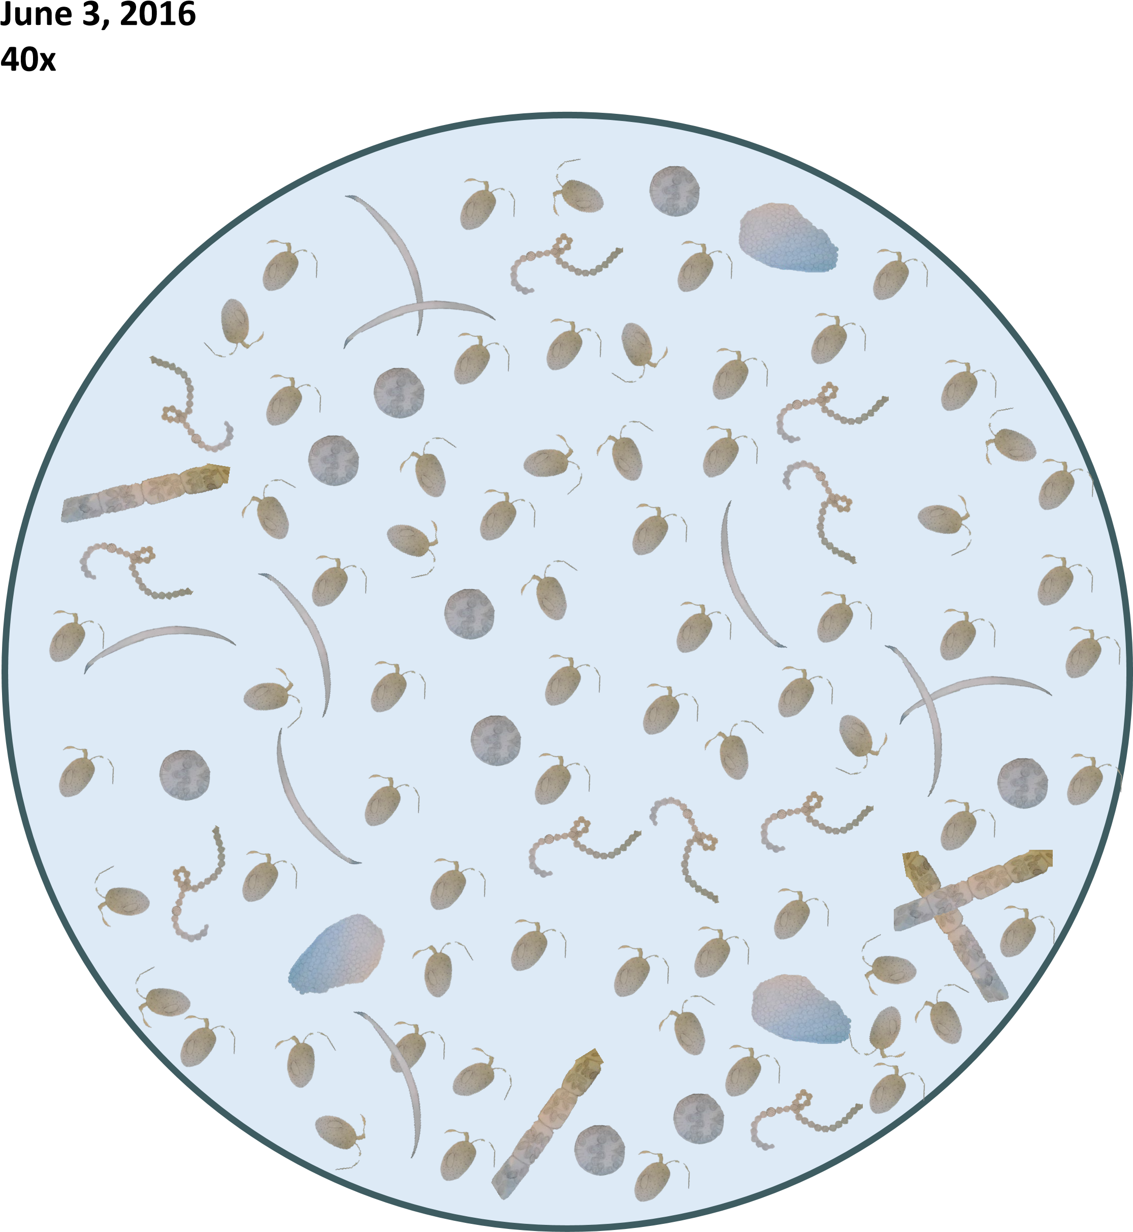

*Miller-DeBoer, C., & Shaffery, H. (2016). Lake Thunderbird 40x [Image].*

**Phytoplankton Community: Lake Stanley Draper**

**June 3, 2016**

**40x**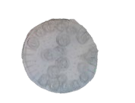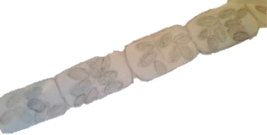

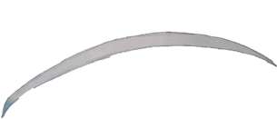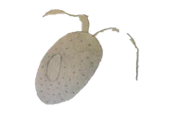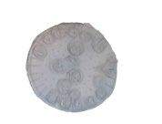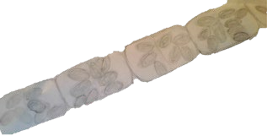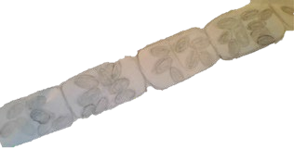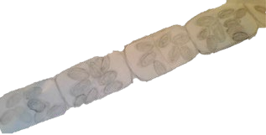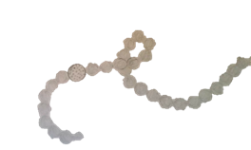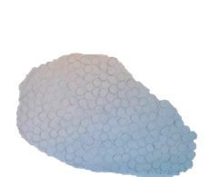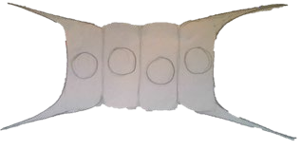

*Miller-DeBoer, C., & Shaffery, H. (2016). Lake Stanley Draper 40x [Image].*

**Phytoplankton Community: Shawnee Twin Lake #1**

**June 3, 2016**

**40x**

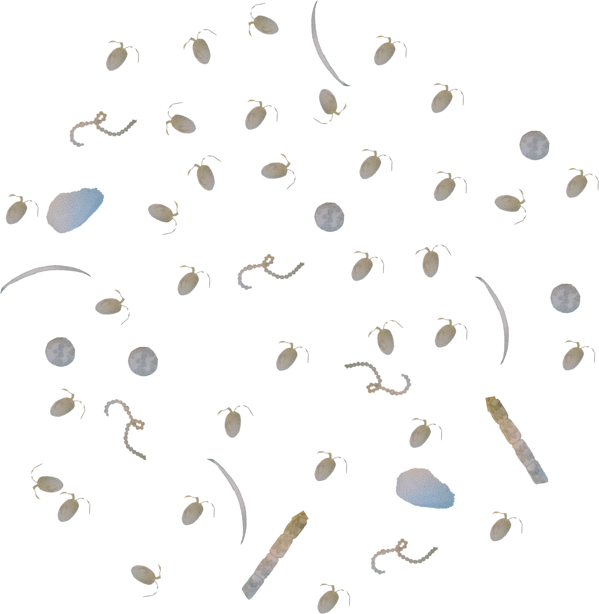

*Miller-DeBoer, C., & Shaffery, H. (2016). Shawnee Twin Lake #1 40x [Image].*

**Phytoplankton Community: Tecumseh Lake**

**June 3, 2016**

**40x**



*Miller-DeBoer, C., & Shaffery, H. (2016). Tecumseh Lake 40x [Image].*