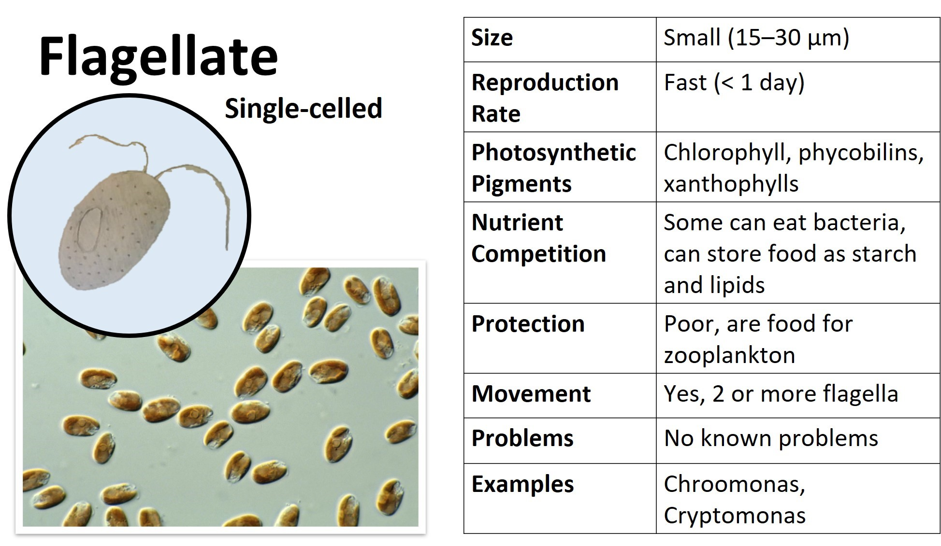

Image credit:
CSIRO. (2000, January 1). Microalgal cultures. CSIRO ScienceImage.
https://www.scienceimage.csiro.au/image/7234

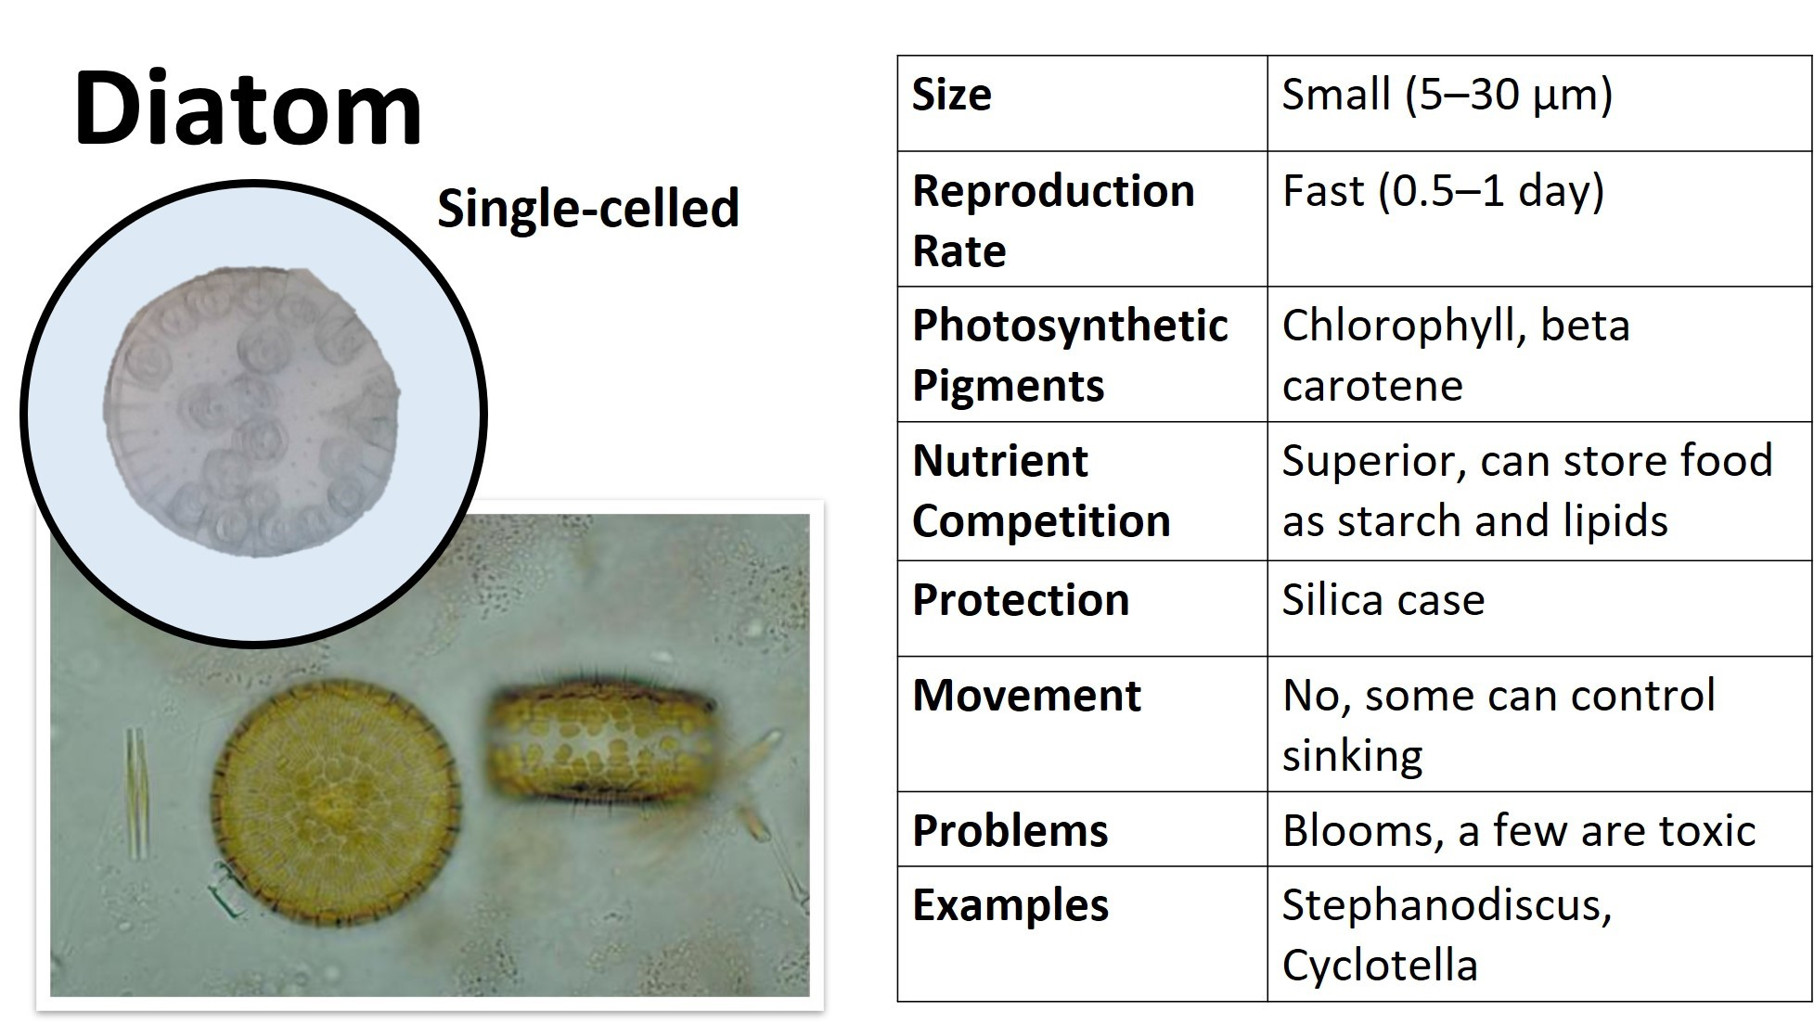

Image credit:
Canter-Lund, H. (2016). Stephanodiscus. Freshwater Biological Association.
http://www.environmentdata.org/archive/fbaia:3040

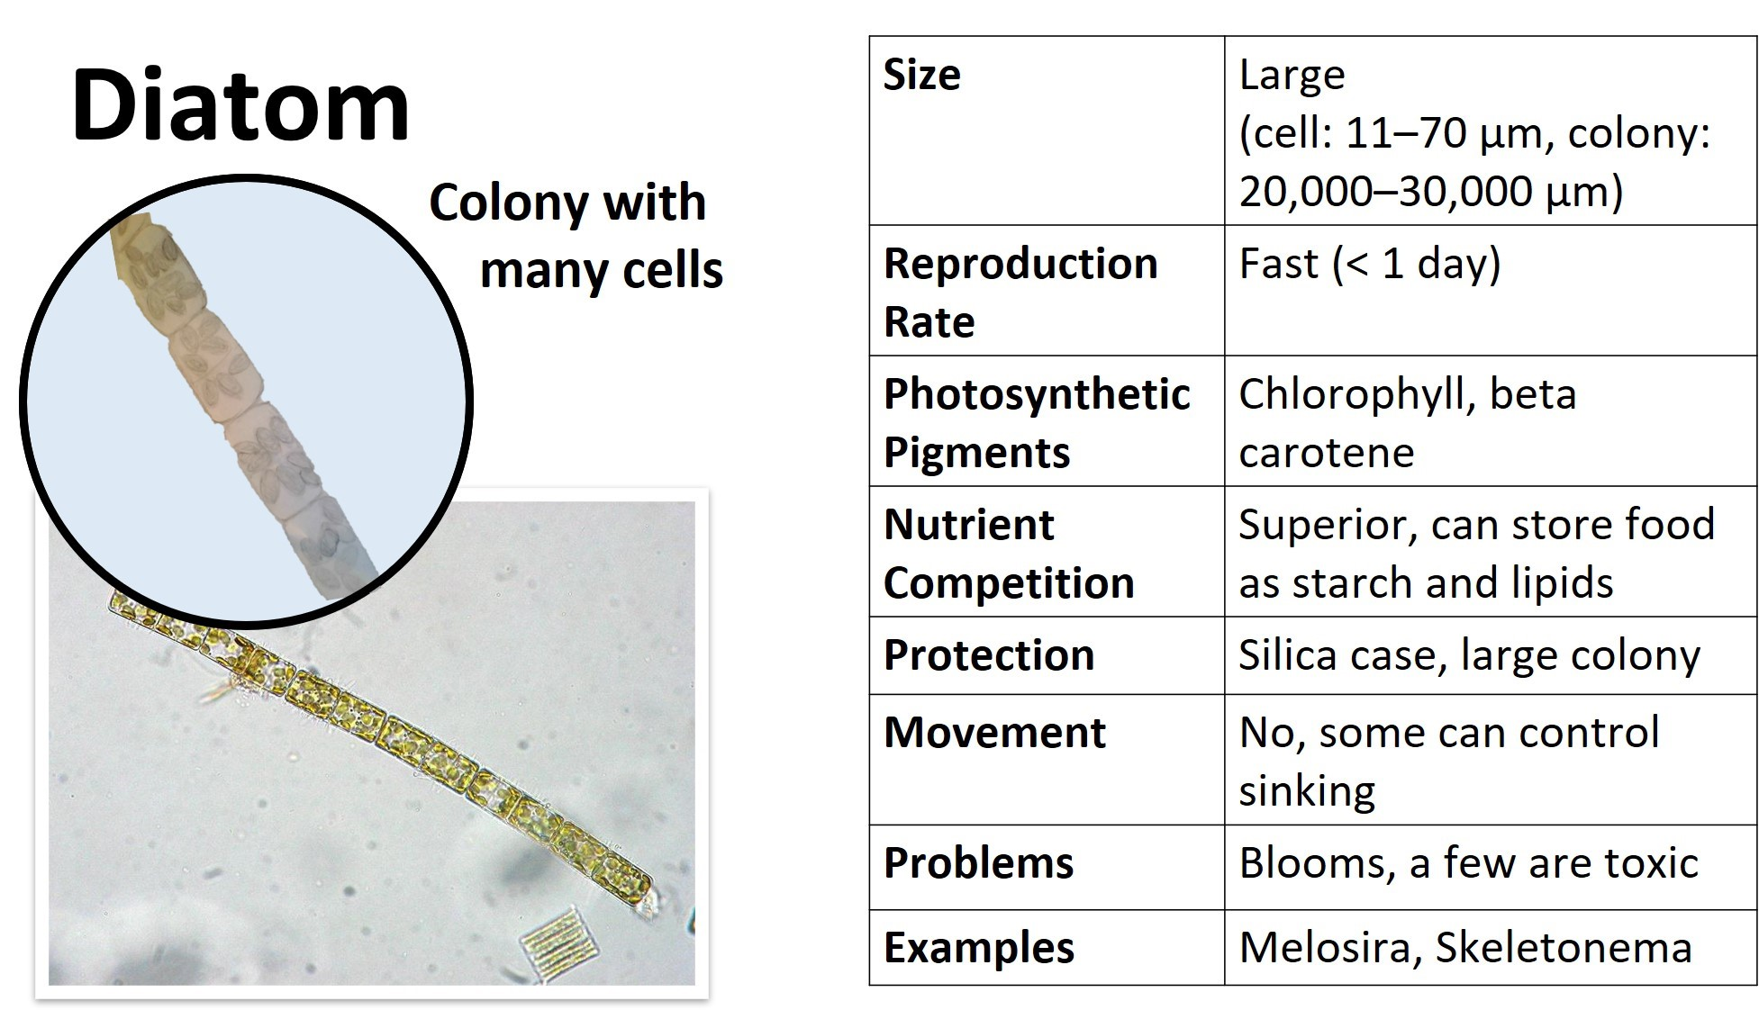

Image credit:
Peters, K. (2009). Melosira varians. Wikimedia Commons. https://commons.wikimedia.org/wiki/File:Melosira_varians.jpeg
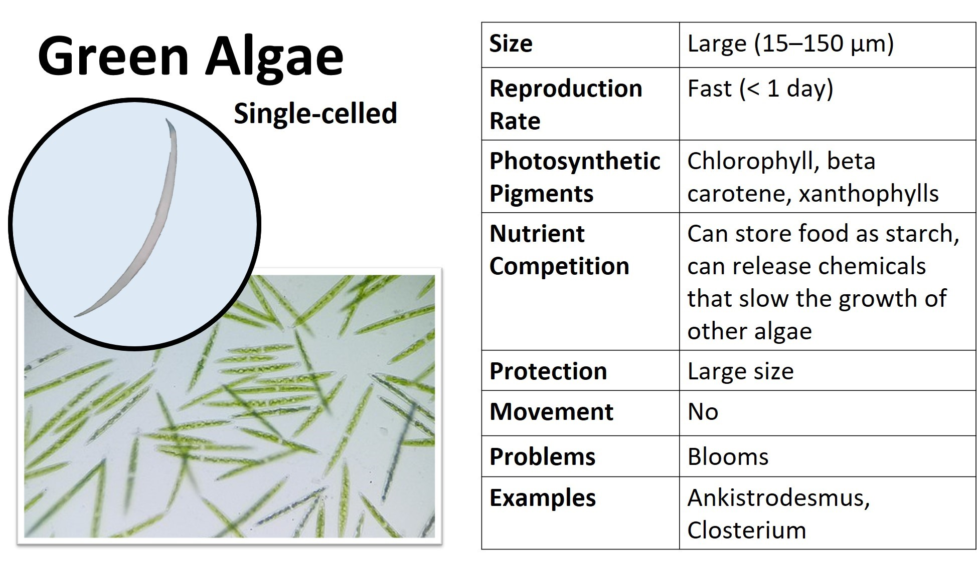

Image credit:
Fritzmann2002. (2017). Closterium under a light microscope. Wikimedia Commons. https://en.wikipedia.org/wiki/File:Closterium_under_a_light_microscope.jpg
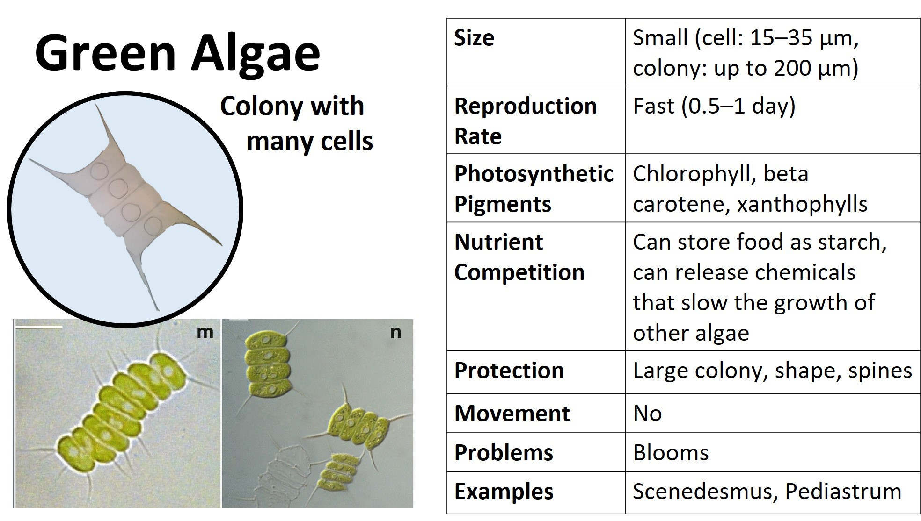

Image credit:
Lortou, U., & Gkelis, S. (2019). Polyphasic taxonomy of green algae strains isolated from Mediterranean freshwaters. Journal of Biological Research-Thessaloniki 26,11. https://doi.org/10.1186/s40709-019-0105-y
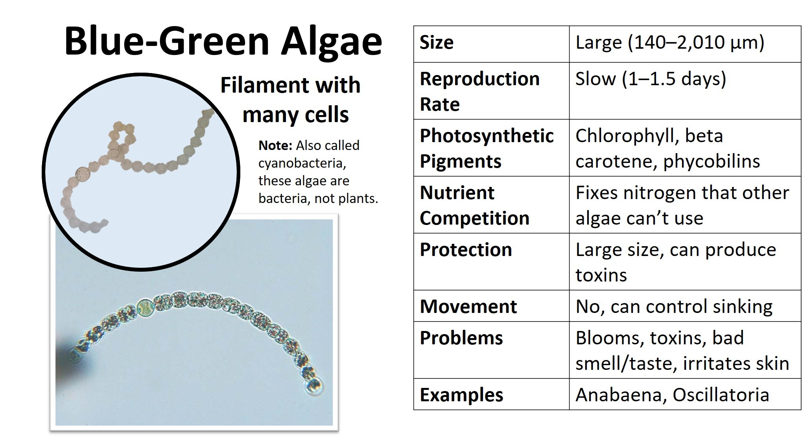

Image credit:
Bdcarl. (2012, April 13). Anabaena circinalis. Wikimedia Commons. https://commons.wikimedia.org/wiki/File:Anabaena_circinalis.jpg
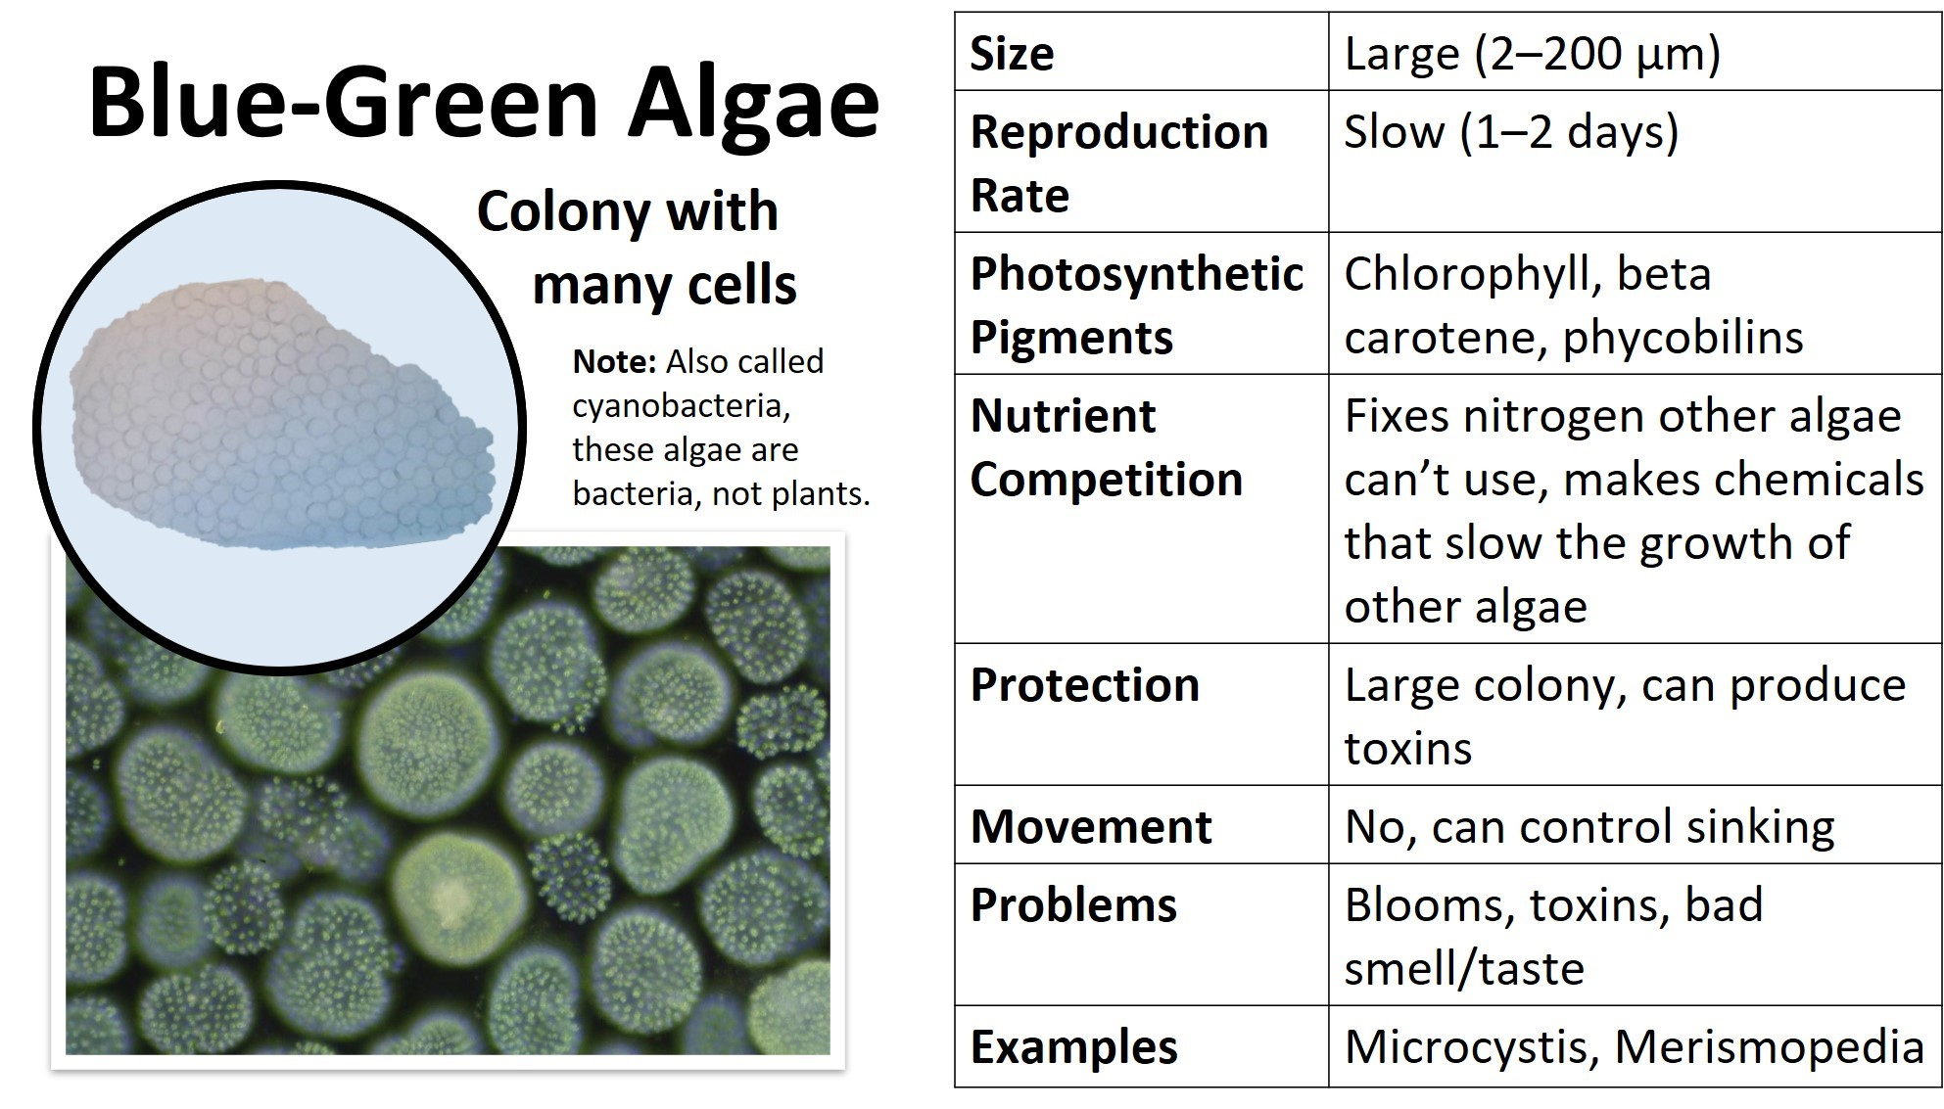

Image credit:
Specious Reasons. (2010, June 22). Serious bacterial bloom. Flickr. https://www.flickr.com/photos/28594931@N03/4726267363/

