Student Notebook (Print)

Four Lakes
These photographs show water from four different lakes in Central Oklahoma. The photos were all taken on the same day in July, about 30 or 45 minutes apart. The lakes are all within an area of about 300 km²; the greatest distance between two lakes is approximately 37 km.
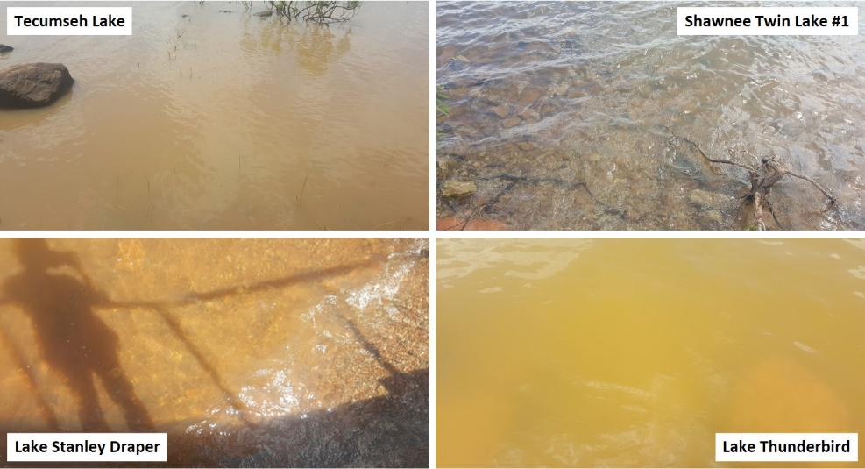

I Notice, I Wonder
I Notice... (Observations) | I Wonder... (Questions)

Four Lakes’ Phytoplankton Communities
Look at these sketches of phytoplankton samples from each of the four lakes, as seen under a microscope. There are many different types of phytoplankton; the ones shown here are some of the most common species found in Oklahoma lakes.
Lake Thunderbird
June 3, 2016
40x
Lake Stanley Draper
June 3, 2016
40x

Tecumseh Lake
June 3, 2016
40x
Shawnee Twin Lake #1
June 3, 2016
40x

I Notice, I Wonder
I Notice... (Observations) | I Wonder... (Questions)

Reflection Questions
- What patterns do you notice in the phytoplankton communities?

- If the number of phytoplankton increases, what do you think happens to water clarity?

- Remember that phytoplankton are plants. What things help plants grow?

Initial Phytoplankton Growth Model
Draw and label a diagram showing the direct and indirect cause-and-effect relationships among plant growth factors, number of phytoplankton, and water clarity.

Roles in Phytoplankton Communities
Use the Phytoplankton Cards to identify the types of phytoplankton in each lake. Then, count how many of each phytoplankton type are in each lake water sample.
 | Number of Phytoplankton in Lake Water Sample
Phytoplankton Type | Lake Thunderbird | Lake Stanley Draper | Shawnee Twin Lake #1 | Tecumseh Lake
Flagellate
Diatom (single cell)
Diatom (colony)
Green algae (single cell)
Green algae (colony)
Blue-green algae (filament)
Blue-green algae (colony)

Classifying Phytoplankton Based on Roles
Read the information on each card and pick one of the characteristics listed. Separate the phytoplankton into at least two groups based on the characteristic you picked.

Characteristic 1
- What characteristic did you choose?

- How do you think the characteristic you chose affects phytoplankton growth?

- Make a table with columns for each group you made based on your chosen characteristic. List all phytoplankton in each group under the designated column.

- Compare the phytoplankton in each category with the phytoplankton in each lake.
What patterns do you notice?

On the next page, choose a different characteristic listed on the cards and re-categorize the phytoplankton based on the new characteristic. Repeat this process twice.

Characteristic 2
- What characteristic did you choose? __________________________________________
- How do you think the characteristic you chose affects phytoplankton growth?

- Make a table with columns for each group you made based on your chosen characteristic. List all phytoplankton in each group under the designated column.

- Compare the phytoplankton in each category with the phytoplankton in each lake.
What patterns do you notice?

Characteristic 3
- What characteristic did you choose? __________________________________________
- How do you think the characteristic you chose affects phytoplankton growth?

- Make a table with columns for each group you made based on your chosen characteristic. List all phytoplankton in each group under the designated column.

- Compare the phytoplankton in each category with the phytoplankton in each lake.
What patterns do you notice?

Class Discussion Notes

Revised Phytoplankton Growth Model
Draw and label a diagram showing the direct and indirect cause-and-effect relationships among plant growth factors, number of phytoplankton, and water clarity. Use a different color of pencil or highlighter to show the changes you made to your initial model.

Phytoplankton Investigation
Choose one factor that causes phytoplankton to grow. How can you test this to see if it is true?

Investigation Question

How does ______________________________ affect phytoplankton growth?
(Write the factor you will test here.)

Investigation Prediction
Use your model to predict what will happen to the number of phytoplankton if the factor you are testing increases.

If _______________________________ increases, the number of phytoplankton
(Write the factor you will test here.)
will __________________________________.
(increase, decrease, stay the same)

Data Collection
- Fill in the blank line at the top of the second column with the factor you are testing.
- Measure and record the Secchi depth and any changes in the water’s color and smell every day. If the Secchi disk touches the bottom of the bottle and you can still see it, record your Secchi depth measurement as “bottom.”
Time (d) | _____________  Secchi Depth | Control Secchi Depth | Water Color | Water Smell
1 | bottom | bottom
2
3
4
5
6
7
8
9
10
11
12
13
14

Data Analysis
Make a line graph from your data, using one color for your factor and a different color for the control. In the graph title at the top, fill in the blank line with the factor you investigated.
Effect of ___________________ on Secchi Depth vs. Time
Time (days)
Secchi Depth (cm)

What changes did you observe in the water’s color and smell over time?

What other changes did you observe over time?

Claim
What do your results mean? Make a claim about how your factor affected the phytoplankton.

Increasing _______________________ caused the number of phytoplankton to
(Write the factor you tested here.)
_________________________ because the Secchi depth ____________________________
(increase, decrease, stay the same) (increased, decreased, stayed the same)
over ____________ days.
(number of days)

Expert Panel Discussion
- Join other groups that tested the same factor in the phytoplankton investigation. Record each group’s Secchi depth data in the table below.
- Enter only numerical measurements; if any data point is “bottom,” leave that cell blank.
- For each day, calculate your groups’ average Secchi depth. Record it in the final column.
Time (d) | Group 1 | Group 2 | Group 3 | Group 4 | Group 5 | Avg. Secchi Depth (cm)
1
2
3
4
5
6
7
8
9
10
11
12
13
14

Group Data Analysis
Make a line graph from your average Secchi depth data. Fill in the blank line with your factor.
Effect of ___________________ on Average Secchi Depth vs. Time
Time (days)
Average Secchi Depth (cm)

Group Claims
As a group, agree on a claim that answers your investigation question: “How does the factor you tested affect phytoplankton growth?”
Increasing _______________________ caused the number of phytoplankton to
(Write the factor you tested here.)
_________________________ because the Secchi depth ____________________________
(increase, decrease, stay the same) (increased, decreased, stayed the same)
over ____________ days.
(number of days)

Now, as a group, compare your phytoplankton classifications.
- What patterns do you notice among the phenotypes?

- Make a few claims about these patterns.

Class Concept Map

Revised Phytoplankton Growth Model
Draw and label a diagram showing the direct and indirect cause-and-effect relationships among plant growth factors, number of phytoplankton, and water clarity. Use a different color of pencil or highlighter to show any new changes you made to your model.

Evaluate Your Phytoplankton Growth Model

Predict
Using your phytoplankton growth model and what you know about the four Oklahoma lakes, make a prediction about the factors that affect phytoplankton growth for each lake.
In Lake Thunderbird, _____________________ is _______________.
(nutrient or other factor) (average, high, low)
In Lake Stanley Draper, _____________________ is _______________.
(nutrient or other factor) (average, high, low)
In Shawnee Twin Lake #1, _____________________ is _______________.
(nutrient or other factor) (average, high, low)
In Tecumseh Lake, _____________________ is _______________.
(nutrient or other factor) (average, high, low)

Analyze
Compare and contrast the parts of your phytoplankton growth model with the claims and ideas in the OWRB lake data reports.

Model
Reports

Are there any elements of your phytoplankton growth model you would revise based on your evaluation and analysis?

Compare your predictions with the data in each report. How well did your predictions match the actual data?
My prediction for Lake Thunderbird ____________ match the actual data because
(did, did not)
_______________________________________________________________________.

My prediction for Lake Stanley Draper ____________ match the actual data because
(did, did not)
_______________________________________________________________________.

My prediction for Shawnee Twin Lake #1 ____________ match the actual data because
(did, did not)
_______________________________________________________________________.

My prediction for Tecumseh Lake ____________ match the actual data because
(did, did not)
_______________________________________________________________________.

