Extend Station Cards
Print one copy of the cards and place them at stations around the room. See notes on LEARN for suggested modifications for class size.

Station 1 (p. 2–3)
- Marine Heat Waves
- Effect of Heat on Photosynthesis

Station 2 (p. 4–5)
- Climate Change Infographic (print in color, if possible)
- Impacts of Climate Change

Station 3 (p. 6)
- Nutrient Pollution

Station 4 (p. 7)
- Algal Blooms

Station 5 (p. 8)
- Light, Ultraviolet Radiation, Photosynthesis, and Coral

Marine Heat Waves
Heat waves are prolonged periods of unusually high temperatures. Just like the land, the ocean also experiences heat waves (i.e., marine heat waves). Because coral are highly sensitive to thermal changes, marine heat waves pose serious threats to coral reefs.
For instance, in the summer of 2022, coral bleaching occurred in some parts of the Great Barrier Reef just from an increased average temperature of 0.4°C (0.72°F). This is because tropical coral live close to their upper thermal limit. Therefore, even a small increase in water temperature can lead to coral bleaching.
Coral’s thermal sensitivity makes them especially vulnerable to the effects of global warming and climate change. As the global climate system warms, so do the tropical oceans. Thus, scientists predict that even if global warming stays within the limit of 1.5°C (2.7° F)—as targeted by the Paris Agreement—coral reefs of the future will not look the same as they did in the past.
Effects on algae
Thermal stress also harms coral by disturbing their symbiotic partner: the algae. In normal circumstances, photosynthetic products from algae help coral regenerate calcium carbonate skeletons faster than they erode (a process called calcification). Sustainable calcification is important for coral because their skeletons provide habitats for thousands of reef organisms. Hence, when temperatures stress the symbiosis between coral and algae, organisms who inhabit the coral are also affected, and the whole ecosystem is disturbed.
Algae also provide coral with their vibrant colors through their photosynthetic pigments. When temperatures stress the algae, the coral tissues turn into a translucent color. When this happens, the coral’s white skeletons become visible, making the coral look bleached—hence the term “coral bleaching”. Due to the effects of global warming on reef temperatures, coral bleaching happens more often recently.
The aftermath of thermal stress: Thermal stress impacts the coral even after the temperature cools down. Corals who survive the thermal stress may have reduced reproduction rates, slowed growth rates, and increased susceptibility to coral diseases. On the other hand, corals who don’t survive have their remains overgrown by macroalgae (like seaweeds) before they erode and break down. These changes in the community make-up may disturb the ecosystem through, for instance, altering the level of fish abundance.
References
Australian Associated Press. (2022). Reef report diagnoses coral bleach cause. Yahoo! News. https://web.archive.org/web/20220511193019/https://au.news.yahoo.com/delayed-barrier-reef-report-imminent-050140185.html
Lough, J. M., Anderson, K. D., & Hughes, T. P. (2018). Increasing thermal stress for tropical coral reefs: 1871-2017. Scientific Reports 8, 6079. https://doi.org/10.1038/s41598-018-24530-9
National Oceanic and Atmospheric Administration. (2019). So what are marine heat waves?. NOAA Research News. https://research.noaa.gov/article/ArtMID/587/ArticleID/2559/So-what-are-marine-heat-waves

Effect of Heat on Photosynthesis
Plants need a specific temperature range to photosynthesize. This range varies among organisms and environments. Some plants, like those who live in places where temperatures fluctuate naturally, adapt better to temperature changes. However, in most places (including coral reefs), big changes in temperatures make photosynthesis less efficient. When photosynthetic productivity is reduced, plants produce less food for coral to feed on.
Heat stress can also make photosynthesis less efficient by:
- Causing damage to light-absorbing proteins
- Changing the regulation of gene expression in photosynthesis pathways
- Stimulating productions of reactive oxygen species (also referred to as ROS) like peroxide, which can be harmful to the organism when produced excessively
- Decreasing production of enzymes that break down ROS
Although not all corals suffer from elevated temperatures, many do. When coral experience heat stress, photosynthesis rates from their symbiotic algae become significantly reduced. In some cases, the lack of photosynthetic products from the algae forces coral to acquire most of their food from external sources. Relying on external food sources is unnatural for corals.
Some species of algae respond poorly to fluctuating temperatures. For those species, heat stress can lead them to produce hydrogen peroxide (H₂O₂) and other ROS during photosynthesis. A high level of ROS is toxic to plant cells and is suspected to be involved in coral bleaching events.
References
Encyclopedia of the Environment (2021, September 27). Effects of temperature on photosynthesis. Encyclopedia of the Environment. Retrieved September 13, 2022, from https://www.encyclopedie-environnement.org/en/life/effects-temperature-on-photosynthesis/
Schoepf, V., Sanderson, H., & Larcombe, E. (2022) Coral heat tolerance under variable temperatures: Effects of different variability regimes and past environmental history vs. current exposure. Limnology and Oceanography 67, 408-418. https://aslopubs.onlinelibrary.wiley.com/share/F4GAUR9RN83FKAZ6NFQ6?target=10.1002/lno.12000
Song, Y., Chen, Q., Ci, D., Shao, X., & Zhang, D. (2014) Effects of high temperature on photosynthesis and related gene expression in poplar. BMC Plant Biology, 14(111). https://bmcplantbiol.biomedcentral.com/articles/10.1186/1471-2229-14-111
Suggett, D. J., Warner, M. E., Smith, D. J., Davey, P., Hennige, S., & Baker, N.R. (2008). Photosynthesis and production of hydrogen peroxide by symbiodinium (pyrrhophyta) phylotypes with different thermal tolerances. Journal of Phycology, 44 (4), 948-956. https://onlinelibrary.wiley.com/share/UBBBJNEMIPXYF6RU5BPV?target=10.1111/j.1529-8817.2008.00537.x

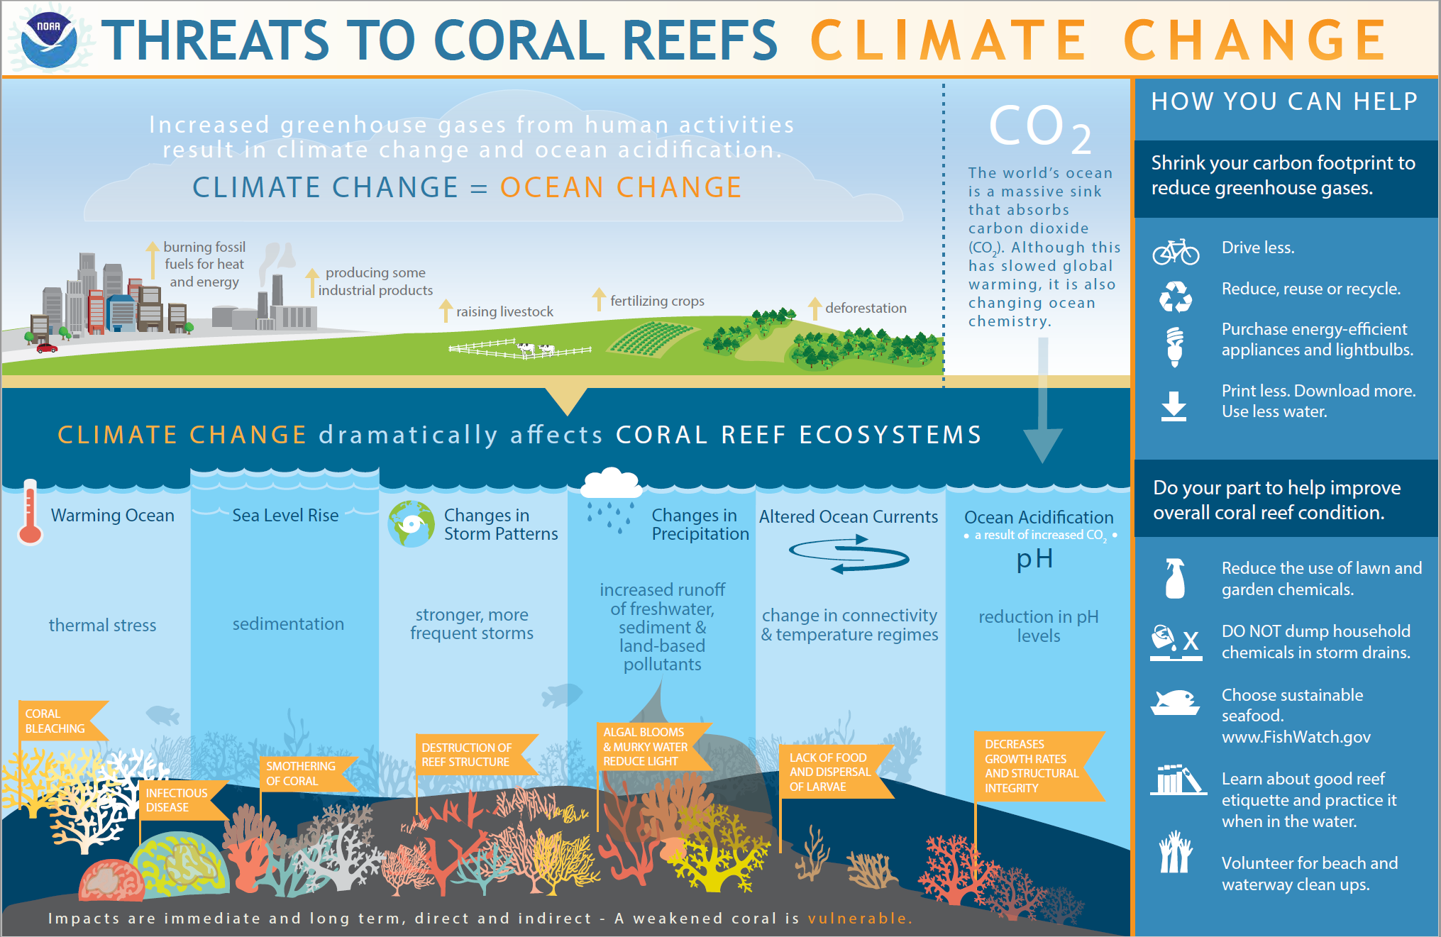
References
National Ocean Service. (2021, February 26). How does climate change affect coral reefs?. National Ccean Service. https://oceanservice.noaa.gov/facts/coralreef-climate.html

Impacts of Climate Change
As humans burn more fossil fuels, raise more livestock, cut down more forests, and produce more industrial products, the amount of carbon dioxide in the air consequently increases. Being a greenhouse gas, too much carbon dioxide in the air contributes to climate change.
Climate change threatens coral reefs in several ways:
Sea level and sedimentation: Rising sea level may increase sedimentation for reefs located near lands with sources of sediment. Sedimentation runoff may make it difficult for coral to breathe and eventually kill them.
A warming ocean: Thermal stress contributes to coral bleaching and infectious disease. The “Marine Heat Wave” station discusses this in more detail.
Storms: As the climate changes, so do the storm patterns. Stronger and more frequent storms may destroy coral reefs.
Changes in precipitation: More rain means more freshwater runoffs. The runoffs carry more sediment and land-based pollutants to the ocean. Nutrient pollutants that are carried to the ocean lead to algal blooms, causing water in coral reefs to become murkier and therefore blocking sunlight from reaching the coral (more information on the “Algal Blooms” station).
Altered ocean currents: Changes in ocean currents alter the connectivity between organisms, which disturbs the equilibrium of coral reef ecosystems. Altered ocean currents also change how temperature regimes move along the ocean. These changes may affect the availability of food for coral. Finally, changes in currents may also prevent coral larvae (coral offspring) to be distributed properly in a body of water, which means that coral reproduction is disturbed.

Ocean acidification: The ocean absorbs a massive amount of carbon dioxide from the air, reducing the amount of greenhouse gases in the air. While this has slowed global warming, absorbing too much carbon dioxide also changes the ocean’s chemistry. Ocean acidification happens when the ocean’s level of pH drops, which decreases coral growth and structural integrity.
References
National Ocean Service. (2021). What is eutrophication?. National Oceanic and Atmospheric Administration. https://oceanservice.noaa.gov/facts/eutrophication.html

Nutrient Pollution
Nutrient runoffs reach the ocean from various sources, such as agricultural chemicals (like fertilizers) that got washed up into the river or from partially untreated sewage, among other sources. When nutrients pollute coral reefs, coral become more susceptible to diseases. There are several ways nutrients can act as pollutants for coral:
- When nutrients act as pathogens for the coral (e.g., a pathogenic fungus called Aspergillus sydowii)
- When nutrients provide the nutrients needed by pathogens to grow
- When nutrients are toxic to coral (e.g., metals and pesticides from industrial discharges)

Nutrient pollution and eutrophication
Nutrients can also pollute coral reefs through a process called eutrophication, which is when excessive nutrient pollution causes a dense growth of plants and algae in a water area (the “Algal Blooms” station discusses this in more detail).

Managing nutrient pollution
Unlike other threats to coral (like global warming), nutrient pollution is more manageable to resolve. Some practical solutions to this issue might include improved sewage treatment or minimizing fertilizer runoff from agricultural and urban areas.
Research showed that coral can recover completely and relatively fast once nutrient pollutants are removed from the environment. This finding suggests that intervention programs to clean coral reefs from pollutants are effective and crucial.
References
National Research Council. (2000). What are the effects of nutrient over-enrichment? Clean coastal waters: Understanding and reducing the effects of nutrient pollution (84–112). The National Academic Press.
Oregon State University (2013, November 26). Large study shows pollution impact on coral reefs, and offers solution. ScienceDaily. https://www.sciencedaily.com/releases/2013/11/131126092656.htm
United States Environmental Protection Agency. (2022, April 13). Threats to coral reefs. United States Environmental Protection Agency. https://www.epa.gov/coral-reefs/threats-coral-reefs

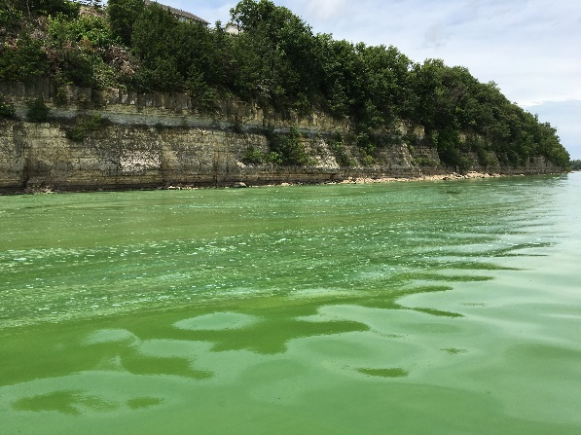
Algal Blooms
A process called eutrophication happens when a body of water has excessive amounts of nutrient pollutants. When nutrient pollutants like nitrogen and phosphorus become excessive in a water area, plants and algae grow densely. The algal overgrowth typically turns the water green and turbid—hence “algal blooms” occur.

Algal blooms disturb photosynthesis
Excessive growth of plants and algae creates hazy layers of water in the ecosystem, which blocks sunlight from entering the body of water. Without enough sunlight, the beneficial algae inside the coral cannot create enough photosynthetic products for corals to feed on. Consequently, coral may starve and die.
Harmful algal blooms turn water in Milford Lake emerald green (Graham, 2016)

Algal blooms deplete water of oxygen
Algal blooms also disturb coral reefs through decomposition. When algae and plant matters die, they decompose. In the process of decomposing, decomposers consume a lot of oxygen and produce a large amount of carbon dioxide. When an ecosystem has too much carbon dioxide but too little oxygen, organisms that rely on oxygen to thrive, such as fish and coral, die.

Harmful algal blooms
Some species of algae also disturb the coral reef ecosystem by clogging fish gills, producing toxins, and reducing the overall water quality. Scientists refer to the blooming of these certain species as “harmful algal blooms”.
References
Iraola, N. (2018, March 22). Are harmful algal blooms a new concern for coral reefs?. Envirobites. https://envirobites.org/2018/03/22/are-harmful-algal-blooms-a-new-concern-for-coral-reefs/
Graham, J. L. (2016, July 14). Harmful algal blooms turn water in Milford Lake emerald green [Photograph]. U.S. Geological Survey. https://www.usgs.gov/media/images/harmful-algal-blooms-turn-water-milford-lake-emerald-green
National Ocean Service (2021). What is eutrophication?. National Oceanic and Atmospheric Administration. https://oceanservice.noaa.gov/facts/eutrophication.html

Light, Ultraviolet Radiation, Photosynthesis, and Coral

Depleting ozone and UVR light
Scientists found that some manmade chemicals, like chlorine and bromine, can deplete ozone layers when released into the air. The depletion of ozone layers allows more ultraviolet radiation (UVR) from the sun to enter the earth. Too much UVR can be detrimental not only to humans but also to coral reefs.

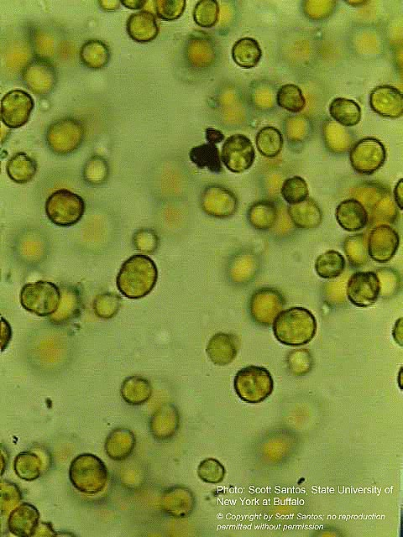
UVR disturbs photosynthesis in coral reefs
UVR harms coral reefs by disturbing tiny algae cells called zooxanthellae which live inside most types of corals. Zooxanthellae produce molecules that help coral absorb light for photosynthesis, and they also produce molecules that act like a “sunscreen” when coral are exposed to UVR. These “sunscreen” molecules are beneficial to corals as they protect coral from UVR damage. However, when coral get overexposed to UVR, zooxanthellae end up producing too much of the “sunscreen” molecules, which makes their photosynthesis becomes less efficient. With less photosynthesis products, coral starve.
In the event of coral bleaching where corals turn translucent, the light inside their skeletons gets too intense for the zooxanthellae (and even more so in higher temperatures). These environmental stressors for zooxanthellae can permanently alter the cells’ capacity to photosynthesize, which further disturbs coral’s source of food.
Furthermore, high levels of UVR also directly damage proteins involved in photosynthesis and produce molecules that damage photosynthetic structures.
Tiny plant cells called zooxanthellae living within most types of coral polyps (NOAA, 2017)
References
National Oceanic and Atmospheric Administration. (2006). What emissions from human activities lead to ozone depletion? National Ocean Service. https://csl.noaa.gov/assessments/ozone/2006/chapters/Q7.pdf
National Oceanic and Atmospheric Administration. (2017). Zooxanthellae, coral tutorial. National Ocean Service. https://oceanservice.noaa.gov/education/tutorial_coral/coral02_zooxanthellae.html

