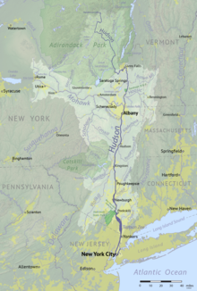
Background Information About the Hudson River
The Hudson River is a 315-mile (507 km) river that flows from north to south primarily through eastern New York in the United States. The river originates in the Adirondack Mountains of Upstate New York, flows southward through the Hudson Valley to the Upper New York Bay between New York City and Jersey City. It eventually drains into the Atlantic Ocean at New York Harbor. The river serves as a political boundary between the states of New Jersey and New York at its southern end. Further north, it marks local boundaries between several New York counties. The lower half of the river is a tidal estuary, deeper than the body of water into which it flows, occupying the Hudson Fjord, an inlet which formed during the most recent period of North American glaciation, estimated at 26,000 to 13,300 years ago. Tidal waters influence the Hudson's flow from as far north as the city of Troy (near Albany).
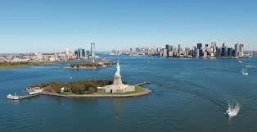
https://en.wikipedia.org/wiki/Hudson_River#/media/File:Hudson_river_basin_map.png
https://www.hudsonriver.org/article/nycef
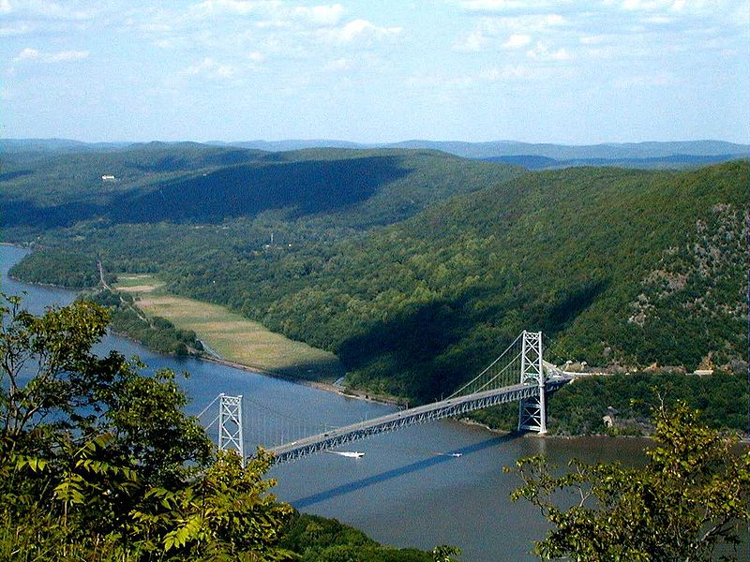
https://en.wikipedia.org/wiki/Hudson_River#/media/File:Bear_Mtn_Bridge.jpg

Background Information About the Sargasso Sea
The Sargasso Sea is a region of the Atlantic Ocean bounded by four currents forming an ocean gyre. A gyre is any large system of circulating ocean currents, particularly those involved with large wind movements. Unlike all other regions called seas, it has no land boundaries. It is distinguished from other parts of the Atlantic Ocean by its characteristic brown Sargassum seaweed and often calm blue water.
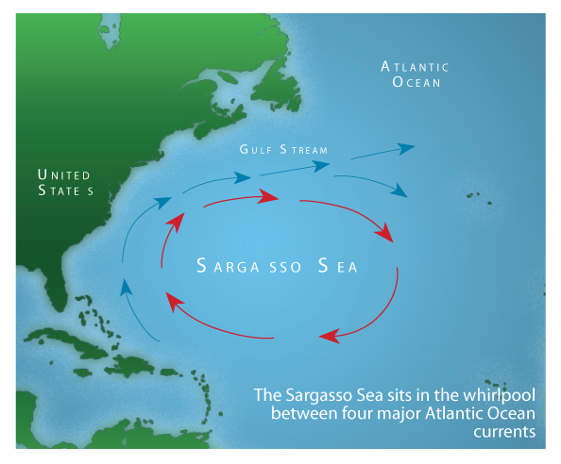
The Sargasso sea is bounded on the west by the Gulf Stream, on the north by the North Atlantic Current, on the east by the Canary Current, and on the south by the North Atlantic Equatorial Current, a clockwise-circulating system of ocean currents termed the North Atlantic Gyre. All of the currents deposit the marine plants and refuse which they are carrying into this sea, yet the ocean water in the Sargasso Sea is distinctive for its deep blue color and exceptional clarity, with underwater visibility of up to 61 m (200 ft). It is also a body of water that has captured the public imagination, and so is seen in a wide variety of literary and artistic works and in popular culture.
https://geography.name/sargasso-sea/
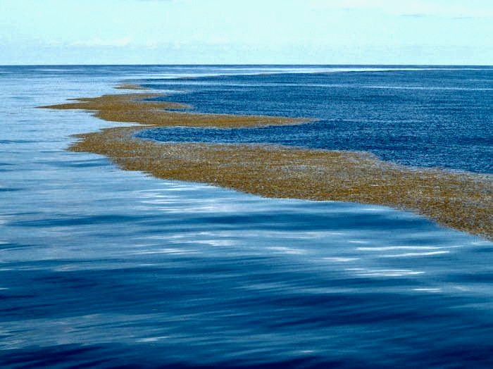
https://mysteriesrunsolved.com/2020/03/sargasso-sea.html

Background Information About the St. Marys River
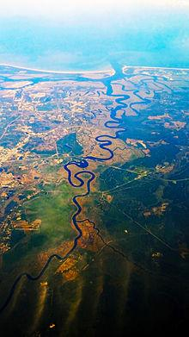
The St. Marys River (sometimes misspelled as St. Mary's River) is a 126-mile-long (203 km) river in the southeastern United States. From near its source in the Okefenokee Swamp, to its mouth at the Atlantic Ocean, it forms a portion of the border between the U.S. states of Georgia and Florida. The river also serves as the southernmost point in the state of Georgia.
The St. Marys River rises as a tiny stream, River Styx, flowing from the western edge of Trail Ridge, the geological relic of a barrier island/dune system, and into the southeastern Okefenokee Swamp. Arching to the northwest, it loses its channel within the swamp, then turns back to the southwest and reforms a stream, at which point it becomes the St. Marys River. Joined by another stream, Moccasin Creek, the river emerges from Okefenokee Swamp at Baxter, Florida/Moniac, Georgia. It then flows south, then east, then north, then east-southeast, finally emptying its waters into the Atlantic, near St. Marys, Georgia and Fernandina Beach, Florida.
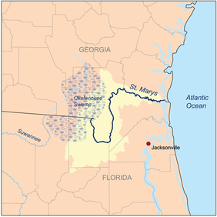
Both images: https://en.wikipedia.org/wiki/St._Marys_River_(Florida%E2%80%93Georgia)

Background Information About Lake Erie
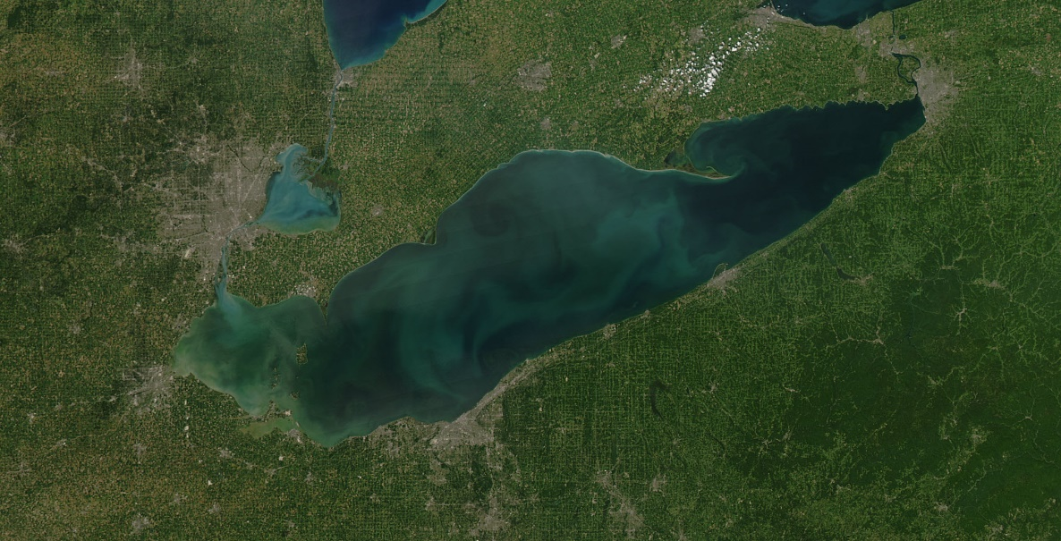
Lake Erie is the fourth-largest lake (by surface area) of the five Great Lakes in North America, and the eleventh largest globally if measured in terms of surface area. Its northern borders are the province of Ontario, Canada, and the U.S. states of Michigan, Ohio, Pennsylvania, and New York may be found along its western, southern, and eastern shores. It lies within a densely populated area. These jurisdictions divide the surface area of the lake with water boundaries. It is the southernmost, shallowest, and smallest by volume of the Great Lakes, and therefore also has the shortest average water residence time of 2.6 years (how long it takes the water in Lake Erie to move from one end to the other). At its deepest point Lake Erie is 210 feet (64 meters) deep. Lake Erie's water level fluctuates with the seasons as in the other Great Lakes. Generally, the lowest levels are in January and February, and the highest in June or July, although there have been exceptions.
https://www.lakescientist.com/research-summary-lake-eries-ecological-history-recorded-by-phytoplankton/
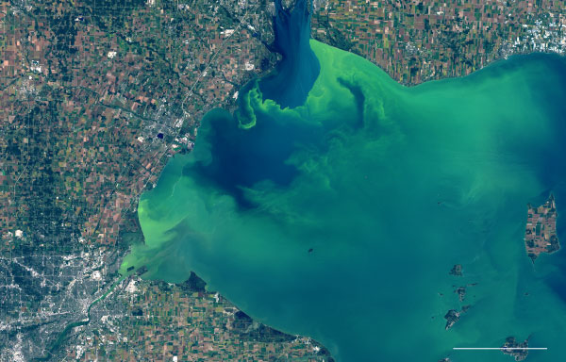
https://www.nytimes.com/interactive/2017/10/03/science/earth/lake-erie.html

