Kermit the Frog
Kermit the frog was a summer guest in a high school classroom in Norman, OK. While in the classroom, he was fed regularly and temporarily lived in a 13 cm² acrylic cube filled with clean bottled Spring Water. The bottom of his cube was filled with gravel and smooth colored stones.
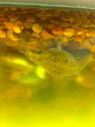
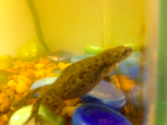
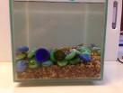
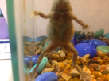
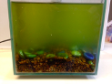
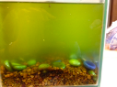
Observe what happened to the color of the water over the one-month period he was visiting the classroom. Don’t worry, Kermit was not neglected! Despite how it looks to us, the water in Kermit’s natural habitat often looks like this in the summer.

June 22nd June 29th

July 6th July 13th

Why is the water turning green?

