Bat Cards (Front)

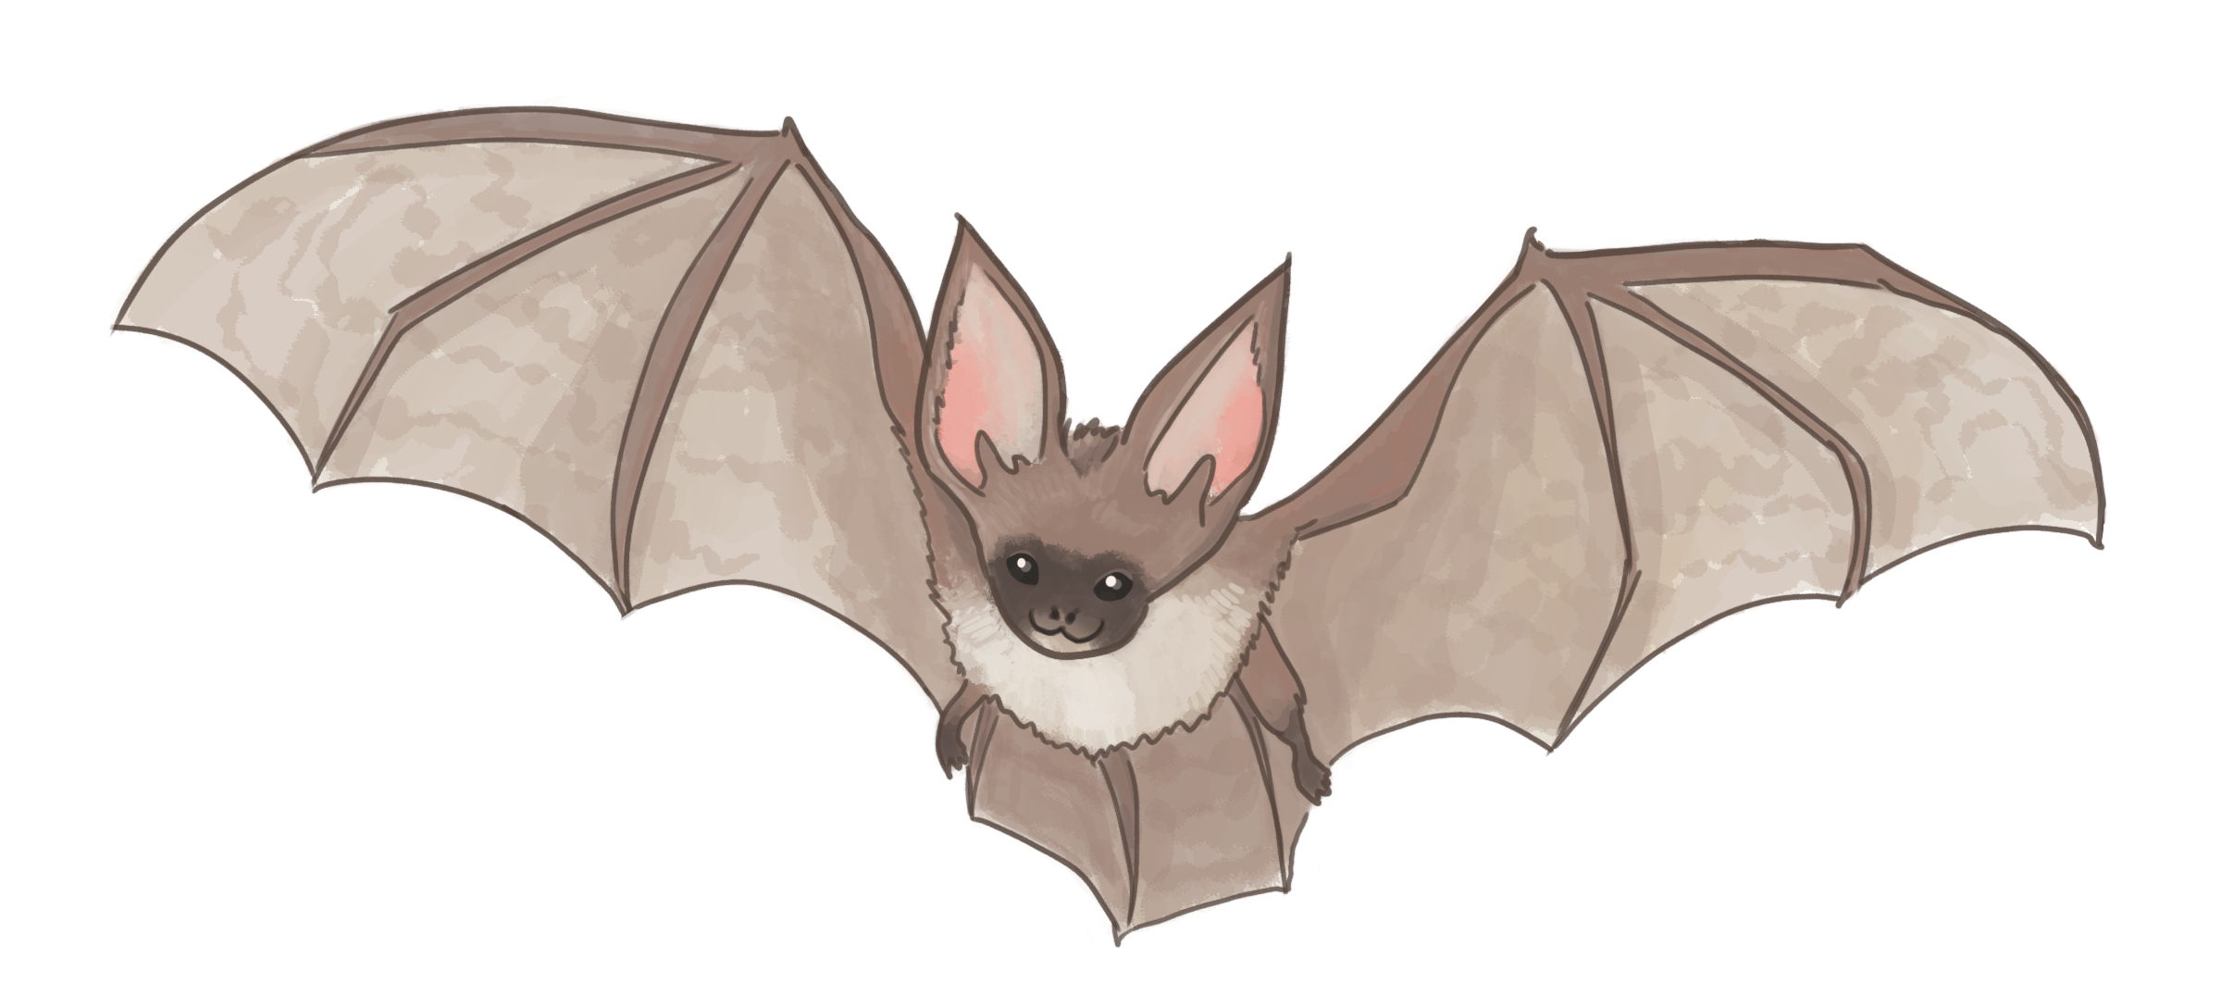

Bat Cards (Back)

20 kHz | 40 kHz
60 kHz | 80 kHz

