Cheques en blanco

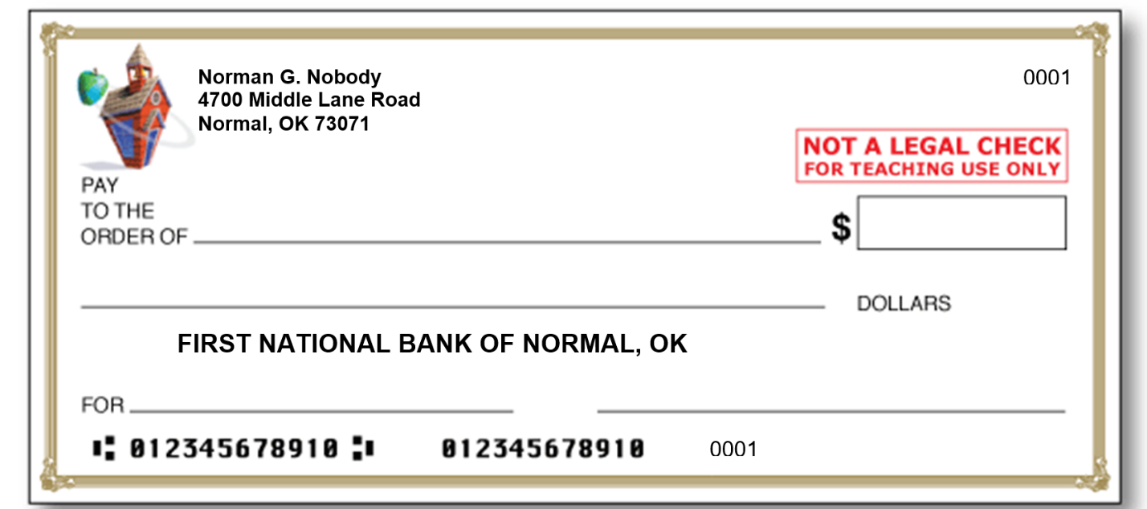

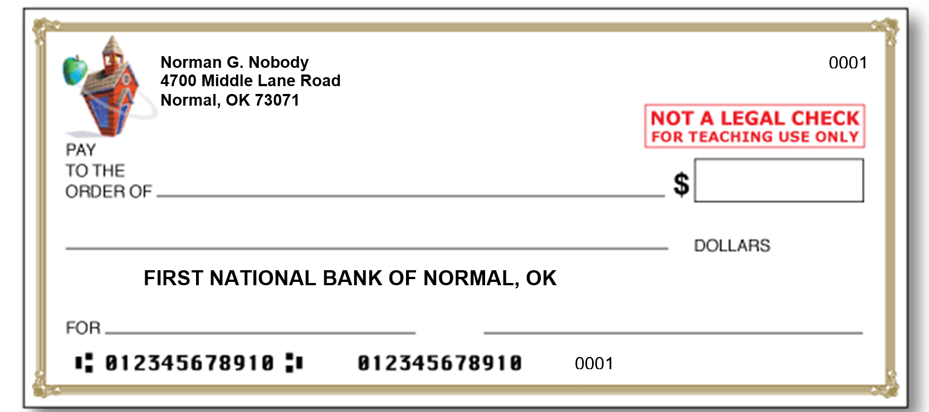

Adaptado de Education World (sin fecha). Blank check template [Imagen]. Education World. https://www.educationworld.com/tools_templates/template_kid_check.doc

