Blank Checks

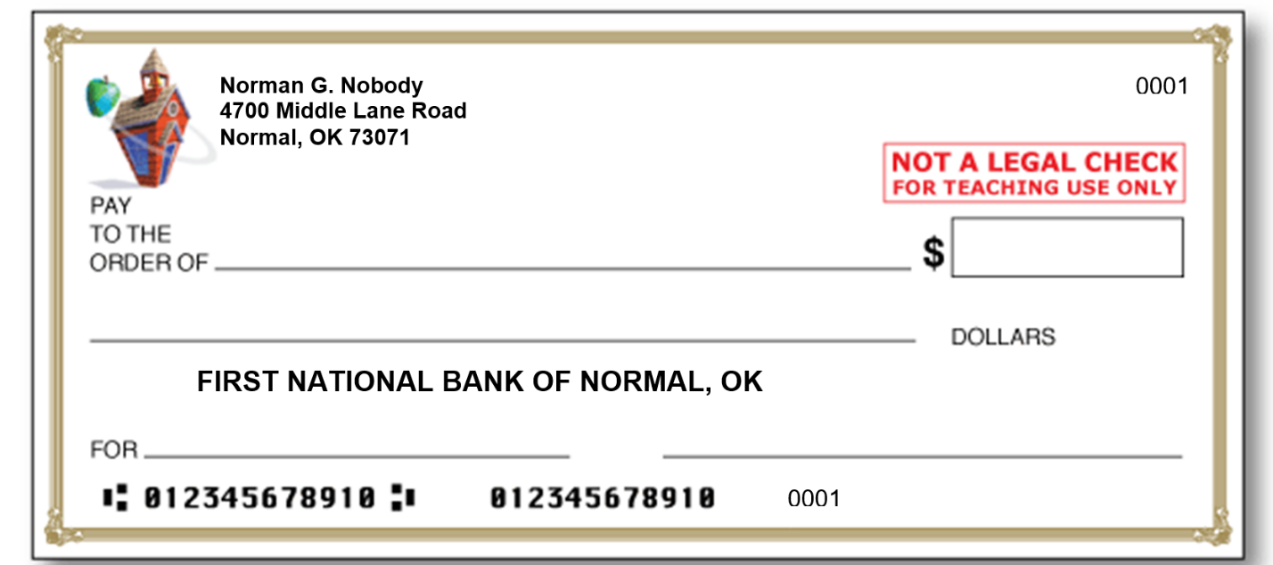

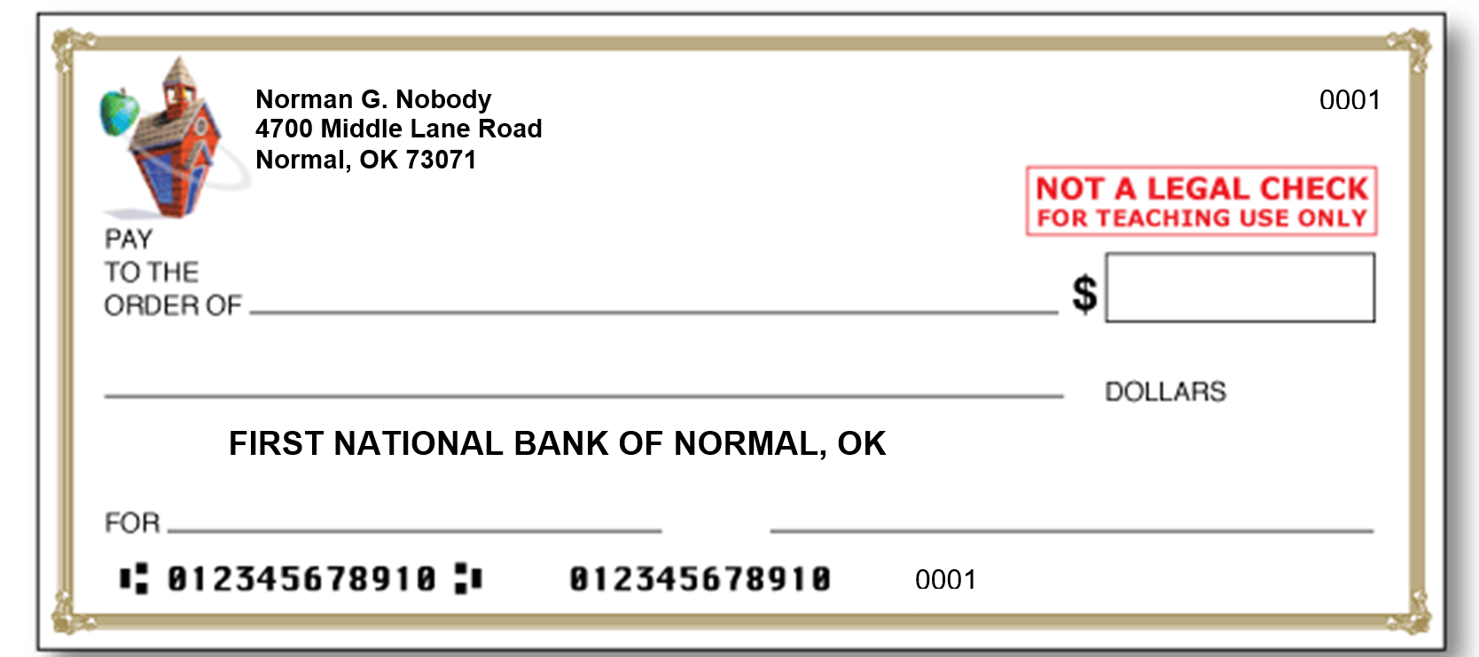

Adapted from Education World. (n.d.). Blank check template [Image]. Education World. https://www.educationworld.com/tools_templates/template_kid_check.doc

