THE HISTORY OF BRICKTOWN MURAL
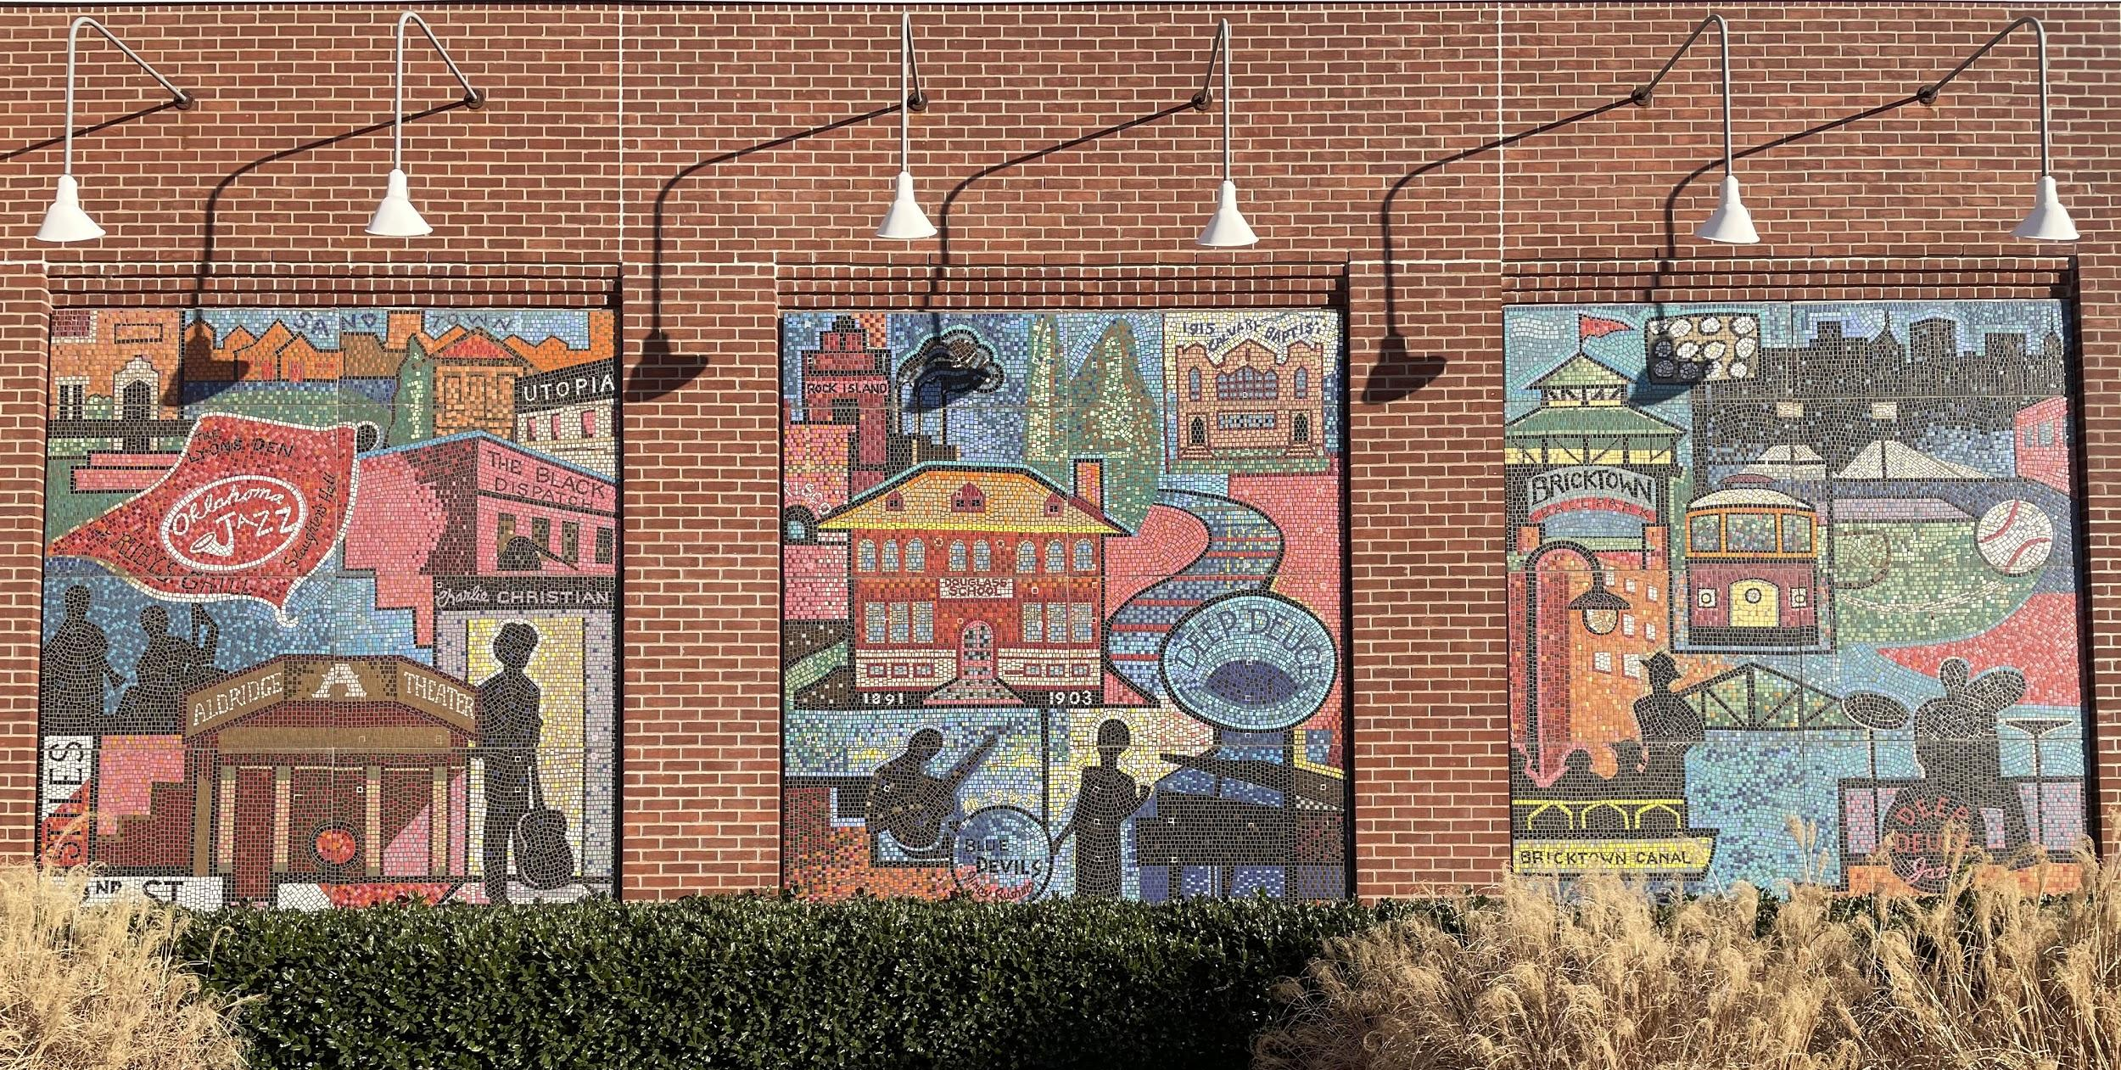
Source: Brewer, S. (2021). The History of Bricktown Mural. [Photograph].

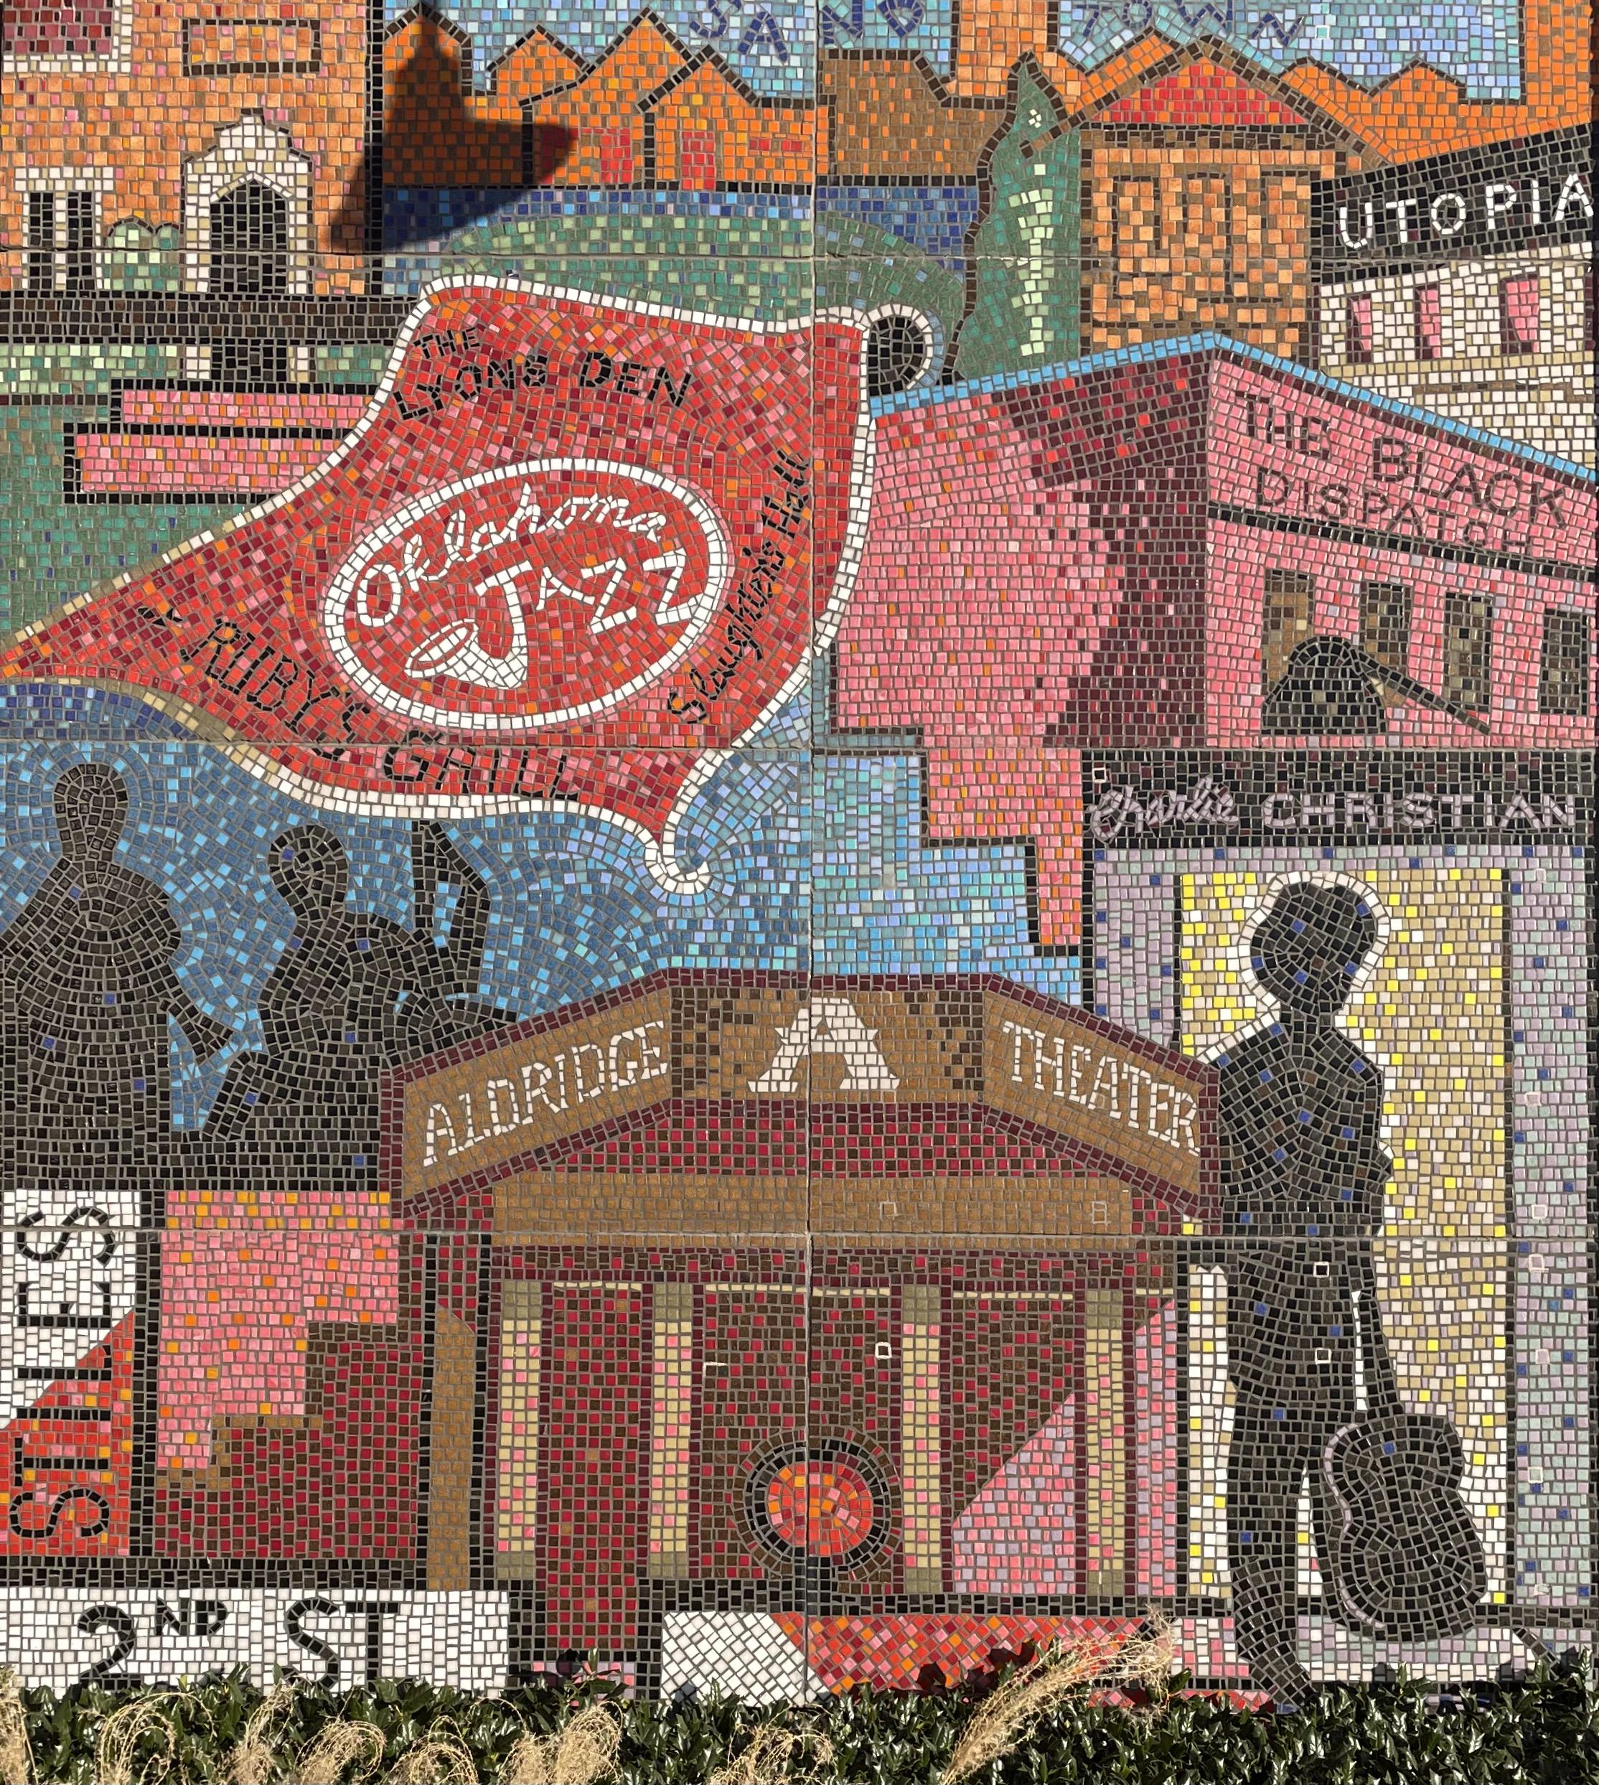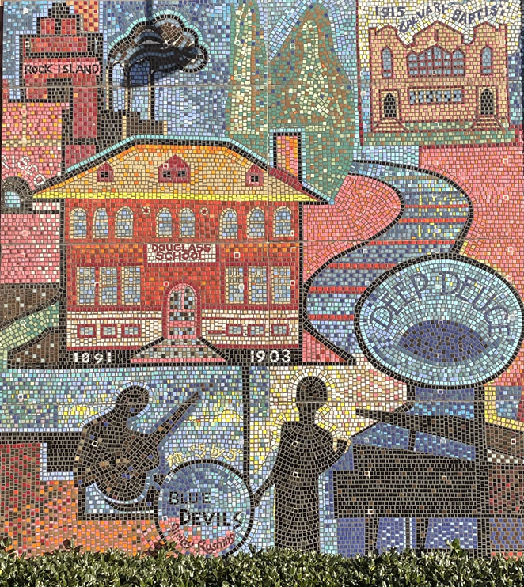
Source: Brewer, S. (2021). The History of Bricktown Mural. Panel 1. Source: Brewer, S. (2021). The History of Bricktown Mural. Panel 2.

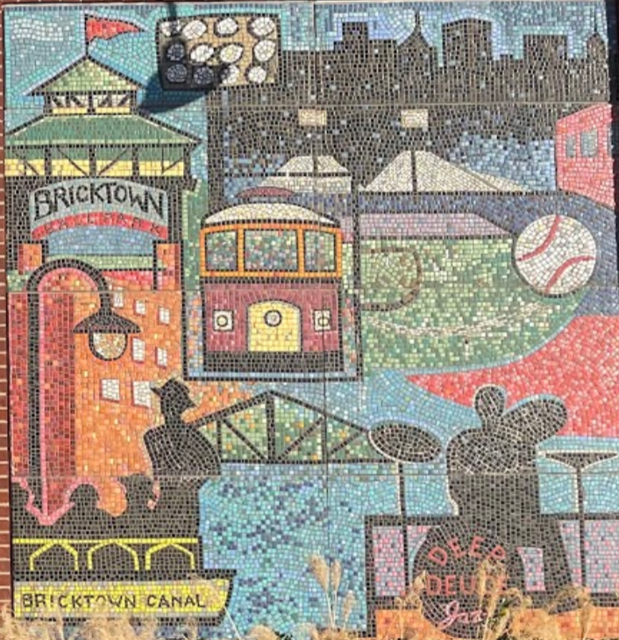
Source: Brewer, S. (2021). Source: Brewer, S. (2021). The History of Bricktown Mural. Panel 3.

