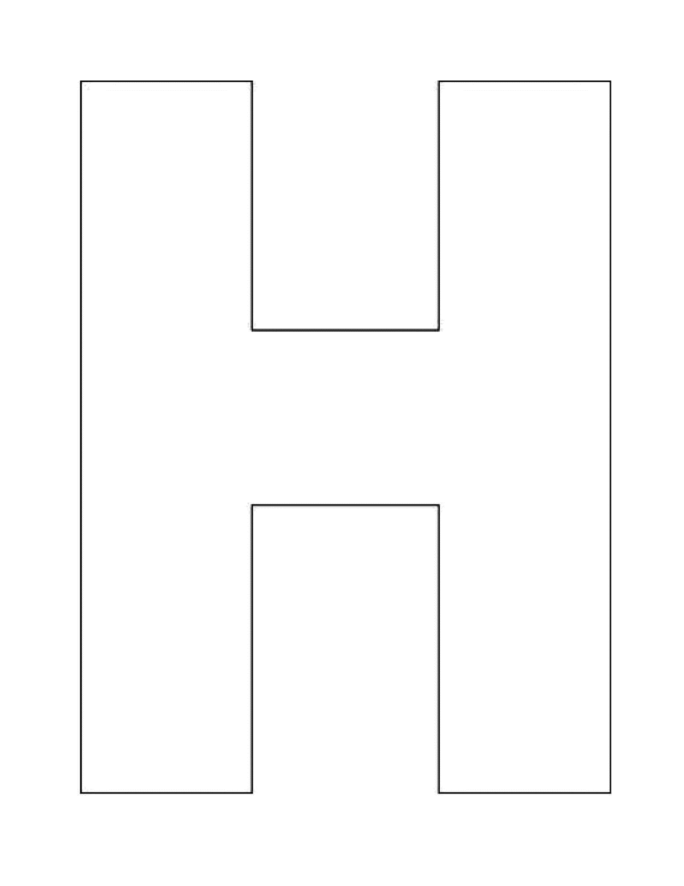


H-Chart
Denote or Connote?
Connotation
Both Videos

