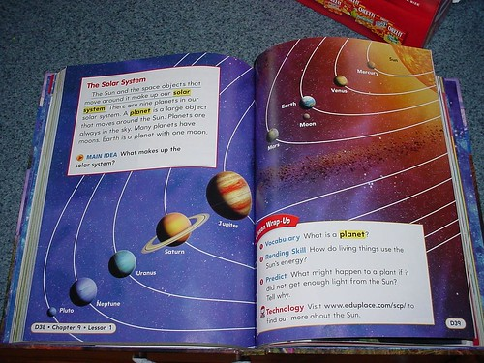  card sort |  |  | 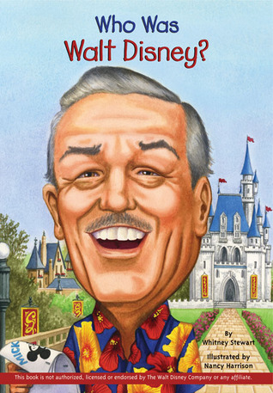
 | 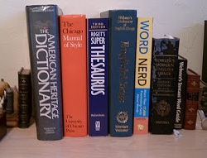 | 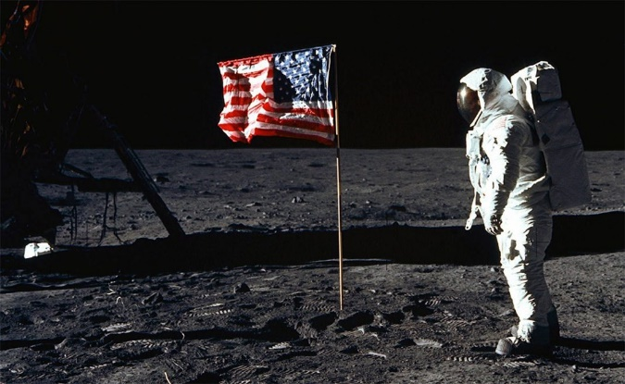 | 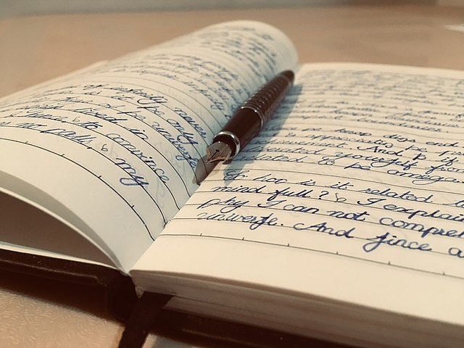
 | 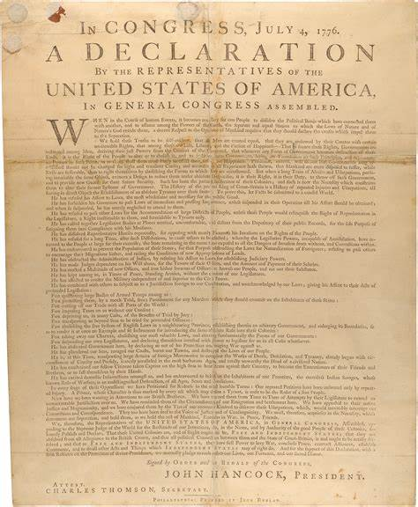 | 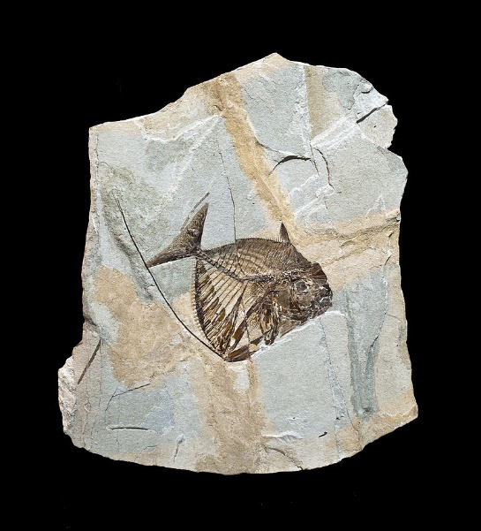 | 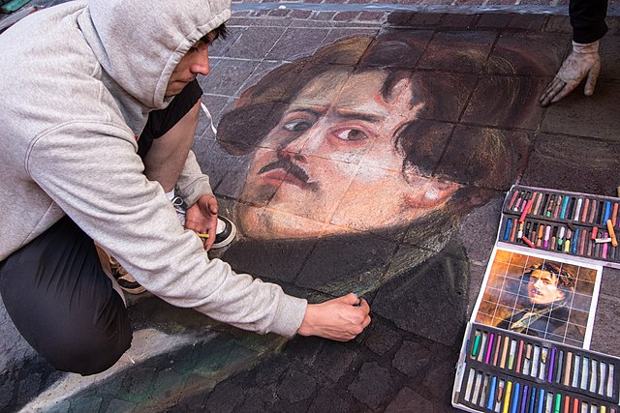

Acagastya. (2018, December 2). My journal. [Image] Wikimedia Commons. https://commons.wikimedia.org/wiki/File:My_journal.jpg

Air Force Space Command Public Affairs. (20199, July 19). Buzz Aldrin, lunar module pilot, walks near the lunar module during the Apollo 11 extravehicular activity. [Image] NASA. https://www.afmc.af.mil/News/Article-Display/Article/1910591/aiming-higher-airmen-contribute-to-human-spaceflight-from-apollo-to-tomorrow/

CBC News. (2017, September 27). Indigenous artifacts found at site of new Highway 7 bridge over Grand River. [Image] CBC News. https://www.cbc.ca/news/canada/kitchener-waterloo/indigenous-artifacts-highway-7-bridge-grand-river-1.4309924

Didier Descouens. (2010, September 26). Mene rhombea Bolca. [Image] Wikimedia Commons. https://commons.wikimedia.org/wiki/File:Mene_rhombea_Bolca.jpg

Fryer, W. (2008, March 27). Untitled image. Moving at the Speed of Creativity. https://www.speedofcreativity.org/2008/03/27/sorry-honey-you-cant-believe-everything-you-read-in-your-printed-science-textbook/

Harrison, N. (2009, April 16). Who Was Walt Disney? [Cover Image]. Grosset & Dunlap.
https://www.goodreads.com/book/show/5818570-who-was-walt-disney

Jkratz. (2016, August 2). Making it Official: The Day the Declaration of Independence Was Signed. Pieces of History. National Archives. https://prologue.blogs.archives.gov/2016/08/02/making-it-official-the-day-the-declaration-of-independence-was-signed/

Scott. (2012, January 13). What Reference Books Do You Keep on Hand? [Image]. Blogspot. https://utahchildrenswriters.blogspot.com/2012/01/what-reference-books-do-you-keep-on.html

Tomascastelazo. (2012, December 2). Street painting in guanajuato 01. [Image] Wikimedia Commons. https://commons.wikimedia.org/wiki/File:Street_painting_in_guanajuato_01.jpg

