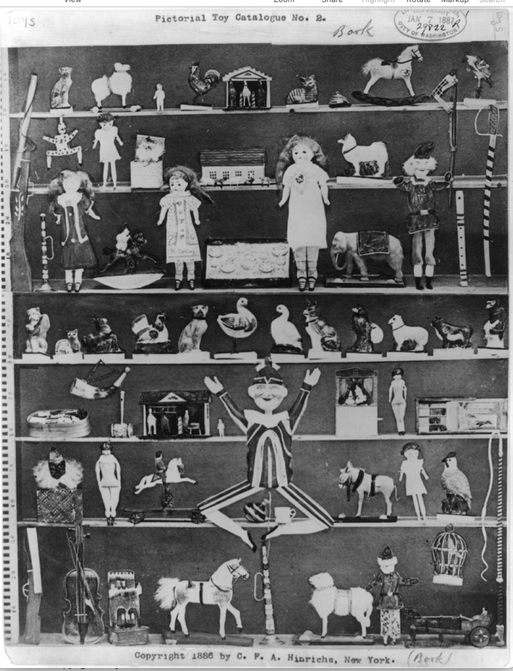
Primary source

Advertisement for Pictorial Toy Catalogue No. 2 showing composite of many toys on shelves. [Jan. 7?] Photograph. The Library of Congress, <www.loc.gov/item/2004672357/>.

