Create Your Presentation Using Google Earth
- Navigate to google.com/earth and select “Launch Earth.”
- Select “Projects” from the sidebar, and then select “New project.”
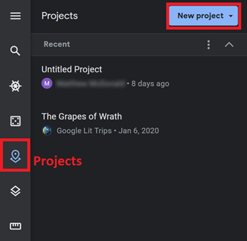
- Select “Create Project in Google Drive.”
- In the “Project Title” field, give your tour a new name and add a description.
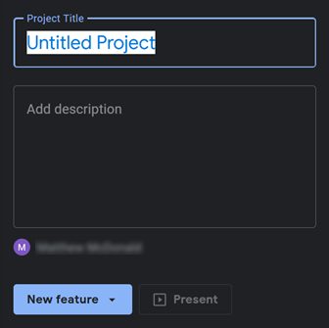
- Choose “New Feature” to add a new location to your tour.

- Use the “Search to add place” option to search for one of your assigned locations, and then choose “Add to project.”
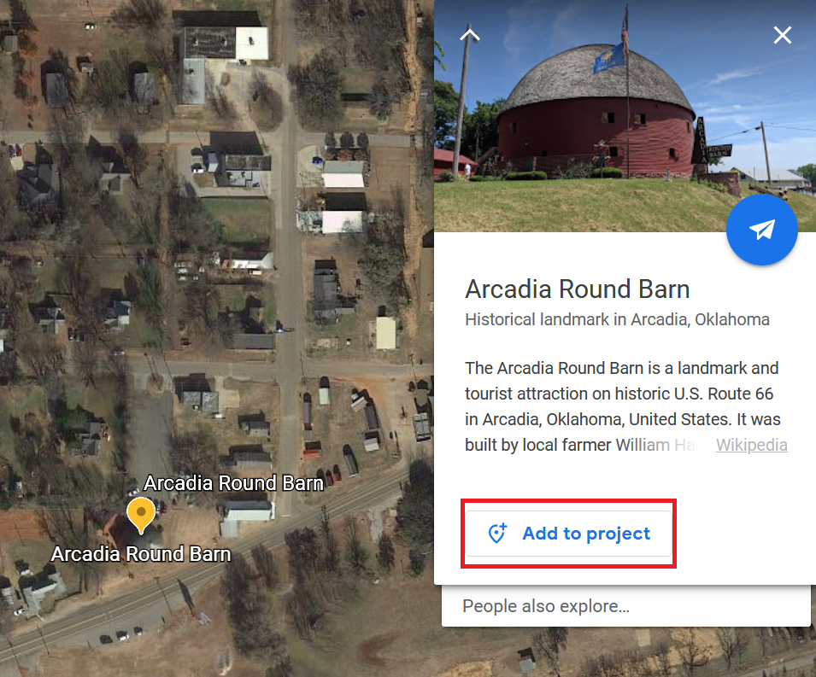
- Follow the same procedure for each historical site on your tour.
- To show off your created tour, select “Present.”
