Exploring the Fossils of the World
Go to paleobiodb.org and take 5–10 minutes to explore the tools and features of the website. After you have had some time to explore, follow the directions below and answer the questions as you work through the tasks.

Where in Oklahoma are these organisms found?
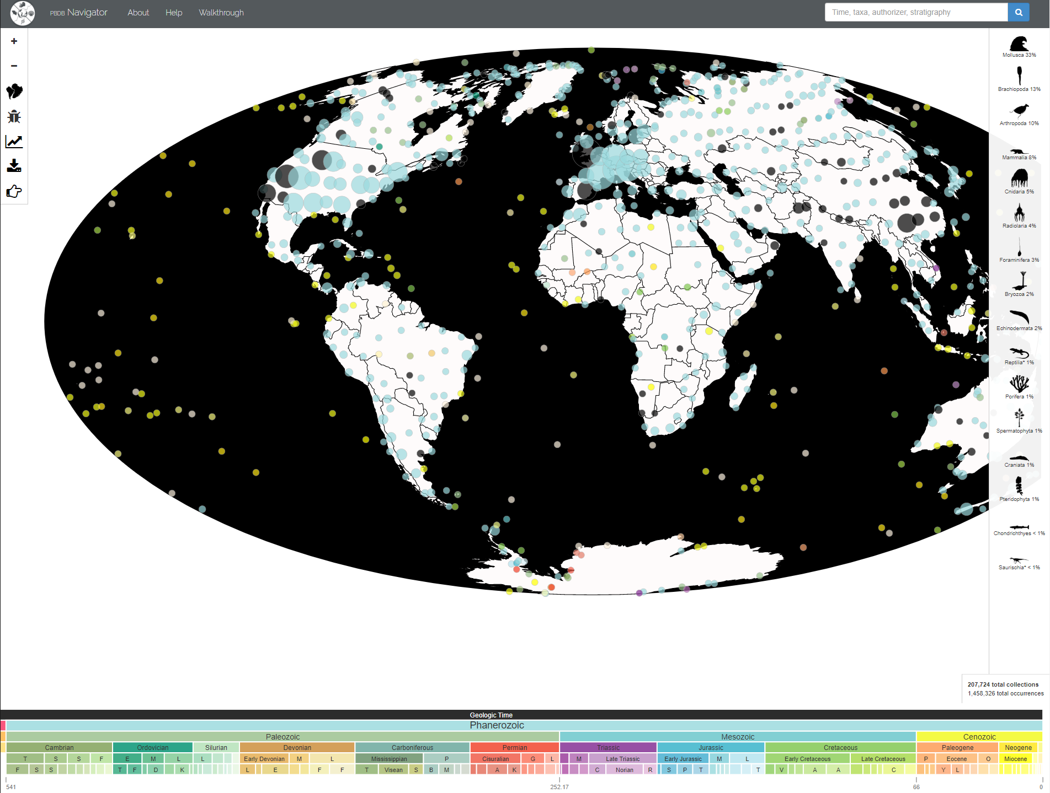
After you have finished exploring the tools and features of the website, select the button on the top-left side of the screen. This should take you back to the home screen, which should look like the image to the right.
Type the phylum name Cnidaria in the search box on the top-right side of the screen. This is the group that the organism from the beginning of the lesson belongs to. Zoom in and drag the screen to show mainly Oklahoma on the map, just as the image below shows.
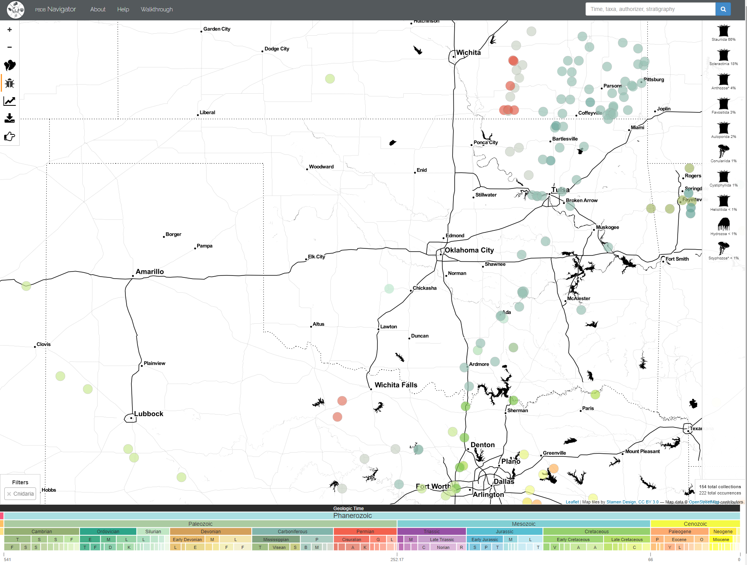

Analysis Questions
- Write two things you notice (true statements) and two things you wonder (questions you have).

- Each dot on the map represents a collection of fossils. What pattern do you notice on the map?

- What might have been different about the environment in the past to allow an organism like the one at the beginning of the lesson to survive?

- Look at the bottom of the page at the geologic timeline. When is the earliest that these organisms would have appeared?

- When is the latest that these organisms would have appeared?

- Select the button on the left-hand side of the screen that looks like this: . A data table should appear on the screen. What patterns do you notice in the data table?

- Predict what might have caused this change in the number of Cnidaria in Oklahoma. Be detailed in your response.

- What else can you infer by looking at the data?

- With a partner, choose an animal you would like to investigate further just as you did with the Cnidaria. Type the phylum name of the animal in the search box. What pattern do you notice on the map?

- What can you predict about the population you chose to investigate?

- Look at the bottom of the page at the geologic timeline. When is the earliest that these organisms would have appeared?

- When is the latest that these organisms would have appeared?

- Select the button. What patterns do you notice in the data?

- Did the population change over time? If so, how and why do you think this happened?

- What else can you infer by looking at the data?

