OBSERVO, ME PREGUNTO

| **Observo...** | **Me pregunto...** |
| --- | --- |
|  |  |

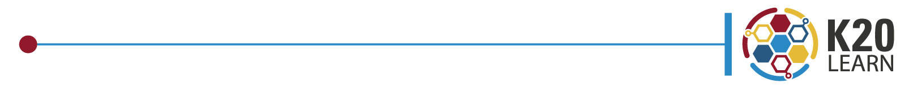 

WHAT’S UNDER OUR FEET?

OBSERVO, ME PREGUNTO

| **Observo...** | **Me pregunto...** |
| --- | --- |
|  |  |