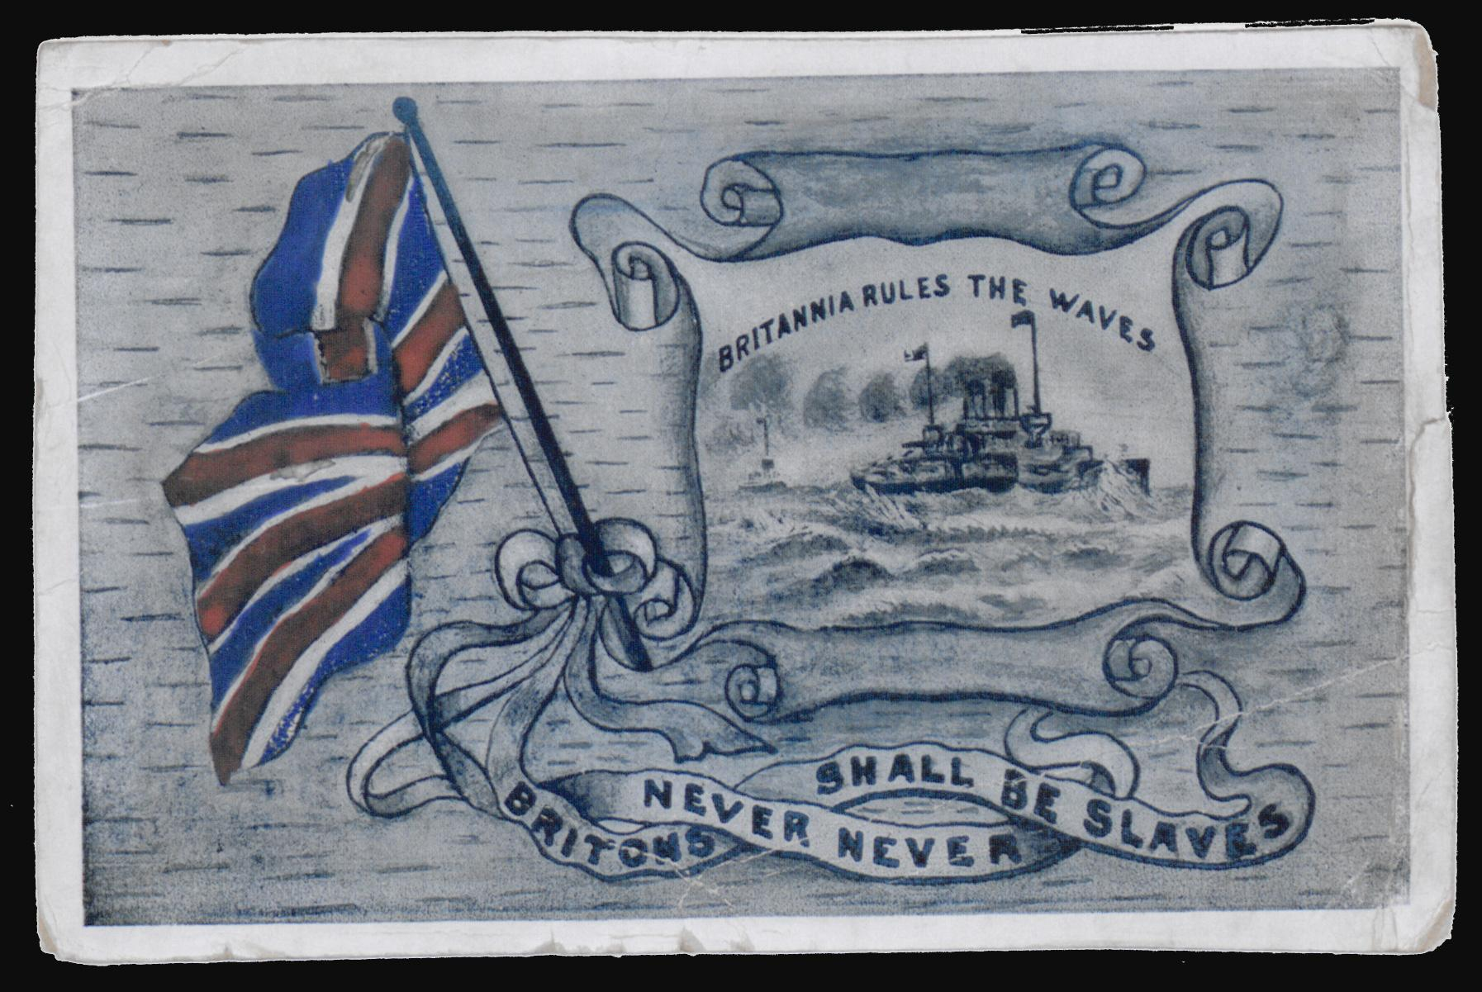

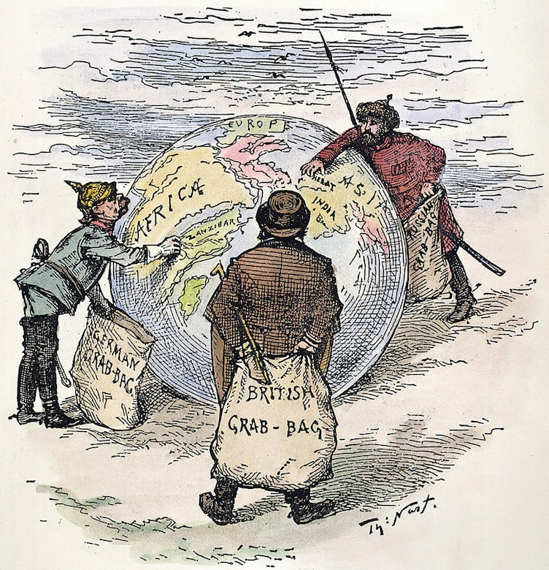

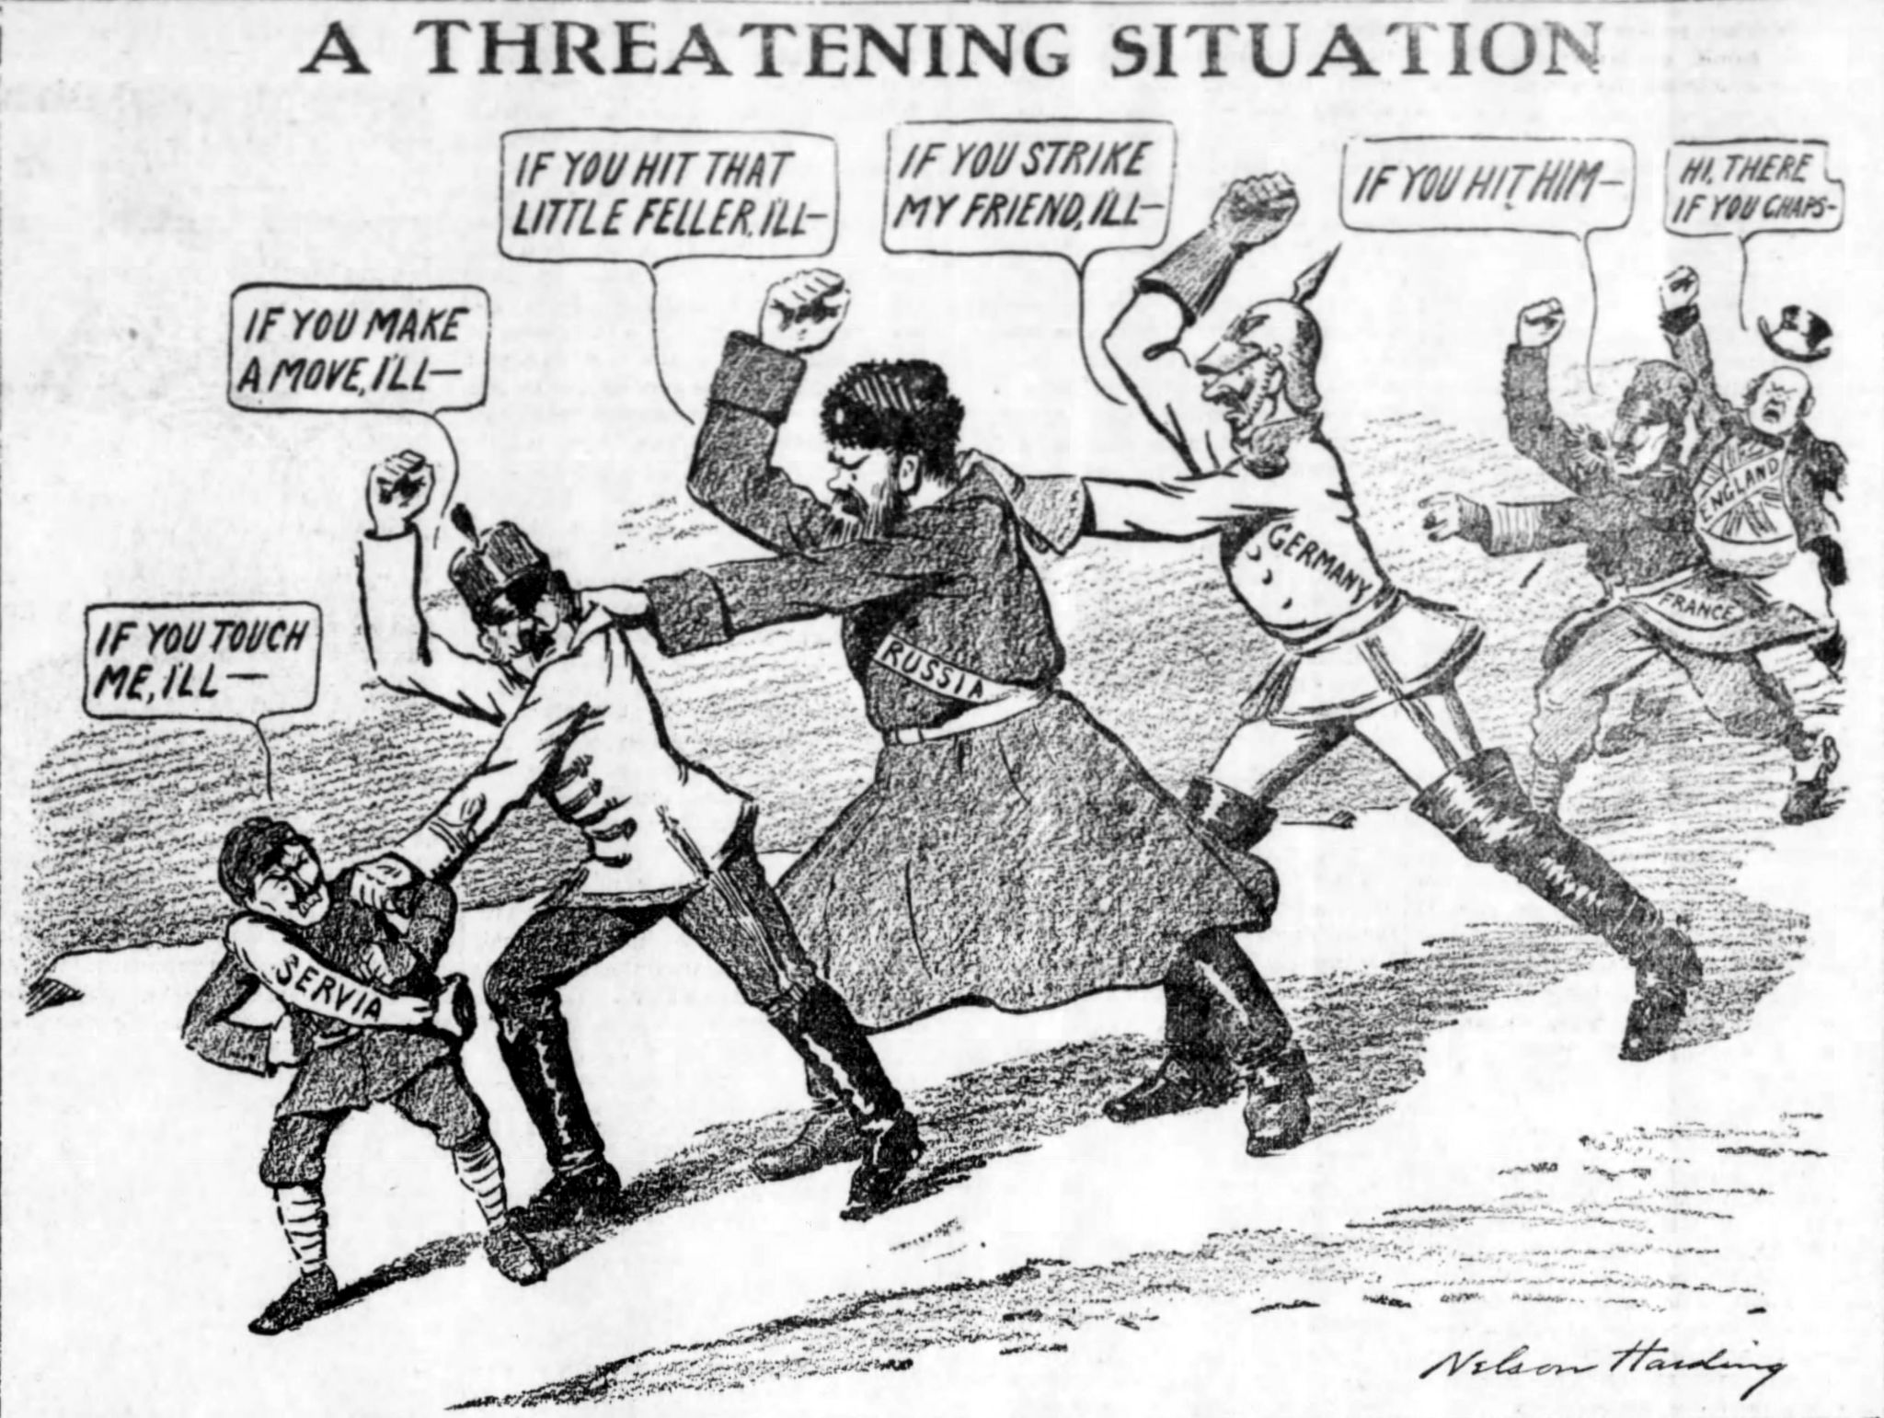

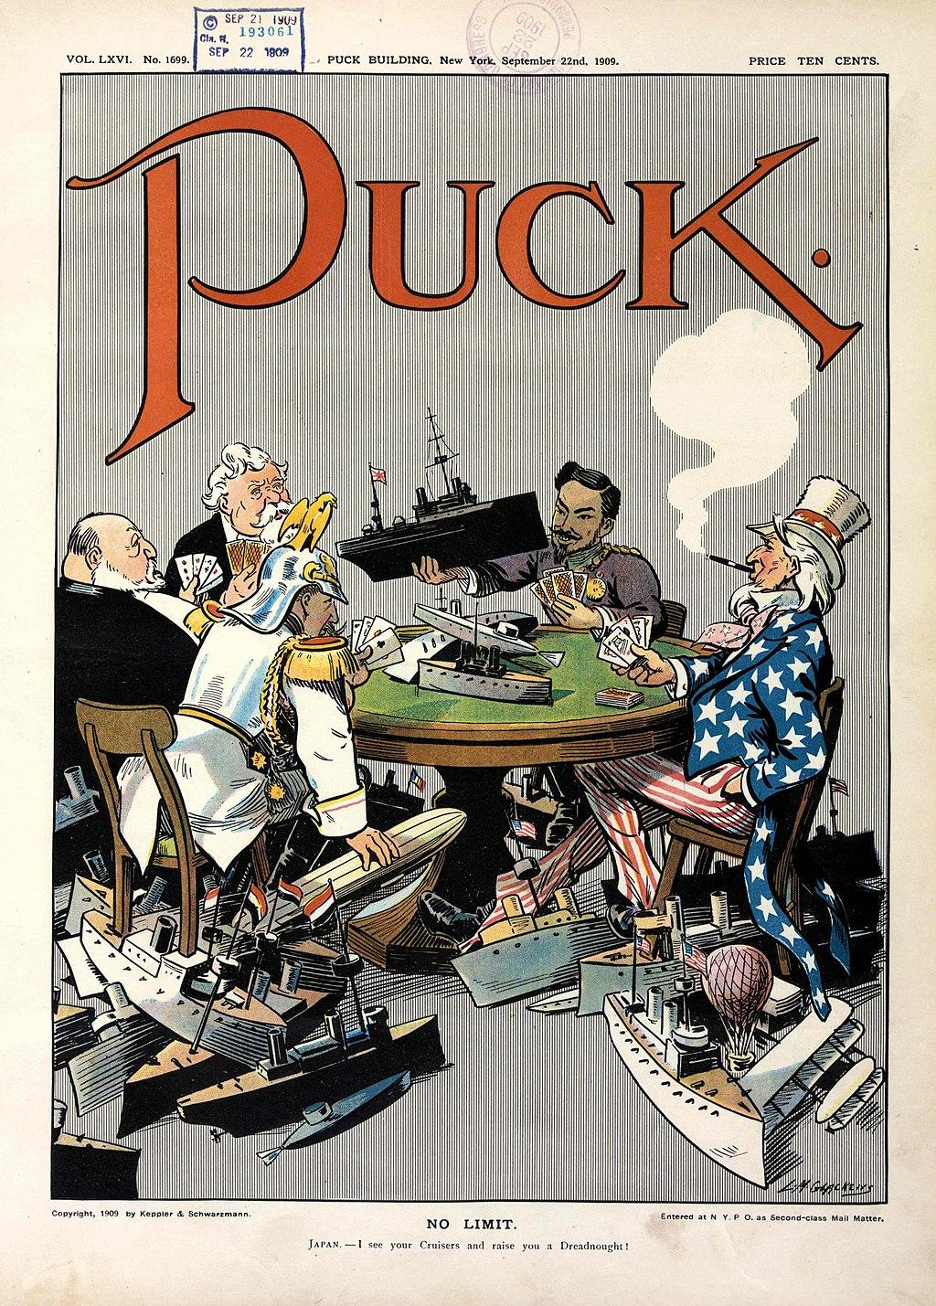

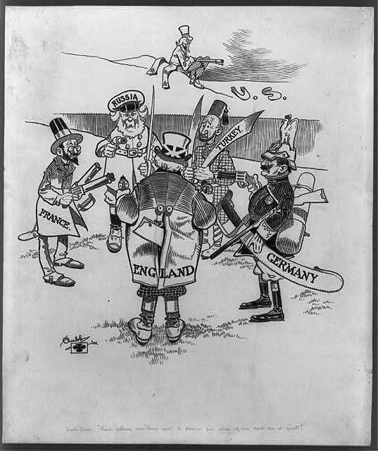

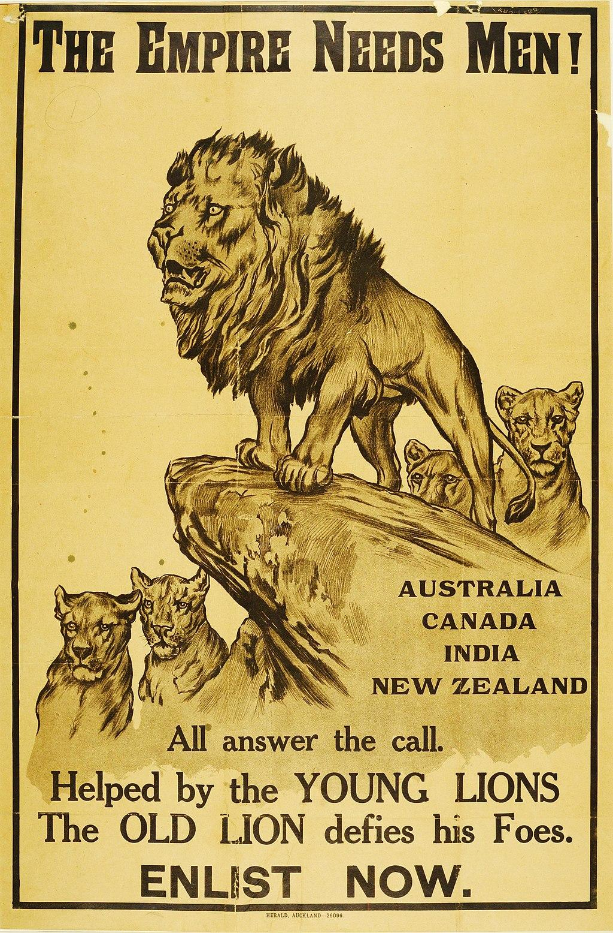

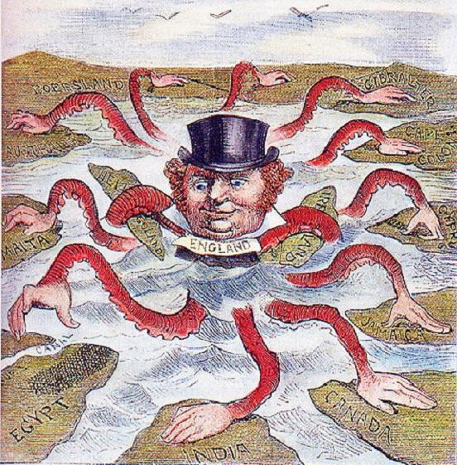

Sources

Britannia rules the waves. (2013, November 13). https://www.bl.uk/collection-items/britannia-rules-the-waves

Clubb, J. S. (n.d.). Uncle Sam: “Them fellers over there want to disarm but none of 'em dast do it first!” digital file from b&w film copy neg. Library of Congress. https://www.loc.gov/resource/cph.3c37103/

Glackens, L. (1909, September 22). No limit. https://www.loc.gov/pictures/item/2011647506/

Harding, N. (1912, December 4). Https://commons.wikimedia.org/wiki/File:Chain_of_Friendship_cartoon.jpg. https://commons.wikimedia.org/wiki/File:Chain_of_Friendship_cartoon.jpg

Nast, T. (n.d.). File:imperialism 1885.JPG. Wikimedia Commons. https://commons.wikimedia.org/wiki/File:Imperialism_1885.jpg

Online collection. (n.d.). from https://collection.nam.ac.uk/detail.php?acc=2005-11-219-1

WikiMedia Commons. (2019, June 7). https://commons.wikimedia.org/wiki/File:English_imperialism_octopus.jpg

