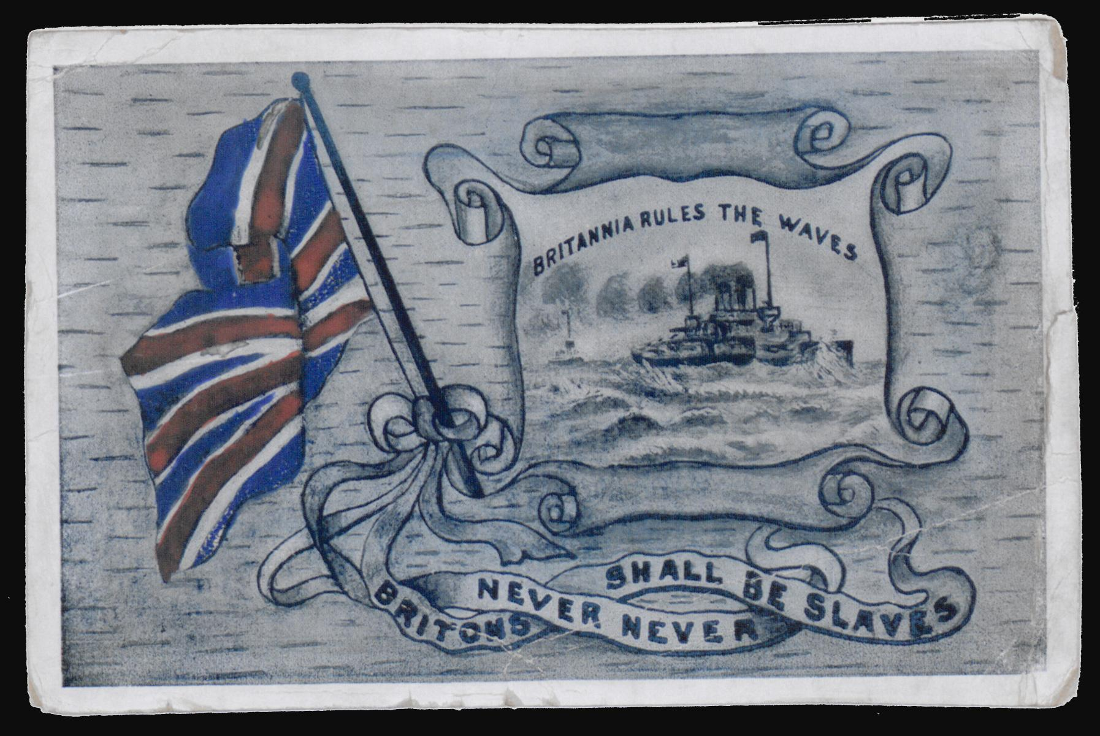

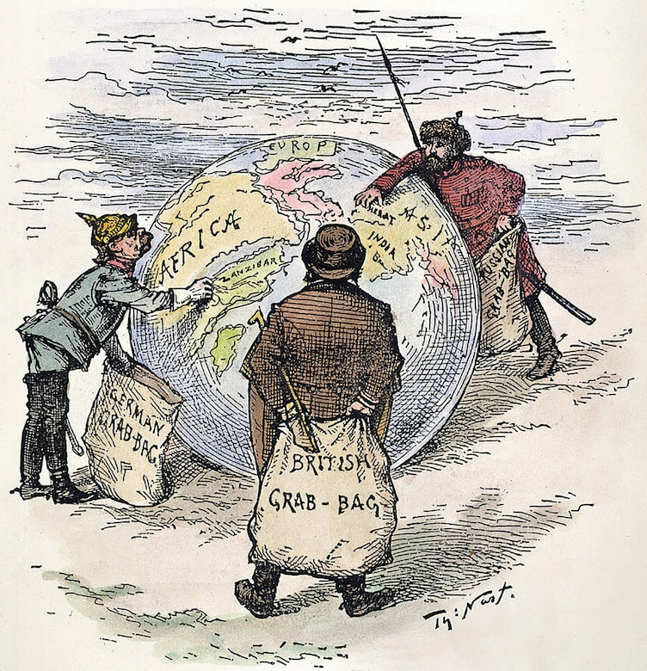

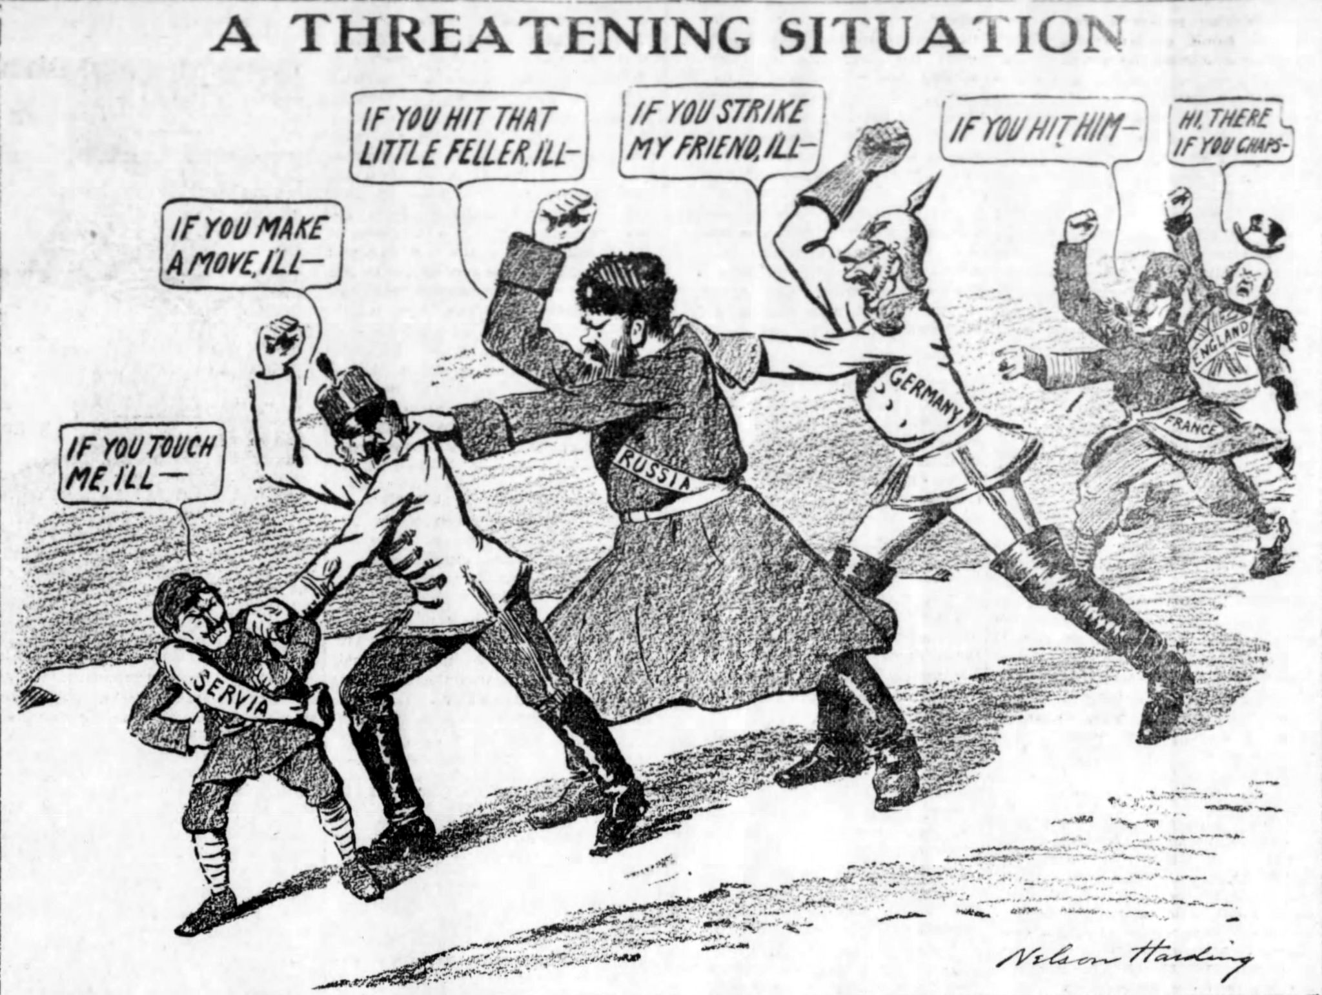

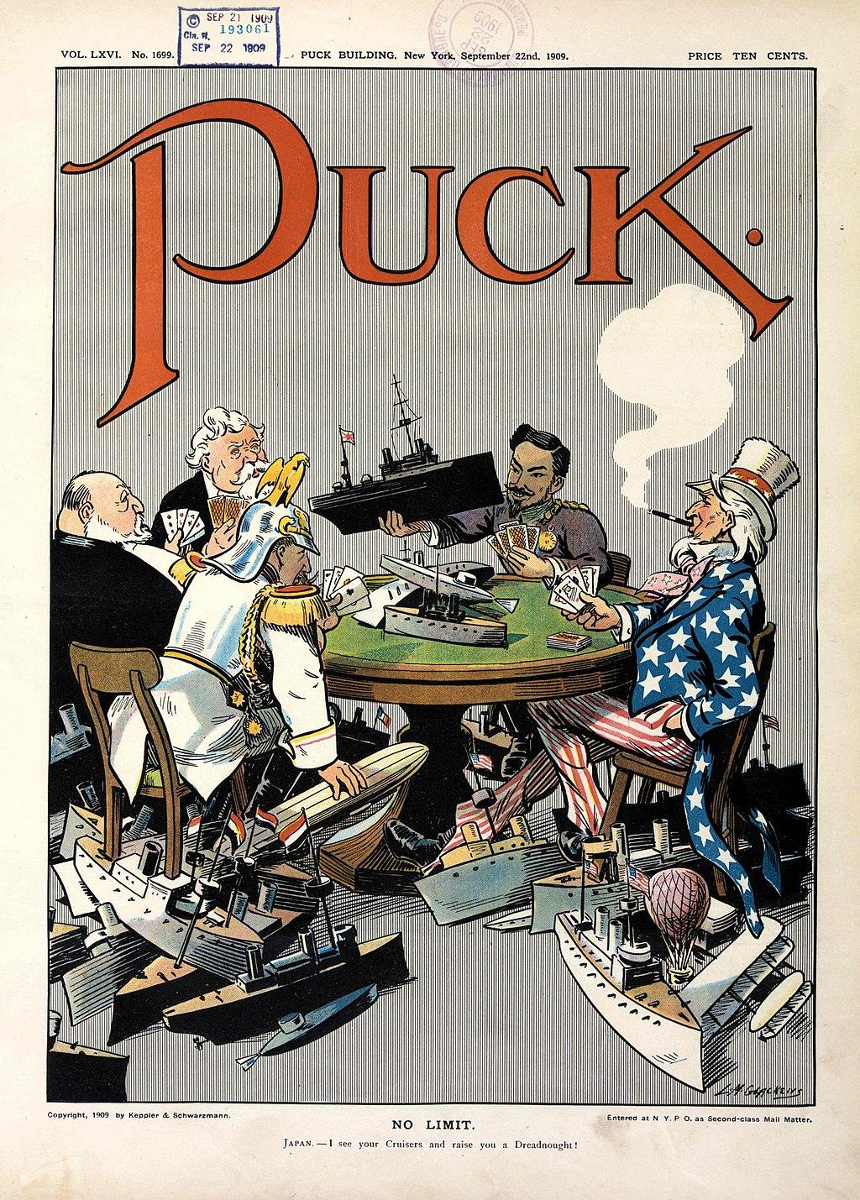

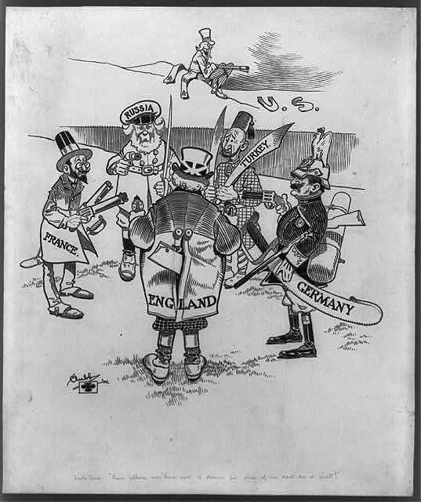

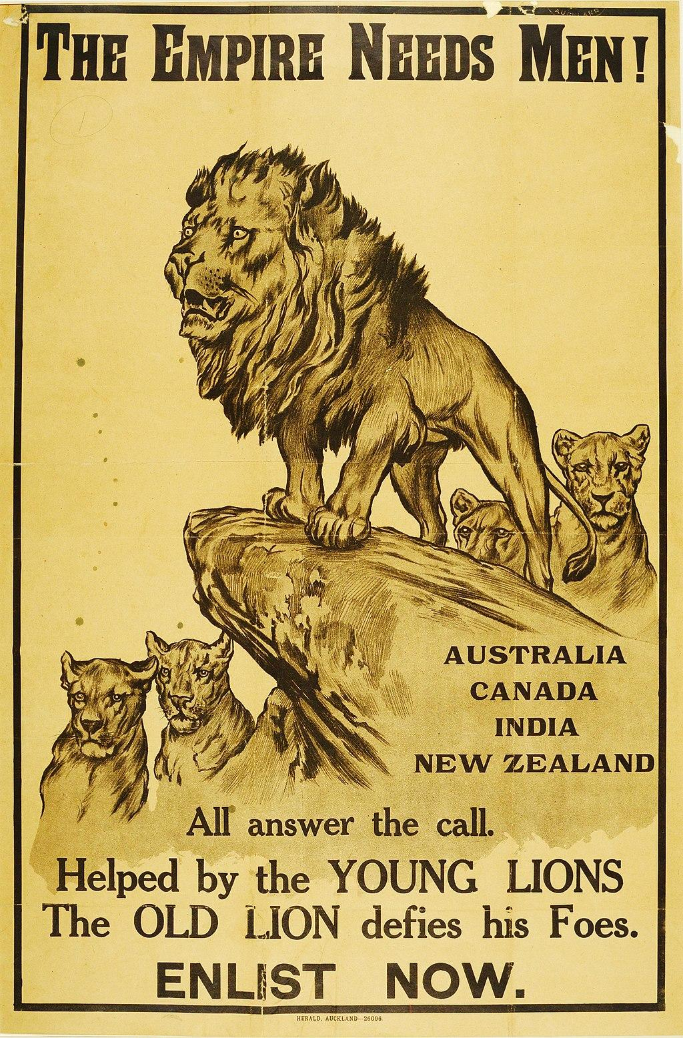

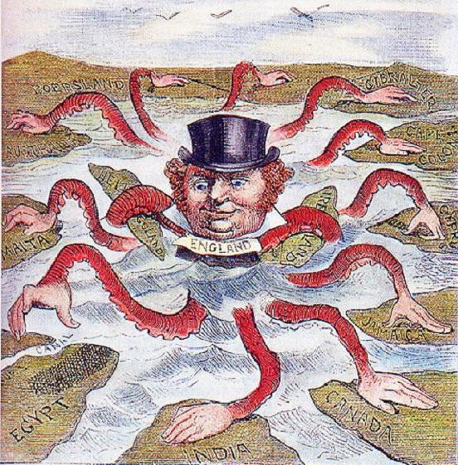

Sources
Bull, J. (1882). The devilfish in Egyptian waters [Cartoon]. Wikimedia Commons. https://commons.wikimedia.org/wiki/File:English_imperialism_octopus.jpg
Clubb, J. S. (1906). Uncle Sam: “Them fellers over there want to disarm but none of ‘em dast do it first!” [Cartoon]. Library of Congress. https://www.loc.gov/resource/cph.3b30703/?st=list
Glackens, L. M. (1909). No limit [Cartoon]. Library of Congress. https://www.loc.gov/pictures/item/2011647506/
Harding, N. (1912). A threatening situation [Cartoon]. Wikimedia Commons. https://commons.wikimedia.org/wiki/File:Chain_of_Friendship_cartoon.jpg
Ingram, W. J. (1914). Britannia rules the waves [Cartoon]. British Library. https://searcharchives.bl.uk/catalog/040-002350814
Nast, T. (1885). The world’s plunderers [Cartoon]. Wikimedia Commons. https://commons.wikimedia.org/wiki/File:Imperialism_1885.jpg
Wardle, A. (1915). The Empire needs men! [Poster]. National Army Museum. https://collection.nam.ac.uk/detail.php?acc=2005-11-219-1

