POLITICAL CARTOONS PACKET

Cartoon 1:
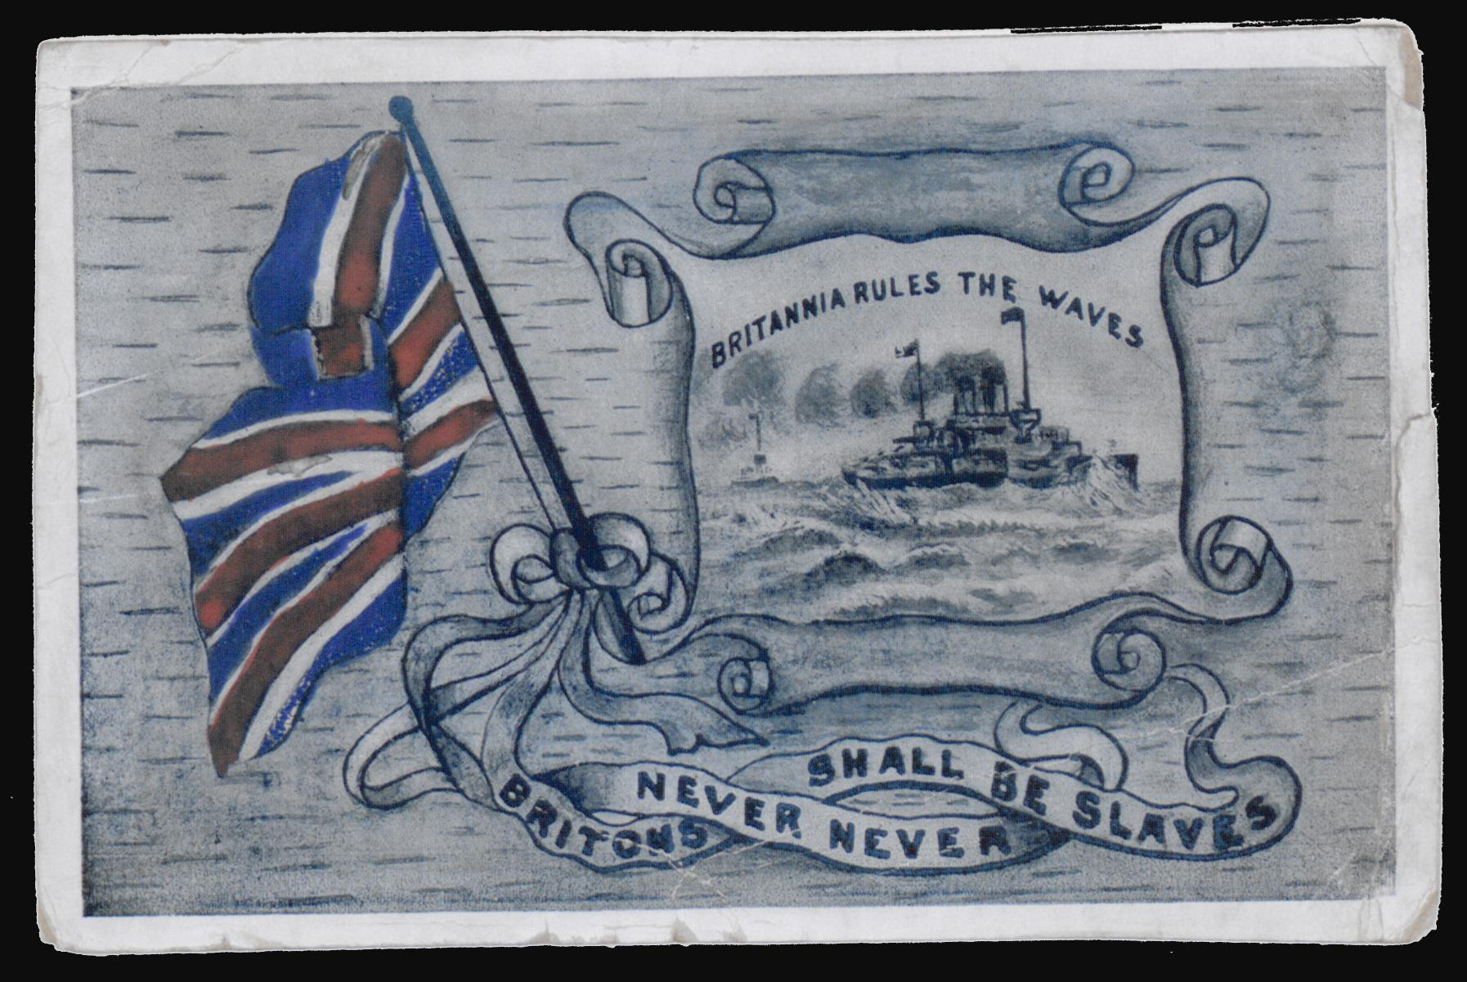

Cartoon 2:

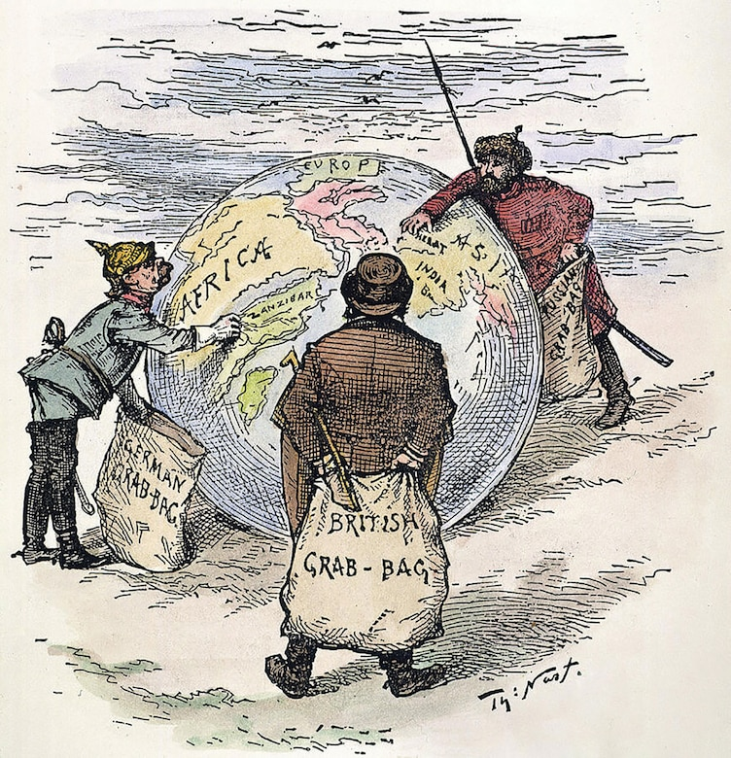

Cartoon 3:

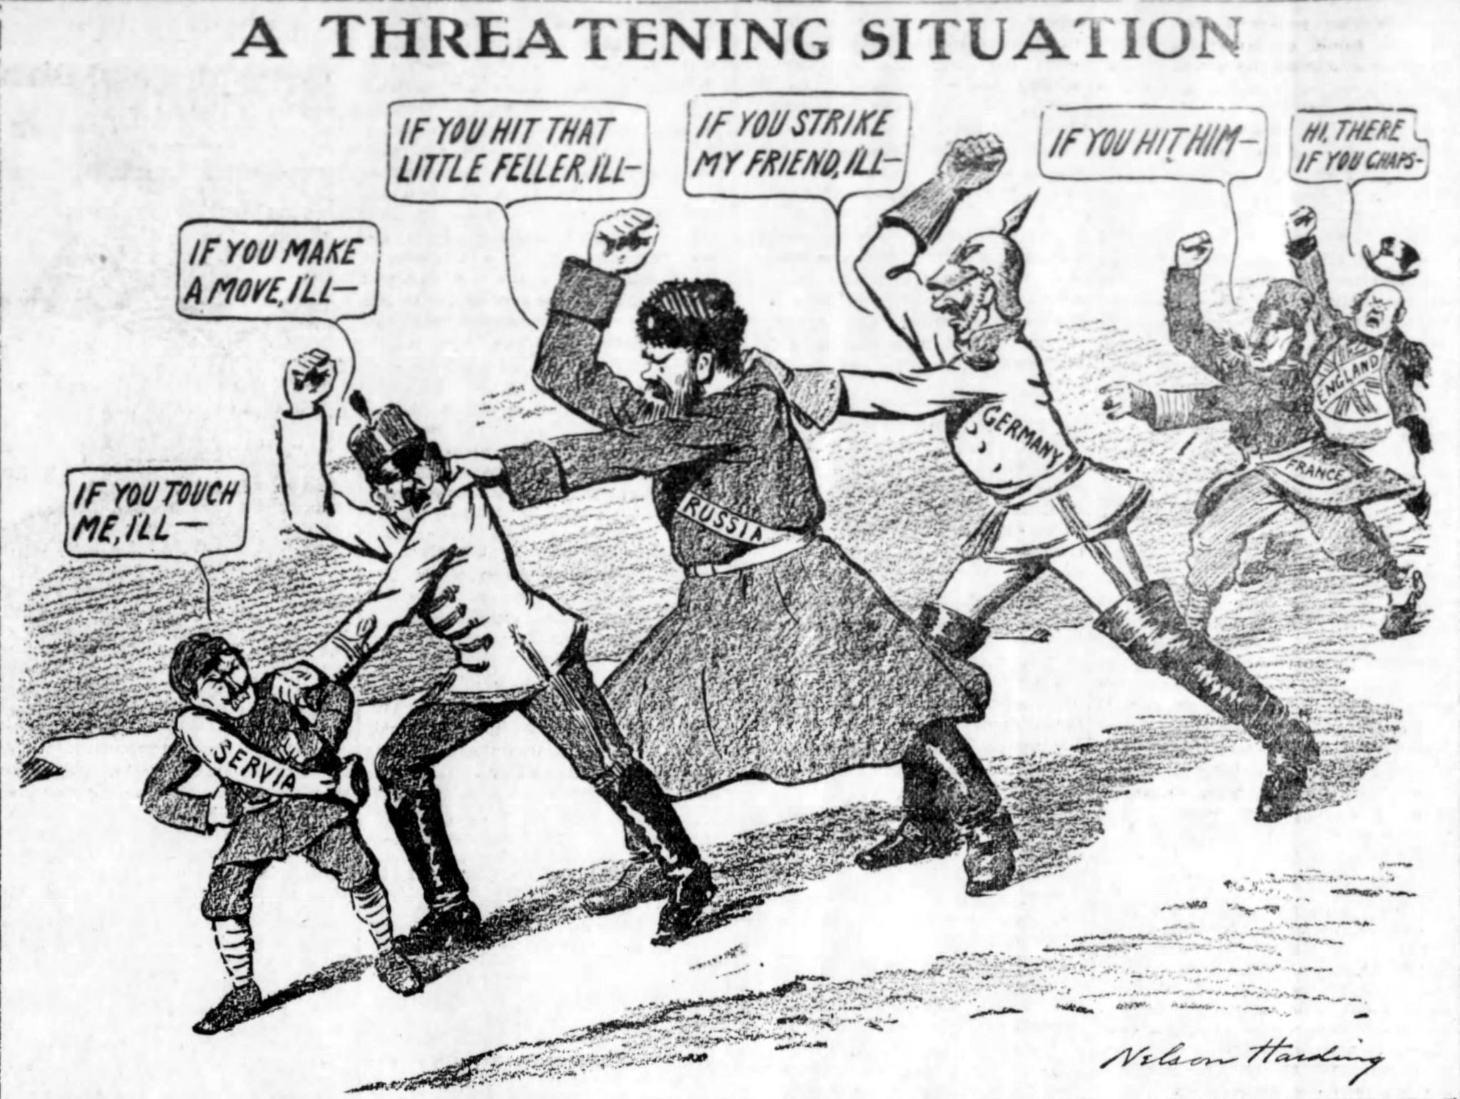

Cartoon 4:

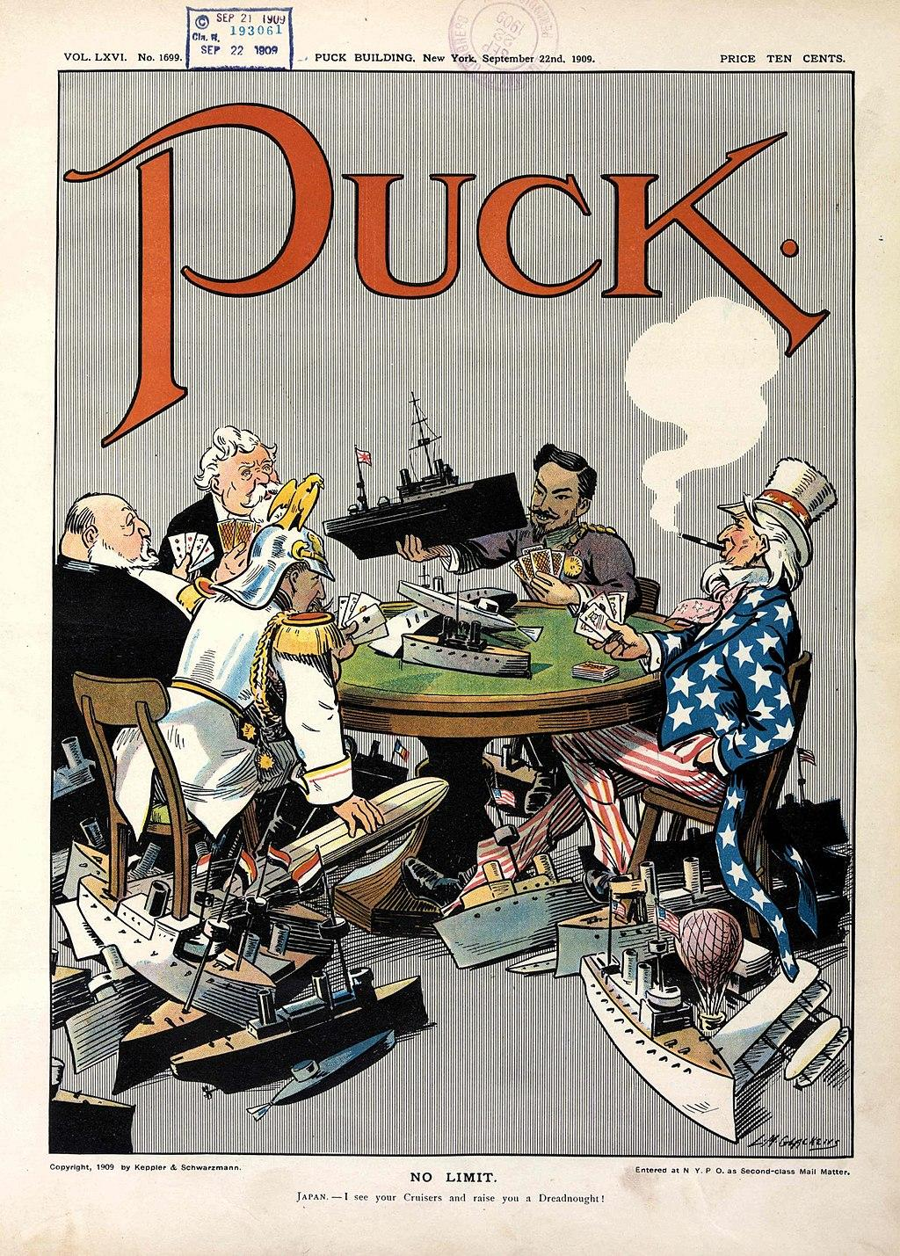

Cartoon 5:

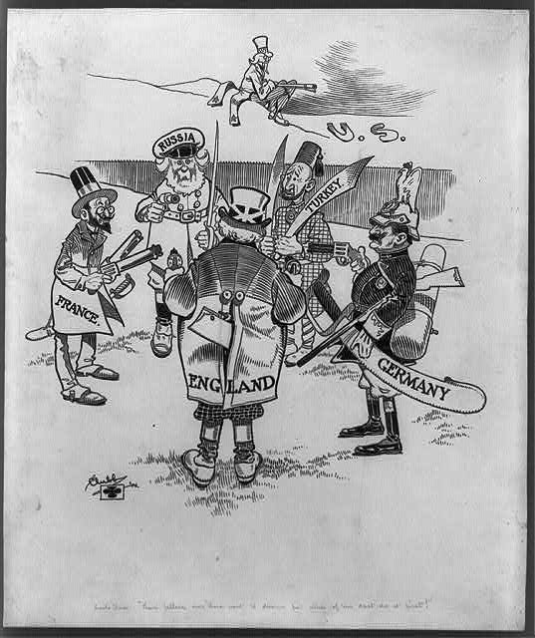

Cartoon 6:

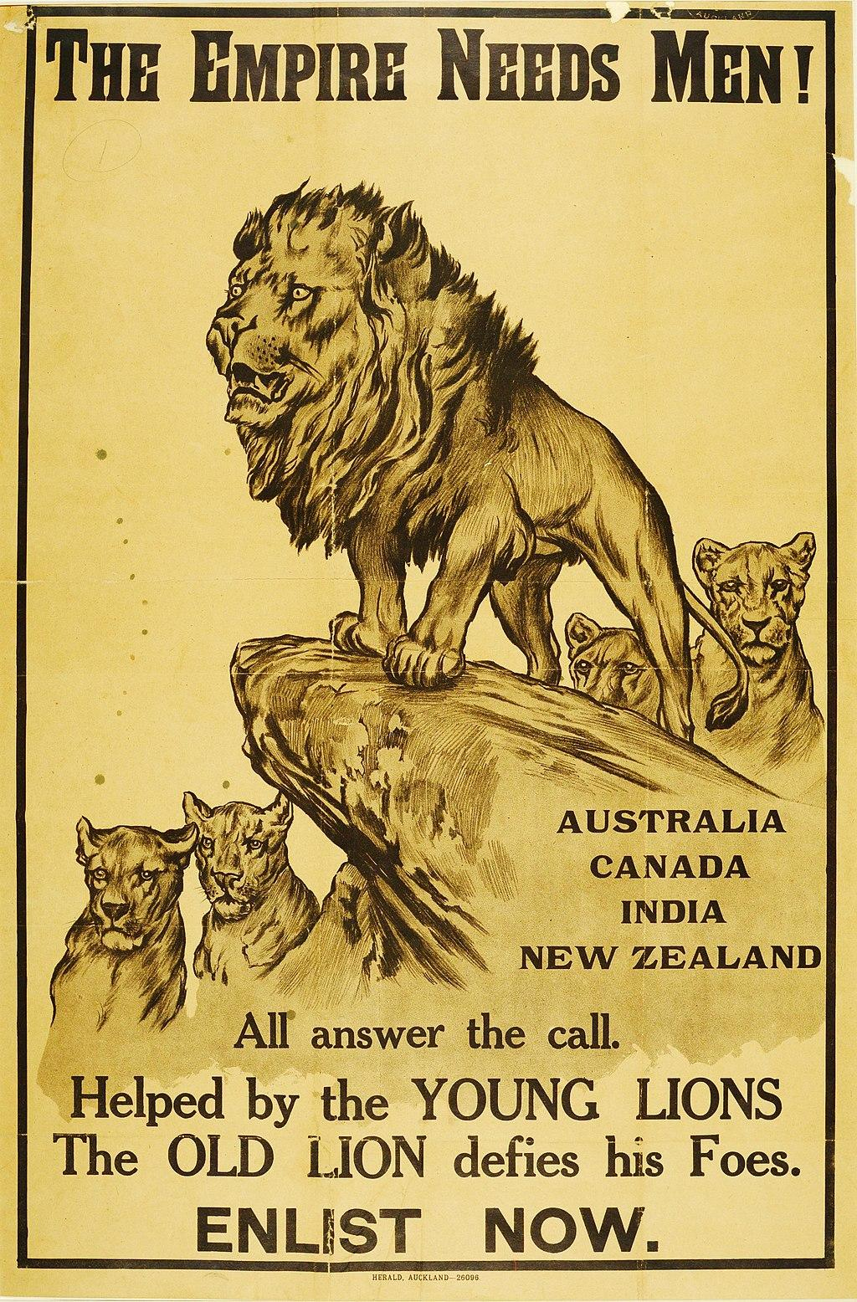

Cartoon 7:

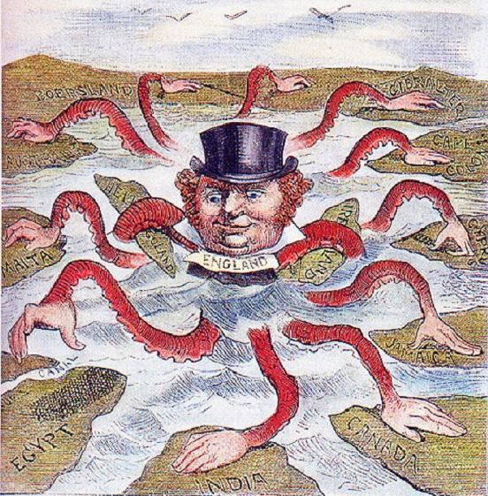

Resources:
Britannia rules the waves. (2013, November 13). https://www.bl.uk/collection-items/britannia-rules-the-waves
Chapter 2: Past eras of great Power Competition: Historical insights and implications. (2020, November 04). https://www.whs.mil/News/News-Display/Article/2405315/chapter-2-past-eras-of-great-power-competition-historical-insights-and-implicat/
Harding, N. (1912, December 4t). Https://commons.wikimedia.org/wiki/File:Chain_of_Friendship_cartoon.jpg. https://commons.wikimedia.org/wiki/File:Chain_of_Friendship_cartoon.jpg
Glackens, L. (1909, September 22). No limit. https://www.loc.gov/pictures/item/2011647506/
Melina DrugaMost kids have an active imagination.My imagination has stayed strong into adulthood. (2021, April 08). The causes of World War ONE: Part 1 – political alliances. Retrieved April 28, 2021, from https://www.melinadruga.com/the-causes-of-world-war-one-part-1-alliances/
Online collection. (n.d.). from https://collection.nam.ac.uk/detail.php?acc=2005-11-219-1
Https://commons.wikimedia.org/wiki/File:English_imperialism_octopus.jpg. (2019, June 7). https://commons.wikimedia.org/wiki/File:English_imperialism_octopus.jpg

