Embryology  The branch of biology and medicine concerned with the study of embryos and their development | Directional selection  A selection that causes a shift in frequency to an extreme phenotype.
Vestigial Structures Inherited, but reduced in size, often unused, and no longer serves its purpose. | Fossil  Preserved remains or imprints of ancient organisms.
Homologous Structures  Traits that are similar in different species because the species share a common ancestor | Biochemistry  The branch of science that explores the chemical processes within and related to living organisms.
Analogous Structures  Structures that are similar in function but are not inherited from a common ancestor. | Stabilizing Selection (Genetic Equilibrium) Constant state of allele frequency.
Disruptive Selection  A selection that does not favor the most common variation within a population. | DNA Technology  The sequencing, analysis, and cutting-and-pasting of DNA. Examples include sequencing, polymerase chain reaction, cloning, and gel electrophoresis.

Vestigial Structures  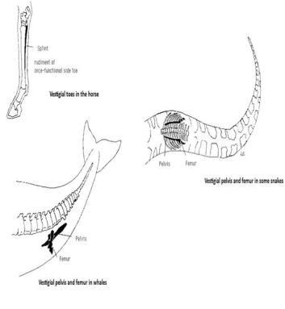 | Analogous Structures  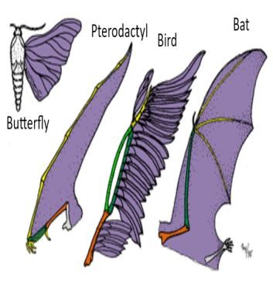 | Homologous Structures  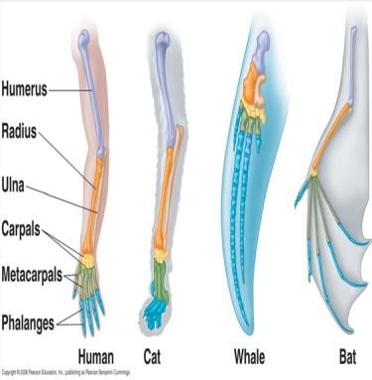 | Biochemistry  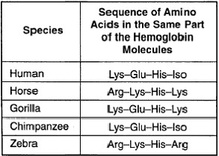
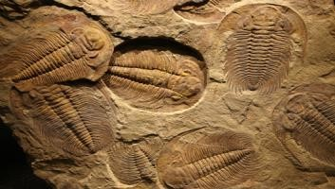  Fossils 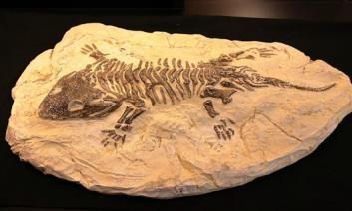 | 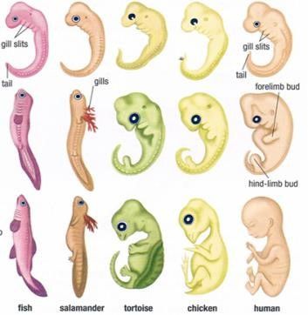  Embryology | 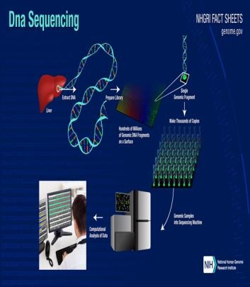  DNA Technology

Sources
Analogous Structure
Analogous and Homologous Traits. (n.d.). Retrieved January 14, 2021, from http://group4cladistics.weebly.com/analogous-and-homologous-traits.html
Biochemistry
Comparative Biochemistry. (n.d.). Retrieved January 14, 2021, from http://eewevolution.weebly.com/comparative-biochemistry.html

Directional, Disruptive, and Stabilizing Selection
What is the effect of directional selection on genetic variation?: Socratic. (2017, March 28). Retrieved January 14, 2021, from https://socratic.org/questions/what-is-the-effect-ofdirectional-selection-on-genetic-variation-1
DNA Technology
DNA Sequencing Fact Sheet. (n.d.). Retrieved January 14, 2021, from https://www.genome.gov/about-genomics/fact-sheets/DNA-Sequencing-Fact-Sheet

Embryology
Sharma, Y., & Scarbrough, H. (2020, January 08). Evolutionary Embryology: Developmental Biology. Retrieved January 14, 2021, from https://microbenotes.com/evolutionaryembryology/

Fossils
Callaway, E. (2020, January 18). Supercomputer Scours Fossil Record for Earth's Hidden Extinctions. Retrieved January 14, 2021, from https://www.scientificamerican.com/article/supercomputer-scours-fossil-record-for-earths-hidden-extinctions/
Black, R. (2009, January 23). If You Found a Fossil on the Ground, What Would You Do? Retrieved January 14, 2021, from https://www.smithsonianmag.com/science-nature/ifyou-found-a-fossil-on-the-ground-what-would-you-do-37694178/

Homologous Structures
Homologous structures. (2019, November 15). Retrieved January 14, 2021, from https://kaiserscience.wordpress.com/biology-the-living-environment/evolution/homologousstructures/

Vestigial Structure
Vestigial Structures - Evolution. (n.d.). Retrieved January 14, 2021, from https://sites.google.com/site/brandtevolution/home/mutatio

